PROFORMA FOR ANNUAL REPORT 2025 (January-December 2025)

1. GENERAL INFORMATION ABOUT THE KVK

1.1. Name and address of KVK with phone, fax and e-mail

Address | Telephone |  | E mail
Address | Office | FAX | E mail
Howrah Krishi Vigyan Kendra  Jagatballavpur, Howrah, West Bengal  PIN: 711408 | 03214- 256577 | 03214 -256577 | howrahkvk@gmail.com  www.howrahkvk.org

1.2 .Name and address of host organization with phone, fax and e-mail

Address | Telephone |  | E mail
Address | Office | FAX | E mail
Directorate of Extension Education,  Bidhan Chandra KrishiViswavidyalaya, Mohanpur, Nadia, 741252 | 03325876048  03473223480  03473222274 | 03325870523 | deebckv@gmail.com

1.3. Name of Senior Scientist and Head with phone & mobile No.

Name | Telephone / Contact
Name | Residence | Mobile | Email
Dr. KironmayBarui |  | 9433376122 | kironmaybckv@gmail.com

1.4. Year of sanction of KVK:
December, 2005 (Sanction vide F. No. 6-4/2002-AE- I dated 19.05.2005)

1.5. Staff Position (as on 1stJanuary 2025)

Sl.  No. | Sanctioned post | Name of the incumbent | Designation | Discipline | Pay  Scale with present basic | Date of joining | Permanent/  Temporary | Category (SC/ST/  OBC/  Others)
1 | Senior Scientist& Head | Dr. Kironmay Barui | Senior Scientist  & Head | Agronomy |  | 17.09.2019 | Temporary | SC
2 | Subject Matter  Specialist | Dr. Sudipta Banerjee | SMS (Agricultural Extension) | M.Sc. (Ag.) Agril. Extension and Ph. D. |  | 29.10.2008 | Temporary | G
3 | Subject Matter  Specialist | Dr. Koushik Nag | SMS (Horticulture) | M.Sc. (Hort.) Floriculture & Landscaping and Ph. D. |  | 05.11.2008 | Temporary | G
4 | Subject Matter  Specialist | Dr. Arka Samanta | SMS (Plant Protection) | M.Sc. (Ag.) Agril. Entomology and Ph. D. |  | 22.06.2018 | Temporary | G
5 | Subject Matter  Specialist | Vacant | Agronomy | — |  | — | Temporary | —
6 | Subject Matter  Specialist | Vacant | Soil Science | — |  | — | Temporary | —
7 | Subject Matter  Specialist | Vacant | Animal Science | — |  | — | Temporary | —
8 | Programme Assistant | Vacant | Programme Assistant (Lab. Tech.) | — |  | — | Temporary | —
9 | Computer  Programmer | Mr. Prabodh Kumar Verma | Programme Assistant (Computer) | M.Tech. (Computer Science) |  | 31.08.2006 | Temporary | G
10 | Farm Manager | Dr. Jayanta Mandal | Farm Manager | M.Sc. (Ag.) Seed Science and Ph. D. |  | 31.07.2018 | Temporary | SC
11 | Accountant / Superintendent | Mr. Kumares Das | Assistant | B.Sc. |  | 05.12.2008 | Temporary | SC
12 | Stenographer | Mr. Fayez Morshed | Stenographer Grade III | B.Com. |  | 05.09.2006 | Temporary | G
13. | Driver | Mr. Arfin Sk. | Driver | VIII |  | 30.08.2006 | Temporary | G
14. | Driver | Mr. Ajoy Mondal | Driver | Madhyamik Pariksha |  | 30.08.2006 | Temporary | SC
15. | Supporting staff | Mr. Subhas Bag | Skilled Supporting Staff | Madhyamik Pariksha |  | 30.08.2006 | Temporary | SC
16. | Supporting staff | Mr. Shyamalendu Roy | Skilled Supporting Staff | B.A. |  | 26.05.2014 | Temporary | G

1.6. Total land with KVK (in ha) :

S. No. | Item | Area (ha)
1 | Under Buildings | 0.25
2. | Under Demonstration Units | 0.10
3. | Under Crops | 5.50
4. | Orchard/Agro-forestry | 1.28
5. | Others with details | 1.47
 | Total | 8.6
Total area should be matched with breakup

1.7. Infrastructure Development:

A) Buildings and others

S. No. | Name of infrastructure | Not yet started | Completed up to plinth level | Completed up to lintel level | Completed up to roof level | Totally completed | Plinth area (sq.m) | Under use or not* | Source of funding
1. | Administrative  Building |  |  |  |  | √ |  | Under use | ICAR
2. | Farmers Hostel |  |  |  |  |  | 305 | Only first floor is being used | ICAR
3. | Staff Quarters (6) |  |  |  |  | √ |  | Not used | ICAR
4. | Piggery unit | √
5 | Fencing |  |  |  |  | √ |  | Under use | ICAR
6 | Rain Water harvesting structure | √
7 | Threshing floor |  |  |  |  | √ |  | Under use | ICAR
8 | Farm godown |  |  |  |  | √ |  | Under use | RKVY
9. | Dairy unit | √
10. | Poultry unit |  |  |  |  | √ |  | Under use | RKVY
11. | Goatary unit |  |  |  |  | √ |  | Under use | ICAR
12. | Mushroom Lab |  |  |  |  | √ |  | Under use | ATMA,Howrah
13. | Mushroom production unit |  |  |  |  | √ |  | Under Use | ATMA, Howrah
14. | Shade house |  |  |  |  | √ |  | Under use
15. | Soil test Lab |  |  |  |  | √ |  | Not used | ICAR
16 | Hi tech Green House |  |  |  |  | √ |  | Under Use | ICAR
17. | Fruit Ripening Chamber |  |  |  |  | √ |  | Under Use | ICAR
18. | Vermicompost production unit |  |  |  |  | √ |  | Under Use | ATMA, Howrah
19. | Pot Gerbera unit under poly house |  |  |  |  | √ |  | Under Use | ATMA, Howrah
20. | Azolla unit |  |  |  |  | √ |  | Under Use | ICAR

* If not in use then since when and reason for non-use

B) Vehicles

Type of vehicle | Year of purchase | Cost (Rs.) | Total km. Run | Present status
Tata Sumo | 2024 | 9,00,000.00 | 13543 km. | Good condition
Tractor | 2024 | 7,40,000.00 | - | Good condition
Motor Cycle | 2016 | 59,397.00 | 27744 km. | Good condition
Motor Cycle | 2016 | 59,397.00 | 22,409 km | Good condition

C) Equipment & AV aids

Name of equipment | Year of purchase | Cost (Rs.) | Present status | Source of fund
a. Lab equipment
Mridhaparikhshak | 2015 | 1,31 ,000 | Running | ICAR
STFR Meter Kit Model: WST-3128 | 2018 | 86,000 | Running | ICAR
b. Farm machinery
c. AV Aids
Display board (1 no.) | 2008-2009 | 1,300.00 | Good | ICAR
Tractor parts
Mounted offset 14” x 20” (1 no.) | 2006-2007 | 24,500.00 | Do | ICAR
Furrow disk plough (1 no.) | 2006-2007 | 25,000.00 | Do | ICAR
Heavy duty blade cum leveler (1 no.) | 2006-2007 | 23,000.00 | Do | ICAR
Two wheel non tripping trailer (1 no.) | 2006-2007 | 70,000.00 | Do | ICAR
Computer & Camera
ACER Power with 17”LCD monitor (1 no.) | 2006-2007 | 35,096.00 | Non functioning | ICAR
Printer HP LZ 1020 (1 no.) | 2006-2007 | 10,096.00 | Good | ICAR
UPS 1000 VA MTK (1 no.) | 2006-2007 | 7,211.00 | Non functioning | ICAR
Pen drive (2 no.) | 2006-2007 | 2,884.00 | Non functioning | ICAR
Sony DSC H-50/B 9.1 MP digital camera (1 no.) | 2008-2009 | 17,500.00 | Non functioning | ICAR
Canon L-14 digital camera (1 no.) | 2008-2009 | 4,850.00 | Do | ICAR
4 GB Sony memory card (1 no.) | 2008-2009 | 2,600.00 | Do | ICAR
INTEL Chipset Mother Board (1 no.) | 2008-2009 | 2,750.00 | Do | ICAR
512 MB DDR RAM (1 no.) | 2008-2009 | 936.00 | Do | ICAR
400 watt SMPS | 2008-2009 | 800.00 | Do | ICAR
Photocopier (1 no.) | 2009-10 | 68,616.00 | Do | ICAR
FAX Machine (1 no.) | 2009-10 | 14,050.00 | Do | ICAR
LCD with Screen | 2010-11 | 97,500.00 | LCD Lamp damaged | ICAR
Public Address system | 2010-11 | 24,800.00 | Good | ICAR
Generator | 2010-11 | 65,700.00 | Do | ICAR
Digital Weighing Machine | 2010-11 | 20,000.00 | Do | ICAR
Winnover | 2010-11 | 40,000.00 | Do | ICAR
Desktop PC (2 nos.) | 2010-11 | 49,300.00 | 1 Functioning,  1 Non-functioning | RKVY
Laser Printer | 2010-11 | 5,350.00 | Good | RKVY
Knapsack sprayer | 2010-11 | 2,300.00 | Do | ICAR
Foot sprayer (2 nos.) | 2010-11 | 10,200.00 | Do | ICAR
Pump | 2010-11 | 17,500.00 | Do | ICAR
Pump set | 2011-12 | 17,500.00 | Do | RKVY
K Yan community computer | 2011-12 | 89,975.00 | Do | RKVY
Desktop PC | 2011-12 | 1,81,990.00 | Do | RKVY
Laptop PC | 2011-12 | 41,000.00 | Do | RKVY
Printer | 2011-12 | 21,350.00 | Non Functioning | RKVY
Scanner | 2011-12 | 3,000.00 | Good | RKVY
Microphone | 2011-12 | 45,500.00 | Do | RKVY
Audio Mixer | 2011-12 | 13,050.00 | Do | RKVY
Conference room | 2011-12 | 3,44,200.00 | Do | RKVY
HP Printer HP 1108 | 2012-13 | 6,200.00 | Do | ICAR
AC Voltas Platinum 5S1 2nos.) | 2012-13 | 77,000.00 | Do | ICAR
Desktop PC (5 Nos.) | 2015-16 | 1,20,000.00 | Do | ICAR
Printer (2 Nos.) | 2015-16 | 30,000.00 | Do | ICAR
Camera Nikon | 2016-17 | 7,300.00 | Do | ICAR
Camera Sony | 2016-17 | 7,900.00 | Do | ICAR
Desktop PC HP | 2017-18 | 33,500.00 | Do | ATMA
Overhead Projector | 2017-18 | 32,950.00 | Do | ATMA
K-Yan | 2017-18 | 1,18,000.00 | Do | ICAR
Printer (2 Nos.) | 2017-18 | 12,000.00 | Do | ICAR
Split AC 1.5 Ton 1pc | 2017-18 | 1,57,050.00 | Do | ICAR
Window Ac 4 pc | 2017-18 |  | Do | ICAR
Ultra Portable Scanner (Canon P-208) | 2018-19 | 10,800.00 | Do | ICAR
Kingstone 32 GB Pendrive | 2018-19 | 950.00 | Do | ICAR
USB Mouse Logitech | 2018-19 | 300.00 | Do | ICAR
Pen drive (32 GB) | 2019-20 | 7736.00 | Good | ICAR
64 GB dual drive | 2019-20 | 1720.00 | Good | ICAR
Tea Table | 2020-21 | 7500.00 | Good | ICAR
Window Grill | 2020-21 | 13821.00 | Good | ICAR
Office Table | 2020-21 | 4500.00 | Good | ICAR
Curtain Fittings | 2020-21 | 8400.00 | Good | ICAR
Office table | 2020-21 | 5700.00 | Good | ICAR
HDD external hard dist | 2020-21 | 5664.00 | Good | ICAR
Hi Flo table fan (Cromptom) | 2020-21 | 7500.00 | Good | ICAR
Orient ceiling fan | 2020-21 | 5200.00 | Good | ICAR
Table top glass (8mm) | 2020-21 | 3600.00 | Good | ICAR
Cromptom wall fan | 2020-21 | 5950.00 | Good | ICAR
Door curtains | 2020-21 | 7800.00 | Good | ICAR
Window curtains | 2020-21 | 7800.00 | Good | ICAR
Fittings for curtains | 2020-21 | 3520.00 | Good | ICAR
Library books | 2020-21 | 10000.00 | Good | ICAR
Door & window curtain | 2020-21 | 14750.00 | Good | ICAR
Dell Laptop | 2021-22 | 44500.00 | Do | ICAR
Projector | 2021-22 | 31872.00 | Do | ICAR
Office Table | 2021-22 | 9900.00 | Good | ICAR
Steel Almirah | 2021-22 | 11500.00 | Good | ICAR
Show Case | 2021-22 | 9000.00 | Good | ICAR
Computer Table | 2021-22 | 9000.00 | Good | ICAR
White Board | 2021-22 | 5040.00 | Good | ICAR
Stand for white board | 2021-22 | 3500.00 | Good | ICAR
Aquaguard | 2021-22 | 55,000.00 | Good | DAESI
Photo Copier | 2021-22 | 95,000.00 | Good | DAESI

D) Farm implements

Name of equipment | Year of purchase | Cost (Rs.) | Present status | Source of fund
Tractor mounted paddy thresher | 2010-11 | 2,15,000.00 | Working | RKVY
Brush cutter | 2010-11 |  | Do | RKVY
Digital weighing machine | 2011-12 | 19000.00 | Do | RKVY
Drum seeder | 2011-12 | 3,850.00 | Do | RKVY
Sewing machine | 2011-12 | 9,880.00 | Do | RKVY
Leaf Colour Chart | 2011-12 | 380.00 | Do | RKVY
Nursery tools | 2011-12 | 16100.00 | Do | RKVY
Sprinkler set | 2011-12 | 38,900.00 | Do | RKVY
Power reaper | 2011-12 | 1,09,720.00 | Do | RKVY
Drum Seeder | 2011-12 | 3850.00 | Do | RKVY
Mini Tractor | 2015-16 | 275000.00 | Functioning | NHB
Fertilizer Spreader | 2015-16 | 90000.00 | Functioning | NHB
Vegetable Seedling Transplanter with cultivator | 2015-16 | 240000.00 | Functioning | NHB
Nail Weeder | 2021-22 | 2232.00 | do | ICAR
Ridger | 2021-22 | 6250.00 | do | ICAR
Khurpi, fencing net for nutritional gardening | 2021-22 | 10000.00 | Functioning | ICAR
Rotavator | 2021-22 | 114000.00 | Functioning | ICAR
Power weeder | 2021-22 | 50000.00 | Functioning | ICAR

1.8. Details of SAC meeting* conducted in the year

PROCEEDINGS OF THE 16TH SCIENTIFIC ADVISORY COMMITTEE MEETING
Venue: Conference Hall, Howrah KVK, Jagatballavpur, Howrah
Date: 19.02.2025
The 16th Scientific Advisory Committee (SAC) Meeting of Howrah Krishi Vigyan Kendra was held on 19th February, 2025 at the Conference Room of Howrah KVK. The meeting was conducted under the Chairmanship of Dr. Ashok Kumar Patra, Vice-chancellor, Bidhan Chandra Krishi Viswavidyalaya.

Members Present:
.
- Dr. Ashok Kumar Patra, Vice-chancellor, Bidhan Chandra Krishi Viswavidyalaya & Chairman, SAC
- Prof. Shubhendu Bikash Goswami, Director of Extension Education, BCKV
- Prof. Subhro Mukherjee, Director of Research, BCKV
- Dr. Shyamal Kumar Mondal, Principle Scientist, ICAR-ATARI, Kolkata (Online)
- Dr. Kironmay Barui, Senior Scientist & Head & Member Secretary, SAC
- Mr. Narayan Chandra Mondal, Deputy Director of Agriculture (Admn), Howrah
- Dr. Partha Pratim Pal, Assistant Director of Horticulture, Uluberia Sadar, Howrah
- Dr. Prasanta Bera, District Veterinary Officer, Howrah
- Mr. Surajit Naskar, Programme Executive, Doordarshan Kendra, Kolkata
- Mr. Tuhin Chatterjee, All India Radio, Kolkata
- Ms. Arunima, Youth Officer, Neheru Yuva Kendra, Howrah
- Mr. Debasis Biswas, Executive Engineer, WBADMIP, Howrah
- Dr. Champak Majumder, District Fishery Officer, Howrah
- Dr. Swarup Mondal, BLDO, Jagatballavpur, Howrah
- Mr. Debabrata Das, Assistant Director of Agriculture (Information), Howrah
- Mr. Parimal Saha, Assistant Director of Agriculture, Jagatballavpur, Howrah
- Mr. Abdul Hanif Sk., Progressive Farmer, Sankrail
- Mr. Anup Kumar Mondal, Progressive Farmer, Uluberia-I
- Mr. Abhisekh Malik, Progressive Farmer, Amta-II
- Ms. Lusi Golui, Agri-entrepreneur, Jagatballavpur
- Mrs. Purnima Ray, Prani Mitra, Jagatballavpur
- Dr. Sudipta Banerjee, SMS (Agril. Extension), Howrah KVK
- Dr. Koushik Nag, SMS (Horticulture), Howrah KVK
- Dr. Arka Samanta, SMS (Plant Protection), Howrah KVK
- Dr. Jayanta Mandal, Farm Manager, Howrah KVK

PROCEEDINGS

The 16th Scientific Advisory Committee Meeting of Howrah KVK has been conducted at its campus on 19th February 2025 under the chairmanship of Hon’ble Vice-Chancellor of Bidhan Chandra Krishi Viswavidyalaya Dr. Ashok Kumar Patra, Director of Research, BCKV; Prof. Subhro Mukherjee, DEE, BCKV Prof. Shuvendu Goswami, Dr. Shyamal Kumar Mondal, Principle Scientist, ICAR-ATARI, Kolkata (Online) apart from the District heads of Agriculture, Horticulture, Animal Resource Department, and Fishery, and Representative from Doordarshan Kendra, Kolkata and AIR, Kolkata. Progressive farmers along with presence of FPC/FPO all provided a rich and meaningful interactive house for chalking out the way forward for Howrah KVK.

Prof. S. B. Goswami, Director of Extension Education, BCKV in his welcome address briefly discussed the importance of this kind of meeting and after welcoming invited the Government line departments for their inputs regarding the need of the district. He also opined that KVKs are acting as Local Hub for Technology Dissemination and should act as technology outlet with the support of all concerned line departments. He praised the KVK for inviting farmer from livestock sector.
Dr. Ashok Kumar Patra, Vice-chancellor, BCKV and other dignitaries published two booklets developed by Howrah KVK on Practical Manual of Vermicompost Production Technology and Dhaner rog o tar protikar.
Dr. Shyamal Kumar Mondal, Principle Scientist, ICAR-ATARI, Kolkata in his opening remarks emphasized on application of Drone, Internet of Things (IoT), Artificial Intelligence (AI) in agriculture and asked the KVK to increase its application for Howrah district. He also requested the Hon’ble Vice-Chancellor to look after the matter of vacancy posts lying with Howrah KVK.
Mr. Narayan Chandra Mondal, Deputy Director of Agriculture (Admn), Howrah in his opening remarks emphasized the linkage developed by KVK with Department of Agriculture in the context of, expert sharing, joint field visit, ATMA Short term Research and DAESI course what he has felt during his short tenure. He also promises to establish one demonstration-cum-production unit of Apical Root Cutting (ARC) technology of potato at Howrah KVK for obtaining virus free seed material if funds are available in the forth coming financial year.
With kind permission from the Chair, Dr. Kironmay Barui, Senior Scientist & Head, KVK presented the outcome of previous SAC meeting and the action taken report for the same. Afterwards he delivered different activities of this Kendra through power point presentation as well as future action plan for the year 2025 (January to December 2025). In his presentation Dr. Barui described the brief activities of Howrah KVK of last year with respect to training, FLDs, OFTs and other different programmes before embarking on with the proposals and planning for the ensuing period in 2025. After technical presentation, chairman of the SAC requested all the members for discussion.
Page 3 of 5
The meeting continued with government departments discussed on the program and their expectation and assured their collaboration in the activities of the KVK. The progressive farmers also shared their inputs for enriching the program which has been documented as salient recommendation mentioned below.
Prof. Subhro Mukherjee, Director of Research, BCKV in his remarks encompassed the issues of Climate change and as a consequence the importance of searching short duration varieties and salt tolerant varieties suitable for local condition along with application of new generation pesticides to combat issues of development of resistance of different pest population and emergence of new pests. He also suggested working out on summer marigold, post harvest technologies and awareness programme on Plastic Free Environment.

In his presidential address Hon’ble Vice-Chancellor, BCKV Dr. Ashok Kumar Patra assured that the vacancy issue will be resolved very soon. He suggested the KVK to provide information of quality seeds and fertilizers to the farmers. He also emphasized on the application of digital media. He advised the KVK to re assess the proven technologies of important crops for the district through OFT and afterwards transfer the technology through FLD. He opined that advisory services for the farmers rendered by KVK should be increased. These advisories should include the aspects of Integrated Farming System (IFS), Integrated Nutrient Management (INM), Integrated Pest Management (IPM), Integrated Disease Management (IDM) etc. which minimize the resources as well as minimize the damage to soil and environment. He suggested the KVK to generate data for assessment of development on a period of five years span. For this KVK has to collect the data on present status and will collect data after five years after technological intervention. Dr. Patra also highlighted to generate qualitative data on soil health status and to work on soil health improvement. He also appreciated Howrah KVK for conducting different achievements apart from its mandated activities.
The entire programme was anchored by Dr. Arka Samanta, SMS (Plant Protection) and the vote of thanks was proposed by Dr. S. Banerjee, SMS (Agril. Extension) of Howrah KVK.
After completion of the meeting Hon’ble VC inaugurated newly developed Integrated Farming System (IFS) Unit and Mushroom Spawn Production Unit of Howrah KVK in presence of other dignitaries and visited different units of the KVK.

Salient Recommendation:

- Increase application of Drone, Internet of Things (IoT), Artificial Intelligence (AI) in agriculture in Howrah district
- Quantitative information should be given in Action Taken Report.
- Specification of area and other attributes to be mentioned in each model demonstration unit exist in the KVK.
- KVK is requested to produce button mushroom and imparts training on the same.
- For the problem of lack of proper Fencing facilities of the KVK, other funding agencies including ICAR may be approached.
- Application of digital media may be increased.
- Establishment of one demonstration-cum-production unit of Apical Root Cutting (ARC) technology of potato at Howrah KVK
- KVK should give more importance on water management, crop selection based on water requirement and availability and workout on reduction of area under boro paddy cultivation with suitable alternatives.
- Fishery related activities like paddy cum fish culture with the help of Fishery Department may be done at Amta and Udaynarayanpur area.
- Technical backstopping may be given to the farmers growing Rose and Chrysanthemum.
- More emphasis should be given on organic farming, organic pesticides and application of different traps.
- KVK should give more emphasis on Soil Sampling and Soil Testing.
- KVK may promote seed production of vegetables for Uluberia area and develop a suitable marketing channel for the selling of the produce for better profit of the farmers.
- KVK is requested to send important agro-advisory to AIR, Kolkata for its quick and prompt circulation to wider domain.
- KVK may develop composite training plan where more than one vocation may be taught to the farmers.
- Emphasis should be given on hands on training programme with live demonstration.
- Training on fodder cultivation, silage preparation may be done. Japanese Quail farming may be promoted.
- KVK may develop composite training plan where more than one vocation may be taught to the farmers.
- Emphasis should be given on hands on training programme with live demonstration
- Promotion of micro irrigation, demonstration of drone technology, farm mechanization may be done by KVK.
- Demonstration unit of Betel vine cultivation through Shed net may be established with fund support of Department of FPI & Horticulture, GoWB at Howrah KVK.

Sl. No. | Salient Recommendations | Action taken | If not conducted, state reason
 | Increase application of Drone, Internet of Things (IoT), Artificial Intelligence (AI) in agriculture in Howrah district | KVK has finalized the action plan accordingly and placed for approval.  Necessary training has been taken from ICAR-NAARM.
 | Establishment of one demonstration-cum-production unit of Apical Root Cutting (ARC) technology of potato at Howrah KVK | Howrah KVK initiated ARC seed production in shed-net house at KVK farm
 | Technical backstopping may be given to the farmers growing Rose and Chrysanthemum | Regular awareness programme and training has been imparted in different flower growing areas in collaboration with District Horticulture department.
 | Awareness programme on Plastic Free Environment | Awareness programme conducted in different schools, farmers clubs, SKUS & FPOs under Swachhta Mission
 | Provide information of quality seeds and fertilizers to the farmers | Information of quality seeds and fertilizers are regularly communicated through DAESI students, TV programme, Kishan Sarathi portal, VKSA
 | Application of digital media | All activities are regularly updated in X-handel (twitter) & facebook.  All trainees are categorically attached with different Whatsapp groups where important information are shared on regular basis.
 | Advisories should include the aspects of Integrated Farming System (IFS), Integrated Nutrient Management (INM), Integrated Pest Management (IPM), Integrated Disease Management (IDM) etc. | Included
 | Generate qualitative data on soil health status and to work on soil health improvement |  | Due to shortage of manpower not yet regularize.
 | Specification of area and other attributes to be mentioned in each model demonstration unit exist in the KVK | Already executed
 | KVK is requested to produce button mushroom and imparts training on the same | Production of button mushroom was initiated at KVK farm for demonstration but not successful because of its sensitivity towards higher temperature.
 | For preparation of OFT plan the Institute name is to be mentioned as Source of Technology. | Included as suggested
 | KVK should give more importance on water management, crop selection based on water requirement and availability and workout on reduction of area under boro paddy cultivation with suitable alternatives | SRI method of paddy cultivation has been promoted by KVK which require 40% less water.
 | Fishery related activities like paddy cum fish culture with the help of Fishery Department may be done at Amta and Udaynarayanpur area | ICAR sanctioned one IFS model unit for Howrah KVK and we have already discussed with the Block Fishery Officer for its better execution.
 | For Howrah Sadar Sub division Shrimp culture may be introduced where the soil is sandy loam |  | Not done
 | Livestock based activities may be added in the action plan | Already conducted in association with ARD department  - Animal health camp during VKSA programme.  - Animal Vaccination Camp under NLM programme  - Seminar on Rabies & other zoonotic disease  - Hydroponic fodder unit
 | KVK may promote seed production of vegetables for Uluberia area and develop a suitable marketing channel for the selling of the produce for better profit of the farmers. | Initiative was taken by distributing planting materials at Uluberia areas, but regarding seed production no satisfactory results were come out especially regarding marketing aspects.
 | KVK is requested to send important agro-advisory to AIR, Kolkata for its quick and prompt circulation to wider domain | Not regularly sent to AIR, but Agro-advisory are frequently sent to Kisan Sarathi Portal covering 7,88,037 farmers
 | KVK may develop composite training plan where more than one vocation may be taught to the farmers | Done on regular basis
 | Emphasis should be given on hands on training programme with live demonstration | Done on regular basis
 | Training on fodder cultivation, silage preparation may be done. | Training on fodder cultivation is conducted.
 | Demonstration unit of Betel vine cultivation through Shed net may be established with fund support of Department of FPI & Horticulture, GoWB at Howrah KVK |  | Not yet executed

2.a. District level data on agriculture, livestock and farming situation (2025)

Sl. no. |  | Item | Information
1 |  | Major Farming system/enterprise | - Rice based farming system  - Wet land farming system  - Vegetables  - Pulses  - Oilseeds  - Betel vine  - Jute  - Flowers  - Orchards  - Sweet water fishes  - Large ruminants  - Small livestocks  - Poultry
2 |  | Agro-climatic Zone | Gangetic Alluvial Region  - Covers 5 Blocks viz. Domjur, Jagatballavpur, Panchla, Sankrailand Bally-Jagachha  - Soil type Loamy & clay loam  - pH: 6-7.2  - Water stagnation & inundation during rainy season  - Rainfall: 1300-1600 mm  - Major crops: Paddy, sesame, ground nut, green gram, vegetables mustard etc.  - Cropping intensity: 191%  Vindhya Alluvial Region  - Covers 3 Blocks viz. Amta-I & II and Udaynarayanpur  - Soil type Loamy & sandy loam  - pH: 5.5-7.0  - Flood prone as well as drought prone area  - Rainfall: 1500-2000 mm  - Major crops: Paddy, mustard, sesame, ground nut, green gram, vegetables, khesari etc.  - Cropping intensity: 250%  Vindhya Alluvial & Coastal Saline Region  - Covers 6 Blocks viz. Uluberia I&II, Bagnan I&II and Shyampur I&II  - Soil type clay & Loamy  - pH: 5.5-7.5  - Water stagnation & inundation during rainy season, salinity problem in pockets  - Rainfall: 1600-1800 mm  - Major crops: Paddy, sesame, ground nut, green gram, vegetables sunflowers, betel vine, flowers etc.  - Cropping intensity: 173%
3 |  | Agro ecological situation | Gangetic Alluvial Soil: Highly productive region, though mainly industrial area  Vindhya Alluvial Soil: Highly productive region, mainly low to medium low land situation, prevailing by rice crop, in high lands vegetables and flowers are grown, some areas are prone to flood  Coastal Saline Soil: Having salinity problem in some pockets, partially flood prone
4 |  | Soil type | Sandy loam to Silty clay loam  (a) Up land  (b) Medium land  Silty clay to clay  (a) Low land  Soilshere are moderately well drained to imperfectly to somewhat poorly drained, deep and medium to heavy textured. Particularly, in most of the paddy fields soils have argillic horizon. The drained uplands have pH around 5.5 to 6.0, and the medium land 6.0 to 7.0 and the low lands 7.0 to 7.5. These soils have a moderate to good base saturation percentage and they are poor to moderate in total N (0.02 to 0.08 %), total P (0.01 to 0.05%) and total K2O from 0.1 to 0.5 %.  Sandy loam to Silty clay loam  Sand: 10 – 65% Silt: 10 – 50 %Clay: 20 – 40%  Pore space: 45.66 to 35.55%  BD: 1.4 g/cm³  Soil texture: Moderately coarse to moderately fine  Silty Clay to clay  Sand: 0 – 20%  Silt: 30 – 50 %  Clay: 30 – 60%  Pore space: 30.45 to 28.41%  BD: 1.6 g/cm³  Soil texture: Fine to very fine
5 |  | Productivity of major 2-3 crops under cereals, pulses, oilseeds, vegetables, fruits and others (Ref 2025)
  Sl.No. | Name of Crop | Area (ha) | Yield rate  (kg/ha)
   | Rice | Area (ha) | Yield rate  (kg/ha)
   | - Autumn | 1250 | 2450 (Cleaned rice)
   | - winter | 78400 | 2850 (Cleaned rice)
   | - Summer (Boro) | 52100 | 3600 (Cleaned rice)
   | Total Rice | 131750 | -
   | Wheat | 350 | 230
   | Maize(Summer) | 180 | 3100
   | Gram | 85 | 950
   | Moong (Summer) | 920 | 880
   | Lentil | 340 | 1050
   | Field Pea (green) | 210 | 1850
   | Khesari | 1150 | 980
   | Sesame (Summer) | 3850 | 920
   | Rape& Mustard | 4200 | 1150
   | Ground Nut (Summer) | 140 | 1650
   | Sunflower | 75 | 1400
   | Jute | 11200 | 2650
   | Sugarcane | 80 | 72000
   | Potato | 1850 | 2850
   | Ginger | 45 | 4200
   | Chilli (Bhadoi) | 650 | 1450
   | Chilli(Rabi) | 1100 | 1800
   | Coconut | 1450 | 9800 nuts/ha
   | Areca nut | 280 | 1150
   | Turmeric | 110 | 2800
   | Vegetable (summer) | 12400 | 15500
   | Vegetable (rainy) | 9800 | 14200
   | Vegetable (winter) | 15200 | 19800
   | Flower (All types) | 4250 | 8500
   | Betelvine | 3050 | 4500
   | Fruits (Total) | 4800 | 12400
6 | Mean yearly temperature, rainfall, humidity of the district
  Month | Rainfall (mm) | Temperature ⁰ C |  | Relative Humidity (%)
   |  | Maximum | Minimum | (Avg.)
  January | 12.5 | 26.7 | 14.5 | 73.7
  February | 20.8 | 29.5 | 17.2 | 56.5
  March | 35.2 | 34.6 | 22.4 | 64.7
  April | 58.4 | 38.0 | 26.5 | 74.0
  May | 142.0 | 36.5 | 27.8 | 75.3
  June | 337.1 | 32.1 | 26.8 | 80.8
  July | 385.4 | 31.9 | 27.2 | 87.6
  August | 360.2 | 31.8 | 26.9 | 86.2
  September | 321.2 | 31.6 | 26.5 | 84.9
  October | 165.5 | 31.5 | 24.2 | 77.6
  November | 25.4 | 29.8 | 19.8 | 75.7
  December | 5.8 | 27.2 | 15.6 | 73.1
7 | Production of major livestock products like milk, egg, meat etc. (2025)
  Category | Population | Production | Productivity
  Cattle & Buffalo | 232219
  Sheep &Goats | 157324
  Pigs | 4120
  Poultry
  Hen | 1450500
  Duck | 385200

Note: Please give recent data only

2.b. Details of operational area / villages (2025)

Sl.  No. | Name of Taluk | Name of the block | Name of the villages | Major crops  & enterprises | Major problems identified (crop-wise) | Identified Thrust Areas
1. | Jagatballavpur | Jagatballavpur | Cluster I (Jagatballavpur)  Santhoshpur  Chandul, , Jhingra, Bankul, Godaria, Sahapara,  Kharapara, Gohalpota,  Hazra Para  Mansinghapur, ChhitSantoshpur, Sialdanga, Shadipara, Batan  Telihati  Prabhatipur,  Uttarmaju, Narendrapur, Nijobalia, Rangmohal, Nimabalia  Patihal purbapara  Ichapasar, Bargachia, Dharmatala,  Gumadangi, Munshirhat,  Moulgachhi | Paddy, Jute, Winter and Summer vegetables, Potato, mustard, sesame, khesari, lentil, mango orchard, goatery, poultry, cattle | - Increasing cost of production.  - Lack of availability of quality seeds and planting materials.  - Less crop diversification  - Low productivity of pulse crops due to lack of proper management  - Poor performance of women led backyard production system | 1. Reduction in production cost for rice and vegetable based production systems.  2. Income augmentation of resource poor farm women.  3. Production of community based quality seeds and planting materials.  4. Diversification of vegetable based production system.  5. Productivity enhancement of summer and kharif pulses.  6. Production enhancement of existing crop and livestock enterprise  7. Feeding and health management of livestock and poultry birds  8. Better management practices for livestock
2. | Amta-I | Amta-I | Cluster II  Amta-I  Napara, Dhurkhali, Sahachak, Balichak, Baje Pratap, Tajpur,  Jikhira  Bhategori, Monuchalk, Sahachalk, Putkhali,  Chandrapur,  Dakshin Rajchandrapur, Anulia, Sahachak, Simchak, Saibona, | Paddy, Jute, Winter and Summer vegetables, Potato, mustard, pulses, fishery &capture fishing poultry, cattle, rope and mat making | - Increasing cost of production.  - Lack of availability of quality seeds and planting materials.  - Poor harnessing of available aquatic niches. | 1. Reduction in production cost for rice and vegetable based production systems.  2. Income augmentation of resource poor farm women.  3. Introduction of community based quality seeds and planting materials production chain.  4. Integrated use of waste wet land ecosystem.  5. Better management practices for livestock  6. Production enhancement of existing crop and livestock enterprise  7. Performance improvement of existing backyard based production system
3. | Udaynarayanpur | Udaynarayanpur | Cluster III  Kalyanchak.  Monsuka,  Kanupat  Pancharul  Singti,  Sukantapark, Sitapur, Sultanpur, Khila, Harali, Debipur, Kurchi, Shibpur | Paddy, Jute, Winter and Summer vegetables, Potato, mustard, sesame, pulses, mango orchard, goatery, poultry, cattle | - Increasing cost of production.  - Lack of availability of quality seeds and planting materials.  - Lack of crop diversification  - 4. Low productivity of pulse crops | 1. Reduction in production cost for rice and vegetable based production systems.  2. Income augmentation of resource poor farm women.  3. Production of community based quality seeds and planting materials.  4. Diversification of vegetable based production system.  5. Productivity enhancement of summer and kharif pulses.  6. Production enhancement of existing crop and livestock enterprise  7. Performance improvement of existing backyard based production system
4. | Domjur | Domjur | Cluster IV  Rajapur, Jhaluarber, Rudrapur, Nonakundu,  Narna, parbatipur, Makardaha, Shibganj,  Mahisara | Paddy, Jute, Winter and Summer vegetables, mustard, sesame, pulses, mango orchard, goatery, poultry, cattle | - Increasing cost of production.  - Lack of availability of quality seeds and planting materials.  - Low return from vegetables  - Low productivity of pulse crops | 1. Reduction in production cost for rice and vegetable based production systems.  2. Cultivation of off season vegetables  3. Production of community based quality seeds and planting materials.  4. Productivity enhancement of summer and kharif pulses.  5. Production enhancement of existing crop and livestock enterprise  6. Performance improvement of existing backyard based production system  7. Income augmentation of resource poor farm women.  8. Better management practices for livestock
5. | Bagnan-I | Bagnan-I | Cluster V  Birampur,  Chandrapur, Rajchandrapur,  Joka, Bakshihat, Kalyanpur | Paddy, winter & summer vegetables, flowers | - Increasing cost of production.  - Depletion of soil nutrient status  - Low productivity of pulse crops  - Poor performance of women led backyard production system | 1. Reduction in production cost for rice and vegetable based production systems.  2. Income augmentation of resource poor farm women.  3. Production of community based quality seeds and planting materials.  4. Diversification of vegetable based production system.  5. Productivity enhancement of summer and kharif pulses.  6. Production enhancement of existing crop and livestock enterprise  7. Performance improvement of existing backyard based production system
6. | Uluberia-I | Uluberia-I | Cluster VI  Bahira, kalinagar  Gouripur  Kasipur  Hirapur  Kajriakhali  Dhulsimla  Kalinagar, Tulsiberia, Joargori, Baragram, Chandipur | Paddy, Jute, Winter and Summer vegetables, Potato, mustard, sesame, pulses, betelvine, mango orchard, goatery, poultry, cattle | - Increasing cost of production.  - Depletion of soil nutrient status  - Low productivity of pulse crops  - Poor performance of women led backyard production system | 1. Reduction in production cost for rice and vegetable based production systems.  2. Income augmentation of resource poor farm women.  3. Production of community based quality seeds and planting materials.  4. Diversification of vegetable based production system.  5. Productivity enhancement of summer and kharif pulses.  6. Production enhancement of existing crop and livestock enterprise  7. Performance improvement of existing backyard based production system
7. | Sankrail | Sankrail | Cluster VII  Mahishgot, Chaturbhujkati, Sarenga,  Hirapur  Kanyamani  Ulaa, Bhagwatipur, Raghudebbati, Kanyamoni | Paddy, Jute, Winter and Summer vegetables, Potato, mustard, sesame, pulses, mango orchard, goatery, poultry, cattle | - Increasing cost of production.  - Lack of availability of quality seeds and planting materials.  - Less crop diversification  - Low productivity of pulse crops due to lack of proper management  - Poor performance of women led backyard production system | 1. Reduction in production cost for rice and vegetable based production systems.  2. Income augmentation of resource poor farm women.  3. Production of community based quality seeds and planting materials.  4. Diversification of vegetable based production system.  5. Productivity enhancement of summer and kharif pulses.  6. Production enhancement of existing crop and livestock enterprise  7. Feeding and health management of livestock and poultry birds  8. Better management practices for livestock
8. | Panchla | Panchla | Cluster VIII Phatikgachhi, Laskarpur, Bhabanandapur, Jadavbati, Sealdanga, Chonghurali | Paddy, Jute, Winter and Summer vegetables, Potato, mustard, sesame, pulses, mango orchard, goatery, poultry, cattle | - Increasing cost of production.  - Lack of availability of quality seeds and planting materials.  - Less crop diversification  - Low productivity of pulse crops due to lack of proper management  - Poor performance of women led backyard production system | 1. Reduction in production cost for rice and vegetable based production systems.  2. Income augmentation of resource poor farm women.  3. Production of community based quality seeds and planting materials.  4. Diversification of vegetable based production system.  5. Productivity enhancement of summer and kharif pulses.  6. Production enhancement of existing crop and livestock enterprise  7. Feeding and health management of livestock and poultry birds  8. Better management practices for livestock
9. | Shyampur-I | Shyampur-I | Cluster IX  Radhapur, Kamalpur  Purulpara,  Dankshin Durgapur, Kalaghatu, Bacchri,Deora, Katilabar, Narkeldaha | Paddy, Jute, Winter and Summer vegetables, Potato, mustard, sesame, pulses, betelvine, mango orchard, goatery, poultry, cattle | - Increasing cost of production.  - Depletion of soil nutrient status  - Low productivity of pulse crops  - Poor performance of women led backyard production system | 1. Reduction in production cost for rice and vegetable based production systems.  2. Income augmentation of resource poor farm women.  3. Production of community based quality seeds and planting materials.  4. Diversification of vegetable based production system.  5. Productivity enhancement of summer and kharif pulses.  6. Production enhancement of existing crop and livestock enterprise  7. Performance improvement of existing backyard based production system
10. | Shyampur-II | Shyampur-II | Cluster X  Narayanpur  Chaula, Radhapur, Kamalpur, Mohanberia, Shibganj, Baneswarpur | Paddy, Jute, Winter and Summer vegetables, Potato, mustard, sesame, pulses, betelvine, mango orchard, goatery, poultry, cattle | - Increasing cost of production.  - Depletion of soil nutrient status  - Low productivity of pulse crops  - Poor performance of women led backyard production system | 1. Reduction in production cost for rice and vegetable based production systems.  2. Income augmentation of resource poor farm women.  3. Production of community based quality seeds and planting materials.  4. Diversification of vegetable based production system.  5. Productivity enhancement of summer and kharif pulses.  6. Production enhancement of existing crop and livestock enterprise  7. Performance improvement of existing backyard based production system
11. | Amta-II | Amta-II | Cluster XI  Napara,  Jaypur, Tajpur, Amaragori, Chiknan, Krishnabati, Binola, Mohanberia | Paddy, Jute, Winter and Summer vegetables, Potato, mustard, pulses, fishery & capture fishing poultry, cattle, rope and mat making | - Increasing cost of production.  - Lack of availability of quality seeds and planting materials.  - Poor harnessing of available aquatic niches. | 1. Reduction in production cost for rice and vegetable based production systems.  2. Introduction of community based quality seeds and planting materials production chain.  3. Integrated use of waste wet land ecosystem.  4. Better management practices for livestock  5. Production enhancement of existing crop and livestock enterprise  6. Performance improvement of existing backyard based production system

2. c. Details of village adoption programme:
Name of the villages adopted by PC and SMS (2024) for its development and action plan
Name of village | Block | Action taken for development
Jhingra | Jagatballavpur | All the relevant primary data have been collected through PRA and training and demonstrations have been carried out for suitable technology dissemination.
Monsuka | Udaynaraynpur
Chandrapur | Bagnan-I
Maju | Jagatballavpur
Radhapur | Shyampur-I

2.1 Priority thrust areas
S. No | Thrust area
1. | Assimilation of Good agronomic practices
2. | Resource Management and Integrated Farming System
3. | Natural farming for rejuvenation of soil
4. | Efficient fertilizer application and Soil health management
5. | IPM, IDM and INM
6. | Providing quality seeds and planting materials
7. | Efficient utilization of water resources through improved fishery technique
8. | Popularization of improved tools and implements
9. | Improvement of Backyard system performance of poultry birds
10. | Widening of agro based Livelihood options
11. | Improvement of Women led vocations
12. | Protected Cultivation of high value crops

Note: Please give recent data only

3. TECHNICAL ACHIEVEMENTS

3.A.Details of target and achievement of mandatory activities by KVK during the year

OFT |  |  |  |  |  |  |  |  |  |  |  | FLD
No. of technologies tested: |  |  |  |  |  |  |  |  |  |  |  | No. of technologies demonstrated:
Number of OFTs |  | Number of farmers |  |  |  |  |  |  |  |  |  | Number of FLDs |  | Number of farmers
Target | Achievement | Target | Achievement |  |  |  |  |  |  |  |  | Target | Achievement | Target | Achievement
 |  |  | SC |  | ST |  | Others |  | Total |  |  |  |  |  | SC |  | ST |  | Others |  | Total
 |  |  | M | F | M | F | M | F | M | F | T |  |  |  | M | F | M | F | M | F | M | F | T
6 | 5 | 42 | 11 | 0 | 0 | 0 | 24 | 0 | 35 | 0 | 35 | 23 | 18 | 710 | 263 | 44 | 21 | 4 | 261 | 39 | 544 | 88 | 636
Summary of On-farm Testing (OFT) conducted
Title of OFT (On-farm Testing) | No. of trials | No. of technologies tested | No. of locations* | No. of farmers involved
Assessment of Integrated Pest Management (IPM) practices against Potato Whitefly, Bemisia tababci (Ginnadius) of potato in medium land situation of Howrah district. | 7 | 3 | 7 | 7
Assessment of different Integrated Pest Management (IPM) practices against Groundnut Red hairy caterpillar, Amsacta albistriga (A. moorei) in medium land situation of Howrah district | 7 | 4 | 7 | 7
Assessment of Fertigation Scheduling in Brinjal (Solanum melongena L.) | 7 | 3 | 7 | 7
Assessment of different farming methods ( conventional, organic and natural) on growth and yield of Tomato | 7 | 3 | 7 | 7
Assessment of performance of different mulching techniques in Mustard crop under Natural Farming | 7 | 3 | 7 | 7

Training |  |  |  |  |  |  |  |  |  |  |  | Extension activities
Number of Courses |  | Number of Participants |  |  |  |  |  |  |  |  |  | Number of activities |  | Number of participants
Target | Achievement | Target | Achievement |  |  |  |  |  |  |  |  | Target | Achievement | Target | Achievement
 |  |  | SC |  | ST |  | Others |  | Total |  |  |  |  |  | SC |  | ST |  | Others |  | Total
 |  |  | M | F | M | F | M | F | M | F | T |  |  |  | M | F | M | F | M | F | M | F | T
148 | 207 | 5049 | 1267 | 698 | 48 | 42 | 4384 | 926 | 5699 | 1666 | 7365 | 235 | 219 | 7832 | 824404

Seed production (q) |  | Planting material (in Lakh)
Target | Achievement | Target | Achievement
186 | 129 | 22000 | 26000

Livestock strains and fish fingerlings produced (in lakh)* |  | Soil, water, plant, manures samples tested (in lakh)
Target | Achievement | Target | Achievement
- | - | - | -
- * Give no. only in case of fish fingerlings

Publication by KVKs
Item | Number | No. circulated | No. of Research papers in NAAS rated Journals | Highest NAAS rating of any publication | Average NAAS rating of the publications | Details of awarded publication, if any | Details of Award given to the publication
Research paper
Seminar/conference/ symposia papers
Books
Bulletins
News letter | 1 | 200
Popular Articles
Book Chapter
Extension Pamphlets/ literature | 8 | 4000
Technical reports | 2 | 50
Electronic Publication (CD/DVD etc)
TOTAL

3.1 Achievements on technologies assessed and refined

OFT-1

 | Title of On farm Trial | Assessment of Integrated Pest Management (IPM) practices against Potato Whitefly, Bemisia tababci (Ginnadius) of potato in medium land situation of Howrah district.
 | Problem diagnosed | Injudicious application of pesticides like oxydemeton–methyl to control Potato Whitefly, Bemisia tababci (Ginnadius)
 | Details of technologies selected for assessment/refinement | Farmers’ Practice: Application of either oxydemeton–methyl or dimethoate in indiscriminate manner.  Technology Option -1: Soil treatment with bleaching powder 10kg/ha. and seed treatment with Imidachloprid 0.04% before sowing the seeds.  Technology Option -2: Spray Neem Seed Kernel Extract (NSKE) 5% and placing 04 yellow sticky traps (15 × 30 cm²) just above the canopy height.  Technology Option -3: Diafenthiuron 50WP @1g/ liter of water at 10 days interval.
 | Source of Technology (ICAR/ AICRP/SAU/other, please specify) | Potato Research (2010) 53:129–139  DOI 10.1007/s11540-010-9152-3
 | Production system and thematic area | Rice –Potato– Groungnut based production system  Integrated Pest Management
 | Performance of the Technology with performance indicators | Different management practices against Bemisia tababci and efficacy of different pesticides against Bemisia tababci, pest occurrence, no. of plant affected and yield (q/ha) was the main indicator and this trial was successfully conducted for the first time during rabi 2025-26.
 | Final recommendation for micro level situation | During the experimentation period it was observed that the Technology Option-3: Diafenthiuron 50WP @1g/ liter of water at 10 days interval have given best results. Though final recommendation will be made after next trial.
 | Constraints identified and feedback for research | No constraints so far
 | Process of farmers participation and their reaction | Farmers participated in collaborative mode and they are very satisfied with this trial.

Thematic area: Integrated Pest Management.
Problem definition: Farmers very much rely on Chemical insecticides to control Potato whitefly.
Technology assessed: Combination of soil treatment, seed treatment and foliar spray to reduce the potato whitefly.

Table:
Technology option | No. of trials | Pest Incidence (%) | No. of plant affected (m²) | Yield  (q/ha) | Cost of cultivation  (Rs/ha) | Gross return (Rs/ha) | Net return  (Rs/ha) | BC ratio
Farmers’ Practice: | 7 | 20.82 | 21.44 | 166.72 | 1,96,000 | 2,90,500 | 94,500 | 1.482
Technology Option -1: | 7 | 09.98 | 5.65 | 248.75 | 1,75,400 | 3,38,000 | 1,62,600 | 1.927
Technology Option -2: | 7 | 11.86 | 6.23 | 241.12 | 1,68,300 | 3,15,600 | 1,47,300 | 1.875
Technology Option -3: | 7 | 03.12 | 0.92 | 258.30 | 1,80,000 | 3,95,000 | 2,15,000 | 2.194
SEm± |  | 1.852 | 1.131 | 4.366 | - | - | - | -
CD (P=0.05) |  | 1.254 | 0.678 | 2.082 | - | - | - | -

OFT-2
 | Title of On farm Trial | Assessment of different Integrated Pest Management (IPM) practices against Groundnut Red hairy caterpillar, Amsacta albistriga (A. moorei) in medium land situation of Howrah district.
 | Problem diagnosed | Injudicious application of insecticides for controlling Groundnut Red hairy caterpillar.
 | Details of technologies selected for assessment/refinement | Farmers’ Practice: Application of chloropyriphos or triazophos in indiscriminate manner.  Technology Option -1: Azadirachtin 1500 ppm @ 3 ml/l alternate with Emamectin Benzoate 5% SG @ 0.75g /l at 15 days interval.  Technology Option -2: Pheromone Trap (Helilure) 6 nos./acre + foliar spray (Emamectin Benzoate 5% SG)@ 0.75g /l at 15 days interval.  Technology Option -3: Pheromone Trap (Helilure) 6 nos./acre + foliar spray (Chlorantraniliprole 18.5% SC) @ 0.33 ml /l at 15 days interval.
 | Source of Technology (ICAR/ AICRP/SAU/other, please specify) | Insect Pest Management of Field Crops (ISBN: 978-93-94375-69-7)
 | Production system and thematic area | Rice –Potato– Groungnut based production system  Integrated Pest Management
 | Performance of the Technology with performance indicators | Different management practices against Amsacta albistriga and efficacy of different pesticides against Amsacta albistriga, pest occurrence, no. of plant affected and yield (q/ha) was the main indicator and this trial was successfully conducted for the first time during pre-kharif 2025-26.
 | Final recommendation for micro level situation | During the experimentation period it was observed that the Technology Option-3: Pheromone Trap (Helilure) 6 nos./acre + foliar spray (Chlorantraniliprole 18.5% SC) @ 0.33 ml /l at 15 days interval have given best results. Though final recommendation will be made after next trial.
 | Constraints identified and feedback for research | No constraints so far
 | Process of farmers participation and their reaction | Farmers participated in collaborative mode and they are very satisfied with this trial.

Thematic area: Integrated Pest Management
Problem definition: Farmers rely on Chemical insecticides to control groundnut red hairy caterpillar.
Technology assessed: Combination of neem oil and chemical insecticides to reduce the population of red hairy caterpillar in groundnut.
Table:
Technology option | No. of trials | Pest occurrence (%) | Mortality rate (%) | No. of plant affected (m²) | Yield  (q/ha) | Cost of cultivation  (Rs/ha) | Gross return (Rs/ha) | Net return  (Rs/ha) | BC ratio
Farmers’ Practice: | 7 | 20.21 | 25.78 | 21.90 | 10.82 | 42,755 | 68,655 | 25,900 | 1.605
Technology Option -1: | 7 | 12.07 | 55.36 | 8.87 | 15.60 | 41,600 | 72,300 | 30,700 | 1.737
Technology Option -2: | 7 | 10.60 | 58.41 | 7.25 | 15.01 | 43,155 | 89,355 | 46,200 | 2.070
Technology Option -3: |  | 08.55 | 69.56 | 3.89 | 16.23 | 45,700 | 95,800 | 50,100 | 2.096
SEm± |  | 1.853 | 2.036 | 1.125 | 1.802 | - | - | - | -
CD (P=0.05) |  | 1.564 | 3.450 | 2.056 | 1.625 | - | - | - | -

OFT-3
 | Title of On farm Trial | Assessment of Fertigation Scheduling in Brinjal (Solanum melongena L.)
 | Problem diagnosed | Indiscriminate use of fertilizers
 | Details of technologies selected for assessment/refinement | Farmers Practice (FP): Indiscriminate use of fertilizers only as basal and two top dressings (42 & 60 DAT)  Technology option-I (TO-I): Application of 75% of RDF at 10, 30,50,60 & 80 DAT  Technology option-II (TO-II): Application of 100% of RDF at 10, 30,50,60 & 80 DAT  (RDF- 200:150:100 kg/ha)
 | Source of Technology (ICAR/ AICRP/SAU/other, please specify) | TNAU and Vijayakumar G.et. al (2010). International Journal of Bio-resource and Stress Management, Volume: 1, Issue: 2, (72-76) Print ISSN: 0976-3988. Online ISSN: 0976-4038.
 | Production system and thematic area | Brinjal are grown with Indiscriminate dose of fertilizers only as basal and two top dressing followed by okra as well as cucurbits
 | Performance of the Technology with performance indicators | Performance is satisfactory so far
 | Final recommendation for micro level situation | TO-II showed higher yield with better BC ratio of 2.43
 | Constraints identified and feedback for research | No constraints so far.
 | Process of farmers participation and their reaction | Farmers participated in collaborative mode.

Thematic area: Precision Farming
Problem definition: Difficulty of getting potential growth and quality produce due to
indiscriminate use of fertilizers
Technology assessed: Brinjal responded better with proper fertigation scheduling
Table:
Technology option | No. of trials | Crop duration (days) | Yield  (q/ha) | Cost of cultivation  (Rs./ha) | Gross return (Rs/ha) | Net return  (Rs./ha) | BC ratio
Farmers Practice: Indiscriminate use of fertilizers only as basal and two top dressings (42 & 60 DAT) | 7 | 140 | 235 | 1,80,000 | 3,65,000 | 1,85,000 | 2.03
TO-I:Application of 75% of RDF at 10, 30,50,60 & 80 DAT | 7 | 160 | 310 | 2,15,000 | 4,75,000 | 2,60,000 | 2.21
TO-II: Application of 100% of RDF at 10, 30,50,60 & 80 DAT | 7 | 165 | 337 | 2,20,500 | 5,40,800 | 3,20,300 | 2.45
SEm± |  | 3.18 | 2.23 | - | - | - | -
CD (P=0.05) |  | 11.65 | 8.84 | - | - | - | -

OFT 4
1 | Title of On farm Trial | Assessment of different farming methods ( conventional, organic and natural) on growth and yield of Tomato
2 | Problem diagnosed | Indiscriminate use of chemical pesticides and fertilizers leading to deterioration of soil health
3 | Details of technologies selected for assessment/refinement | Farmers’ Practice: Indiscriminate use of chemical pesticides and fertilizers  Technology Option -1: Vermicompost @ 250 kg/ha as basal+ seedling treatment with trichoderma @ 5g/lt.+ spraying of panchagavvya @ 30g/lt. at 15 days interval + spraying of neemazal TS (10000 ppm) @ 2ml/lt.  Technology Option -2: Ghanjeevamrit @ 250 kg/ha as basal+ seed treatment with beejamrit @ 200 ml/kg seed+ spraying of jeevamrit @50ml, 65 ml, 100 ml, 75 ml, 100 ml per liter of water at every 15 days interval + spraying of neemstra @ 25ml/lt of water
4 | Source of Technology (ICAR/ AICRP/SAU/other, please specify) | Dr. Y.S.Parmer University of Horticulture and Forestry, Solan, HP
5 | Production system and thematic area | Tomato mainly grown in the rabi season followed by cucurbits with the thematic area of Natural farming
6 | Performance of the Technology with performance indicators | Good so far
7 | Final recommendation for micro level situation | TO-II showed higher yield with better BC ratio of 2.52
8 | Constraints identified and feedback for research | A little bit difficulty to get the raw materials from desi cow. BC ration higher in TO:2.
9 | Process of farmers participation and their reaction | Farmers participated in collaborative mode.

Thematic area: Natural Farming
Problem definition: Indiscriminate use of chemical pesticides and fertilizers leading to deterioration of soil health
Technology assessed: With natural farming system, B:C ration may be higher.

Table:

Technology option | No. of trials | Plant height at 50 DAT (cm) | Yield  (q/ha) | Organic carbon status | Cost of cultivation  (Rs./ha) | Gross return (Rs/ha) | Net return  (Rs./ha) | BC ratio
Farmers’ Practice: Indiscriminate use of chemical pesticides and fertilizers. | 7 | 105.10 | 315 | - | 175000 | 315000 | 140000 | 1.80
Technology Option -1: Vermicompost @ 250 kg/ha as basal+ seedling treatment with trichoderma @ 5g/lt.+ spraying of panchagavvya @ 30g/lt. at 15 days interval + spraying of neemazal TS (10000 ppm) @ 2ml/lt. | 7 | 96.25 | 290 | - | 152000 | 340000 | 188000 | 2.23
Technology Option -2: Ghanjeevamrit @ 250 kg/ha as basal+ seed treatment with beejamrit @ 200 ml/kg seed+ spraying of jeevamrit @50ml, 65 ml, 100 ml, 75 ml, 100 ml per liter of water at every 15 days interval + spraying of neemstra @ 25ml/lt of water | 7 | 90.20 | 285 | - | 145000 | 366000 | 221000 | 2.52
SEm± |  | 3.22 | 2.18 | - | - | - | - | -
CD (P=0.05) |  | 8.75 | 7.23 | - | - | - | - | -

OFT-5

1. | Title of On farm Trial | Assessment of performance of different mulching techniques in Mustard crop under Natural Farming
2. | Problem diagnosed | Mulching or ‘Achchhadana’ is one of important factors for natural farming which reduce the water requirement, keep the root zone congenial for benefial microbes to survive eliminating the direct Sun rays on the soil.
3. | Details of technologies selected for assessment/refinement | Farmers’ practice: Cultivation of Mustard as paira crop in conventional farming  Technology option I: Natural farming of mustard as paira crop  Technology option-II: Natural farming of mustard mixed cropping with lentil used as live mulch
4. | Source of Technology (ICAR/ AICRP/SAU/other, please specify) | Gurukul, Kurukshetra
5. | Production system and thematic area | Aman paddy- Mustard- Ground nut  Natural farming
6. | Performance of the Technology with performance indicators | Good so far
7. | Final recommendation for micro level situation | Natural farming of mustard mixed cropping with lentil used as live mulch provides much better result and yield is also at per as compared with chemical based farming.
8. | Constraints identified and feedback for research | A little bit difficult to get the raw materials from desi cow, particularly cow urine.
9. | Process of farmers participation and their reaction | Farmers participated in collaborative mode.

Thematic area: Natural Farming
Problem definition: Indiscriminate use of chemical pesticides and fertilizers leading to deterioration of soil health
Technology assessed: With natural farming system, B:C ratio may be higher.

Table:
Technology option | No. of trials | Yield  (q/ha) | Organic carbon status* | Cost of cultivation  (Rs./ha) | Gross return (Rs/ha) | Net return  (Rs./ha) | BC ratio
Farmers’ practice: Cultivation of Mustard as paira crop in conventional farming | 7 | 9.6 | - | 24500 | 50000 | 25500 | 2.4
Technology option I: Natural farming of mustard as paira crop | 7 | 8.8 | - | 21000 | 48000 | 27000 | 2.29
Technology option-II: Natural farming of mustard mixed cropping with lentil used as live mulch | 7 | 8.4 + 2.2 |  | 22000 | 51000 | 29000 | 2.32
SEm± |  | 0.34 | - | - | - | - | -
CD (P=0.05) |  | 1.05 | - | - | - | - | -

3.2 Achievements of Frontline Demonstrations

A. Details of FLDs conducted during the year

Sl.  No. | Crop | Thematic area | Technology Demonstrated with detailed treatments | Area (ha) |  | No. of farmers/demonstration
 |  |  |  | Proposed | Actual | SC |  | ST |  | Others |  | Total
 |  |  |  |  |  | M | F | M | F | M | F | M | F | T
 | Paddy | Crop production | Swarna Sub-1 | 10 | 10 | 56 | 0 | 0 | 0 | 32 | 0 | 88 | 0 | 88
 | Mustard | Crop production | Good quality seed var PM30 | 5 | 5 | 40 | 0 | 0 | 0 | 0 | 0 | 40 | 0 | 40
 | Lentil | Crop production | Good quality seed var. WBL-77 | 5 | 5 | 36 | 0 | 0 | 0 | 0 | 0 | 36 | 0 | 40
 | Potato | Integrated Disease Management | Mancozeb 75%WP for late blight | 5.0 | 5.0 | 6 | 2 | 3 | 1 | 42 | 6 | 50 | 10 | 60
 | Mustard | Integrated Pest Management | Azadirachtin alternate with Imidacloprid against aphid | 5.0 | 5.0 | 15 | 1 | 13 | 2 | 22 | 2 | 50 | 5 | 55
 | Mustard | Integrated Disease Management | Metalaxyl 8% + Mancozeb 64% WP for downy mildew | 5.0 | 5.0 | 4 | 0 | 0 | 0 | 44 | 12 | 48 | 12 | 60
 | Groundnut | Integrated Disease Management | Pheromone trap & chlorantraniliprole aginst pod borer | 2.0 | 2.0 | 8 | 2 | 1 | 0 | 39 | 5 | 48 | 7 | 55
 | Groundnut | Integrated Pest Management | Azoxystrobin + Tebuconazole against tikka | 2.0 | 2.0 | 5 | 2 | 0 | 0 | 28 | 5 | 33 | 7 | 40
 | Paddy | Integrated Pest Management | Azadirachtin + cartap hydrochloride 4G, and chlorantraniiprole for YSB | 5.0 | 5.0 | 4 | 1 | 2 | 1 | 29 | 3 | 35 | 5 | 40
 | Paddy | Integrated Disease Management | Azadirachtin alternate with hexaconazole for sheath blight | 5.0 | 5.0 | 5 | 2 | 2 | 0 | 25 | 6 | 32 | 8 | 40
 | Elephant foot yam | Crop diversification | Replacement of local varieties with cv. Bidhan Kusum | 0.23 | 0.23 | 11 | 5 | 0 | 0 | 0 | 0 | 11 | 5 | 16
 | Turmeric | Crop diversification | Introduction of Suguna variey | 0.27 | 0.27 | 10 | 2 | 0 | 0 | 0 | 0 | 10 | 2 | 12
 | Tomato | Crop diversification | Seedling raised in plug tray with new variety (LHT-Nandi) | 0.33 | 0.33 | 12 | 4 | 0 | 0 | 0 | 0 | 12 | 4 | 16
 | Brinjal | Crop diversification | Popolarisation of muktokeshi variety with plug tray seedlings | 0.5 | 0.5 | 9 | 5 | 0 | 0 | 0 | 0 | 9 | 5 | 14
 | Coloured cauliflower | Crop diversification | Introduction of coloured cauliflower( Var. Carotina, Valentia) | 0.5 | 0.5 | 12 | 5 | 0 | 0 | 0 | 0 | 12 | 5 | 17
 | Chilli | Crop diversification | New verity (SW-403)introduction with plug tray seedling | 0.33 | 0.33 | 10 | 5 | 0 | 0 | 0 | 0 | 10 | 5 | 15
 | Broccoli | Crop diversification | Introduction of new crops (Var. A-1) | 0.5 | 0.5 | 12 | 6 | 0 | 0 | 0 | 0 | 12 | 6 | 18
 | Capsicum | Crop diversification | Introduction of new crops (Var. Hungtington) | 0.33 | 0.33 | 8 | 2 | 0 | 0 | 0 | 0 | 8 | 2 | 10

Details of farming situation
Crop | Season | Farming situation (RF/Irrigated) | Soil type | Status of soil  (Kg/ha) |  |  | Previous crop | Sowing date | Harvest date | Seasonal rainfall (mm) | No. of rainy days
 |  |  |  | N | P₂O₅ | K₂O
Potato | Rabi | Irrigated | Clay Loam | 220 | 20 | 240 | Paddy | 06.11.24-11.11.24 | 20.02.25-25.02.25
Mustard | Rabi | Irrigated | Clay Loam | 242 | 40 | 285 | Paddy | 22.11.24-27.11.24 | 23.02.25-28.02.25
Mustard | Rabi | Irrigated | Clay Loam | 228 | 42 | 275 | Paddy | 20.11.24-25.11.24 | 02.03.25-07.03.25
Groundnut | Summer | Irrigated | Sandy loam | 235 | 46 | 305 | Potato | 03.03.25-  07.03.25 | 01.06.25-  04.06.25
Groundnut | Summer | Irrigated | Sandy loam | 235 | 46 | 305 | Potato | 05.03.25-  07.03.25 | 02.06.25-  05.06.25
Paddy | Kharif | Rainfed | Silt clay loam | 240 | 45 | 320 | Sesame | 02.07.25-05.07.25 | 27.10.25-28.10.25
Paddy | Kharif | Rainfed | Silt clay loam | 240 | 45 | 320 | Sesame | 02.07.25-06.07.25 | 26.10.25-29.10.25
Elephant foot yam | Replacement of local varieties with cv. Bidhan Kusum | Irrigated | loamy | 214 | 40 | 252 | Cole crops and Chilli | 15.03.25-20.03.25 | 30.11.25- 10.12.25
Turmeric | Introduction of Suguna variey | Irrigated | loamy | 210 | 42 | 262 | Cole crops and Chilli | 10.03.25-20.03.25 | 25.10.25- 10.11.25
Tomato | Seedling raised in plug tray with new variety | Irrigated | loamy | 235 | 44 | 275 | Cucurbits | 10.10.2025-20.102025 | 20.01.2026-30.01.2026
Brinjal | Popolarisation of muktokeshi variety with plug tray seedlings | Irrigated | loamy | 264 | 57 | 302 | Leafy vegetables, cucurbits | 15.10.25- 21.10.25 | 30.01.2026- 10.02.2026
Coloured Cauliflower | Introduction of coloured cauliflower | Irrigated | loamy | 252 | 46 | 273 | Okra | 25.10.25- 30.10.25 | 25.01.2026-05.02.2026
Chilli | New verity introduction with plug tray seedling | Irrigated | loamy | 242 | 58 | 266 | Brinjal, Chilli | 25.10.25- 30.10.25 | 25.01.2026-05.02.2026
Broccoli | Introduction of new crops | Irrigated | loamy | 252 | 48 | 272 | Cucumber, ridge gourd | 25.10.25- 30.10.25 | 25.01.2026-05.02.2026
Capsicum | Introduction of new crops | Irrigated | loamy | 230 | 34 | 255 | Cucurbits | 25.10.25- 30.10.25 | 25.01.2026-05.02.2026

In both the Tables, information of same crop should be provided. For example, if in Table 3.2A crops are mentioned as a,b,c,d etc., in the table for Details of farming situation, the same crop should be mentioned in the identical sequence.

Performance of FLD
Oilseeds:
Crop | Thematic Area | Name of the technology demonstrated | No. of Farmers | Area  (ha) | Yield (q/ha) |  | % Increase | *Economics of demonstration (Rs./ha) |  |  |  | *Economics of check  (Rs./ha)
 |  |  |  |  | Demo | Check | % Increase | Gross  Cost | Gross  Return | Net Return | **  BCR | Gross  Cost | Gross  Return | Net Return | **  BCR
Mustard | Crop production | Good quality seed var PM30 | 40 | 5 | 12.37 | 10.5 | 17.8 | 27000 | 74220 | 47220 | 2.75 | 26250 | 63000 | 36750 | 2.4
Mustard | Integrated Pest Management | Aphid management of mustard | 55 | 5 | 11.90 | 9.10 | 30.76 | 45100 | 111000 | 65900 | 2.46 | 44650 | 96350 | 51650 | 2.14
Mustard | Integrated Disease Management | Downy mildew management of mustard | 60 | 5 | 13.50 | 10.30 | 31.06 | 43600 | 115000 | 71400 | 2.63 | 45000 | 92600 | 47600 | 2.05
Groundnut | Integrated Pest Management | Gram pod borer management | 40 | 2 | 13.80 | 10.00 | 38.00 | 55250 | 107000 | 51750 | 1.93 | 60500 | 95000 | 34500 | 1.75
Groundnut | Integrated Disease Management | Tikka disease management | 55 | 2 | 12.90 | 9.10 | 31.66 | 51350 | 106900 | 55550 | 2.08 | 54000 | 92000 | 38000 | 1.70
Total |  |  | 250 | 19

Pulses
Frontline demonstration on pulse crops
Crop | Thematic Area | Name of the technology demonstrated | No. of Farmers | Area  (ha) | Yield (q/ha) |  | % Increase | *Economics of demonstration (Rs./ha) |  |  |  | *Economics of check  (Rs./ha)
 |  |  |  |  | Demo | Check | % Increase | Gross  Cost | Gross  Return | Net Return | **  BCR | Gross  Cost | Gross  Return | Net Return | **  BCR
Lentil | Crop Production | New var. WBL 77 | 40 | 5 | 10.5 | 9 | 16.6 | 27000 | 89250 | 62250 | 3.31 | 24000 | 76500 | 52500 | 3.19
 |  |  | 40 | 5

Other crops

Crop | Thematic area | Name of the technology demonstrated | No. of Farmer | Area  (ha) | Yield (q/ha) |  | % change in yield | *Economics of demonstration (Rs./ha) |  |  |  | *Economics of check  (Rs./ha)
 |  |  |  |  | Demons  ration | Check | % change in yield | Gross  Cost | Gross  Return | Net Return | **  BCR | Gross  Cost | Gross  Return | Net Return | **  BCR
Paddy | Crop production | Swarna Sub-1 | 88 | 10 | 4.87 | 4.4 | 8.22 | 48750 | 112010 | 63260 | 2.30 | 45000 | 101200 | 56200 | 2.25
Potato | Integrated Disease Management | Late blight management of potato | 60 | 5 | 262.5 | 212.5 | 23.58 | 140560 | 198770 | 58210 | 1.41 | 137500 | 158100 | 20600 | 1.15
Paddy | Integrated Pest Management | Yellow stem borer management | 40 | 5 | 30.2 | 21.7 | 40.47 | 112500 | 202782 | 90282 | 1.80 | 116250 | 164285 | 48035 | 1.41
Paddy | Integrated Disease Management | Sheath blight Disease management | 40 | 5 | 29.9 | 21.2 | 41.42 | 110565 | 210535 | 99970 | 1.90 | 125035 | 175660 | 50625 | 1.40
Turmeric | Crop diversification | Improved agro-technique of Suguna Variety | 12 | 0.27 | 129 | 108 | 19.44 | 195250 | 474200 | 278950 | 2.43 | 179050 | 391500 | 212450 | 2.19
Elephant foot yam | Crop diversification | Improved agro-technique | 16 | 0.23 | 550 | 363 | 51.52 | 232000 | 686250 | 454250 | 2.96 | 225250 | 505000 | 279750 | 2.24
Tomato | Crop diversification | Improved agro-technique | 16 | 0.33 | 462 | 371 | 24.53 | 120000 | 299740 | 179740 | 2.50 | 118750 | 228000 | 109250 | 1.92
Brinjal | Crop diversification | Improved agro-technique | 14 | 0.5 | 259 | 225 | 15.11 | 128750 | 306500 | 177750 | 2.38 | 137000 | 228800 | 91800 | 1.67
Coloured cauliflower | Crop diversification | Introduction of of coloured cauliflower | 17 | 0.5 | 325 | 290 | 12.07 | 166000 | 488000 | 322000 | 2.94 | 158500 | 375900 | 217400 | 2.37
Chilli | Crop diversification | Introduction of of SW-403 variety of chilli | 15 | 0.33 | 116 | 86 | 34.88 | 147050 | 478200 | 331150 | 3.25 | 147265 | 318000 | 170735 | 2.16
Broccoli | Crop diversification | Introduction of broccoli cultivation | 18 | 0.5 | 368 | 332 | 10.84 | 158200 | 458000 | 299800 | 2.90 | 159400 | 337000 | 177600 | 2.11
Capsicum | Crop diversification | Introduction of Capsicum cultivation | 10 | 0.33 | 184 | 163 | 12.88 | 138350 | 420000 | 281650 | 3.04 | 130255 | 262090 | 131835 | 2.01

Livestock
Category | Thematic  area | Name of the technology demonstrated | No. of Farmer | No.of units | Major parameters |  | % change in major parameter | Other parameter |  | *Economics of demonstration (Rs.) |  |  |  | *Economics of check  (Rs.)
 |  |  |  |  | Demons  ration | Check | % change in major parameter | Demons  ration | Check | Gross  Cost | Gross  Return | Net Return | **  BCR | Gross  Cost | Gross  Return | Net Return | **  BCR
Dairy
Cow
Buffalo
Poultry
Rabbitry
Pigerry
Sheep and goat
Duckery
Nutrition management
Others (pl.specify)
Total
* Economics to be worked out based on total cost of production per unit area and not on critical inputs alone.
** BCR= GROSS RETURN/GROSS COST
Fisheries
Category | Thematic area | Name of the technology demonstrated | No. of Farmer | No.of units | Major parameters |  | % change in major parameter | Other parameter |  | *Economics of demonstration (Rs.) |  |  |  | *Economics of check  (Rs.)
 |  |  |  |  | Demons  ration | Check | % change in major parameter | Demons  ration | Check | Gross  Cost | Gross  Return | Net Return | **  BCR | Gross  Cost | Gross  Return | Net Return | **  BCR
Common carps
Mussels
IMC
Ornamental fishes
Nutrition management
Others (pl.specify)
 | Total
* Economics to be worked out based on total cost of production per unit area and not on critical inputs alone.
** BCR= GROSS RETURN/GROSS COST

Other enterprises
Category | Name of the technology demonstrated | No. of Farmer | No.of units | Major parameters |  | % change in major parameter | Other parameter |  | *Economics of demonstration (Rs.) or Rs./unit |  |  |  | *Economics of check  (Rs.) or Rs./unit
 |  |  |  | Demons  ration | Check | % change in major parameter | Demons  ration | Check | Gross  Cost | Gross  Return | Net Return | **  BCR | Gross  Cost | Gross  Return | Net Return | **  BCR
Oyster mushroom | Enterprise development
Button mushroom
Vermicompost
Sericulture
Apiculture
Nutrigarden
Fodder
IFS
Value Addition
Others (pl.specify)
Total
* Economics to be worked out based on total cost of production per unit area and not on critical inputs alone.
** BCR= GROSS RETURN/GROSS COST

Women empowerment
Category | Name of technology | No. of demonstrations | Observations |  | Remarks
Category | Name of technology | No. of demonstrations | Demonstration | Check | Remarks
Farm Women | Vermicompost & Mushroom production | 10 | - | - | Training converting towards self employment

Farm implements and machinery

Category | Name of the implement / Equipment / Tool | Crop | Name of the technology demonstrated | No. of Farmer | Area (ha) | Filed observation (output/man hour) |  | % change in major parameter | Labor reduction (man days) |  |  |  | Cost reduction (Rs./ha or Rs./Unit)
 |  |  |  |  |  | Demons  ration | Check | % change in major parameter
Sowing and planting tools and machineries
Intercultural operation tools and machineries
Irrigation management tools and machineries
Plant protection tools and machineries
Harvesting tools and machineries
Postharvest processing tools and machineries
other mechanization tools and machineries
* Economics to be worked out based on total cost of production per unit area and not on critical inputs alone.
** BCR= GROSS RETURN/GROSS COST

Demonstration details on crop hybrids
Crop | Name of the Hybrid | No. of  farmers | Area  (ha) | Yield (kg/ha) / major parameter |  |  | Economics (Rs./ha)
Cereals |  |  |  | Demo | Local check | % change | Gross  Cost | Gross  Return | Net  Return | BCR
Bajra
Maize
Paddy
Sorghum
Wheat
Others (Pl. specify)

Total
Oilseeds
Castor
Mustard
Safflower
Sesame
Sunflower
Groundnut
Soybean
Others (Pl. specify)
Total
Pulses
Greengram
Blackgram
Bengalgram
Redgram
Others (Pl. specify)

Total
Vegetable crops
Bottle gourd
Capsicum
Cucumber
Tomato
Brinjal
Okra
Onion
Potato
Field bean
Others (Pl. specify)

Total
Commercial crops
Cotton
Coconut
Others (Pl. specify)

Total
Fodder crops
Napier (Fodder)
Maize (Fodder)
Sorghum (Fodder)
Others (Pl. specify)

Total

Good quality photographs of FLDs

Technical Feedback on the demonstrated technologies

S. No | Crop | Feed Back
 | Potato | The fungicide mancozeb 75%WP performed very well against late blight of potato. The farmers are very satisfied with their yield. It increases more than 23.58% crop yield
 | Mustard | Azadirachtin 10000 ppm @ 1.5 ml/l alternate with (imidacloprid 17.8% SL) performed very well against mustard aphid. The farmers are well satisfied with their production. It increases more than 30.76% crop yield
 | Mustard | The fungicide Metalaxyl 8% + Mancozeb 64% WP @ 2.5gm/l done very well against mustard downy mildew. The farmers are well satisfied with their production. It increases more than 31.06% crop yield
 | Groungnut | Pheromone trap (Helilure) 6 nos./acre + chlorantraniliprole 18.5% SC performed very well against groundnut pod borer. The farmers are well satisfied with their production. It increases more than 38.00% crop yield
 | Groungnut | Azoxystrobin 11% + Tebuconazole 18.3% w/w SC @ 2.5 gm/l performed very well against tikka disease. The farmers are well satisfied with their production. It increases more than 31.66% crop yield
 | Paddy | Azadirachtin 10000 ppm @ 1.5 ml/l alternate with cartap hydrochloride 4G and chlorantraniiprole 18.5% w/w performed very well against yellow stem borer. The farmers are well satisfied with their production. It increases more than 40.47% crop yield
 | Paddy | Azadirachtin 10000 ppm @ 1.5 ml/l alternate with hexaconazole 5% SC performed very well against paddy sheath blight. The farmers are well satisfied with their production. It increases more than 41.42% crop yield
 | Elephant foot yam | Variety Bidhan Kusum performed very well and accepted by the farmers.
 | Turmeric | Variety Suguna performed very well and accepted by the farmers
 | Tomato | Application of Ca improved the crop yield and accepted by farmers
 | Brinjal | Farmers are showing interest gradually after getting healthy return during winter season.
 | Coloured Cauliflower | As a new crop, the farmers got wonderful return by cultivating the coloured cauliflower
 | Chilli | Production is very good and farmers are interested to accept the variety
 | Broccoli | As a new crop, the farmers got wonderful return by cultivating the plug tray seedlings of broccoli
 | Capsicum | As a new crop, the farmers got wonderful return by cultivating the plug tray seedlings of capsicum

B. Details of CFLD conducted during the year

Sl No. | Crop | Variety | Area (ha.) | No. of Farmer
1. | Groundnut | GJG-32 and KL-1812 | 100 | 504
2. | Sesame | Unnat Rama | 100 | 460
(Crop is still in the field, Details report will be added later)
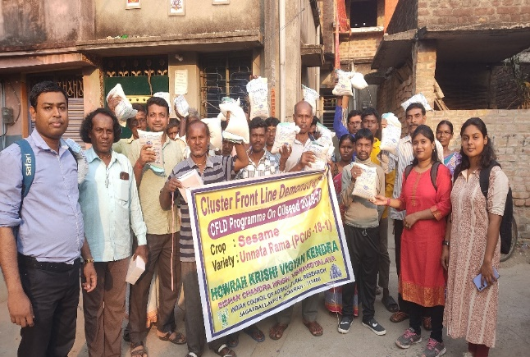
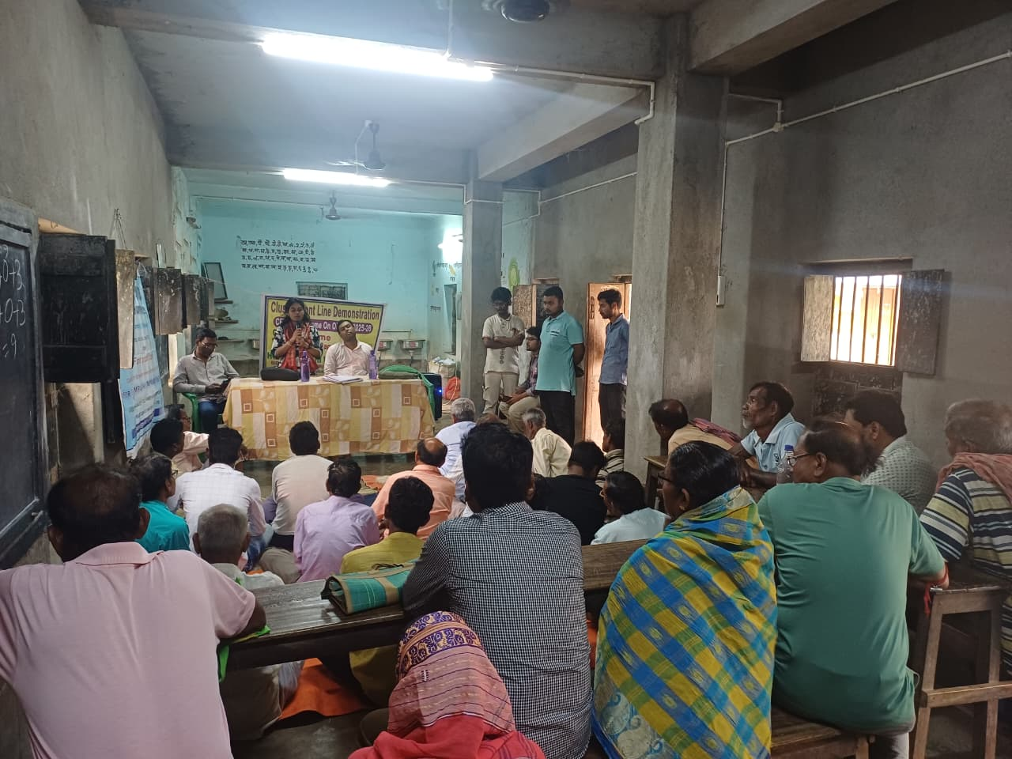
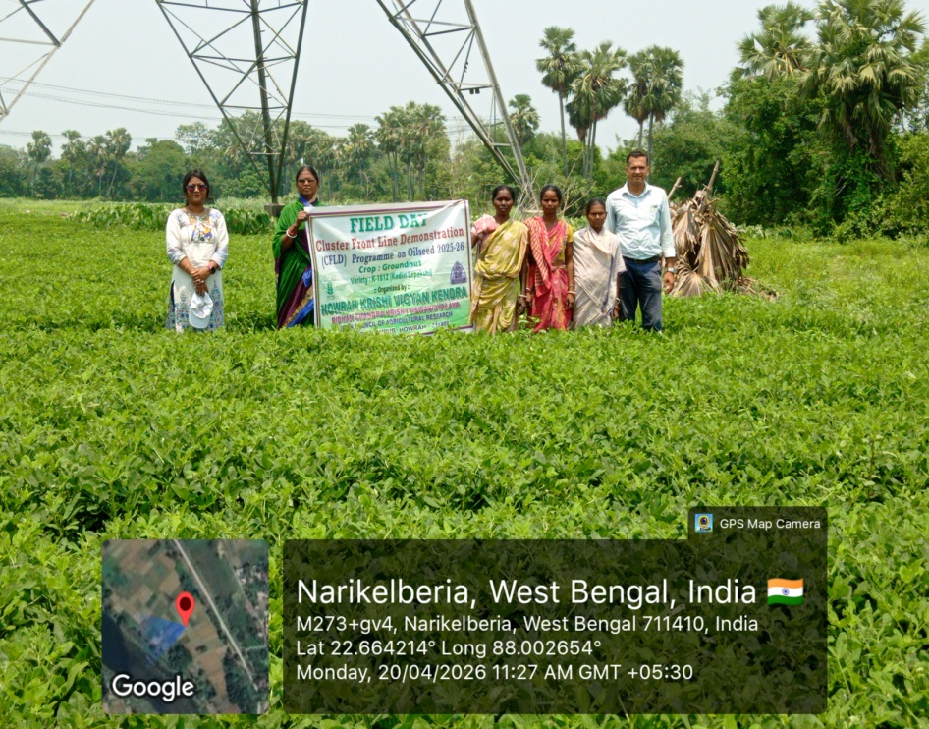
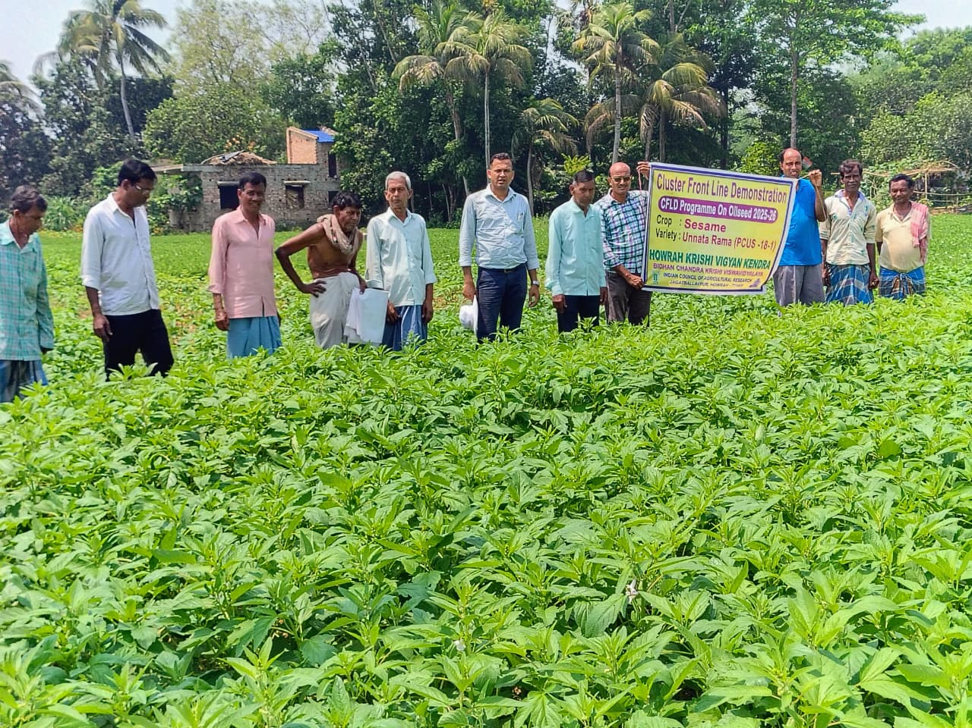
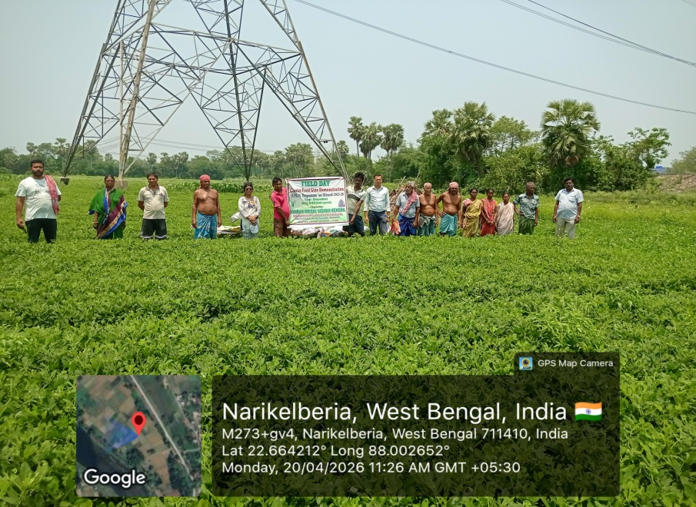
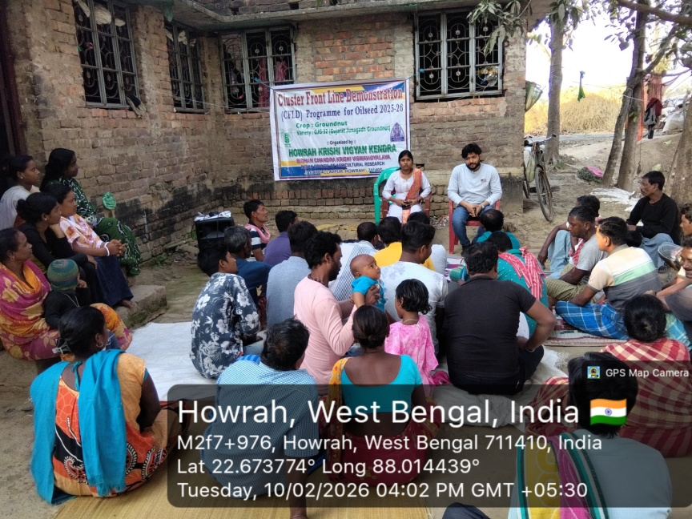
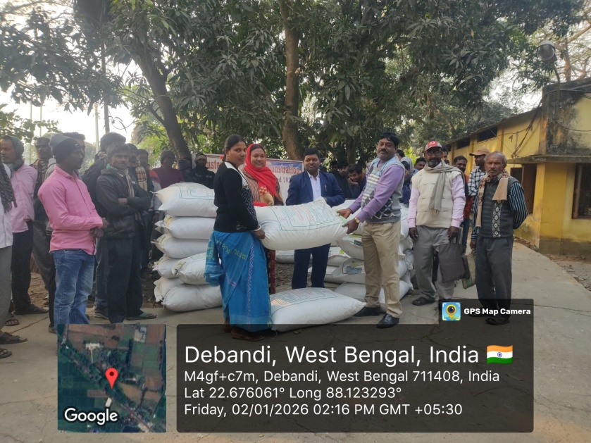
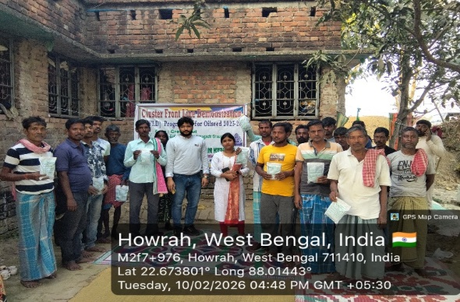
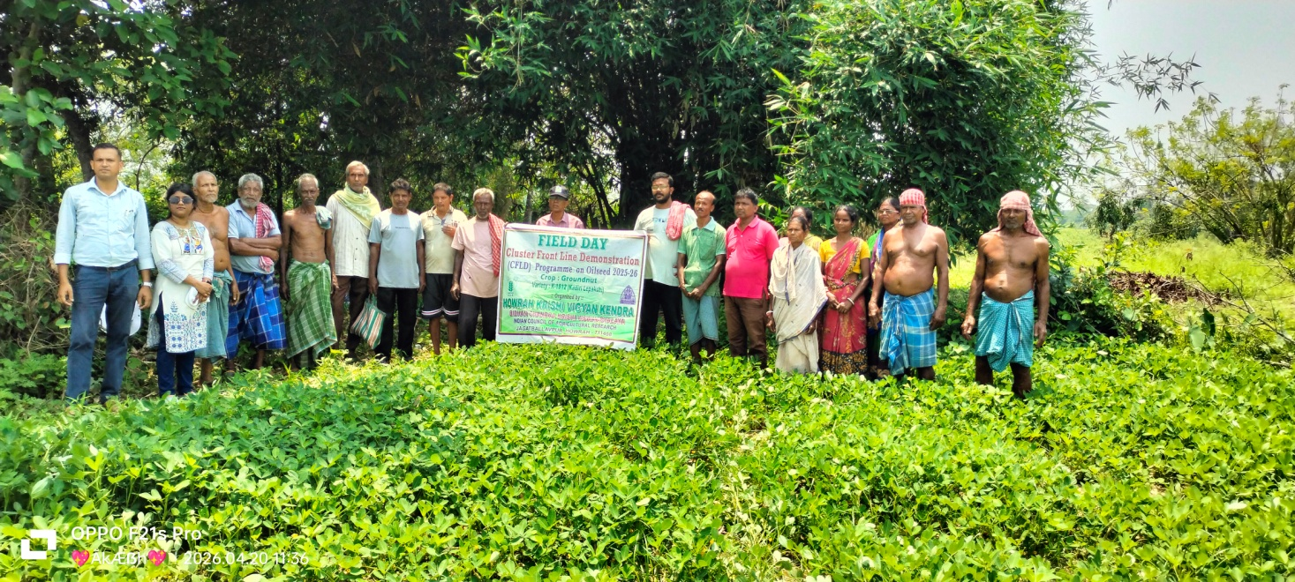

Demonstration & Input distribution under SCSP
Sl No. | Category | Thematic  area | Name of the technology demonstrated | No. of Farmer | Quantity
 | Paddy | Crop production | Var. Swarna sub-1 &  Var. MTU-7029  Var. IET 4786 | 285 | 1250 kg
 | Lentil | Crop production | Var. WBL-77 | 50 | 200 kg
 | Mustard | Crop production | Var. PM-30 | 150 | 175 kg
 | Chick | Animal husbandry | Var. Sonali & Banraja | 200 | 2000
 | Feed | Animal husbandry |  | 100 | 200
 | Power Sprayer | Input distribution |  | 20 | 20
 | Spade | Input distribution |  | 40 | 40
 | Vegetable seedling | Horticulture |  | 100 | 20000
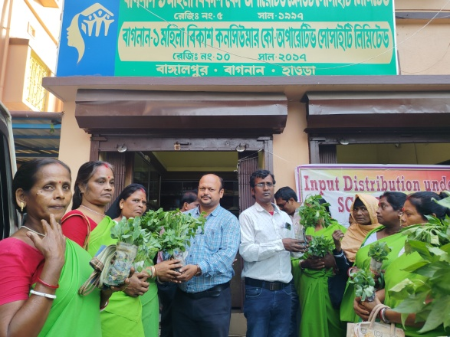
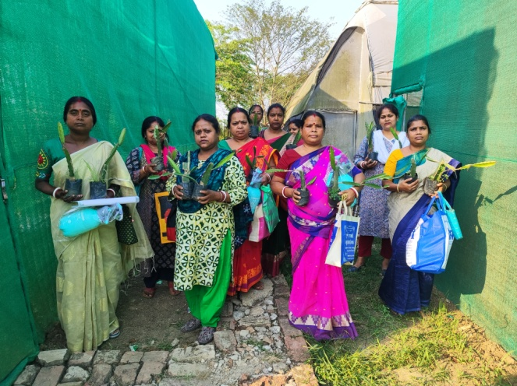
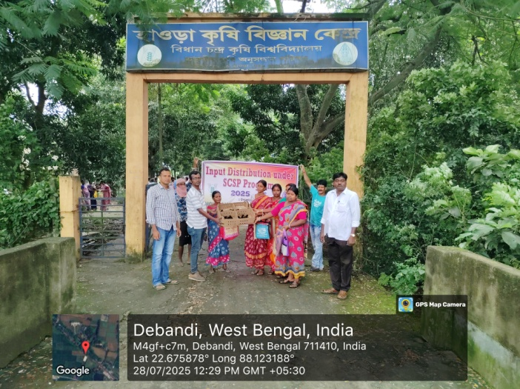
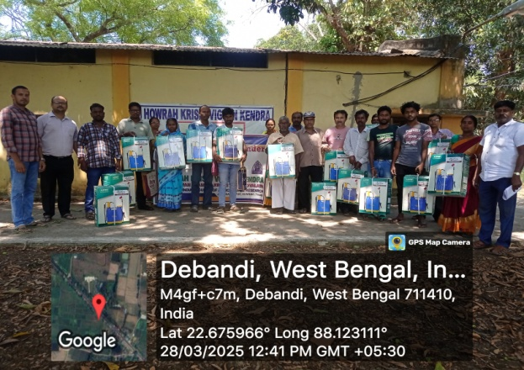
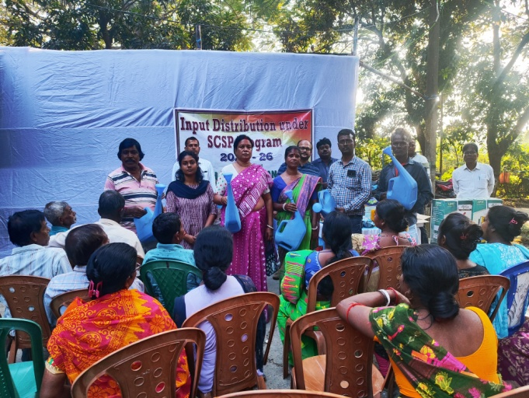
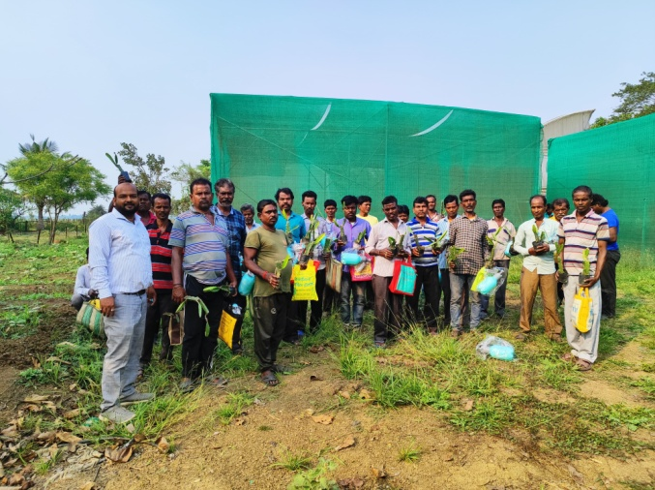

  - Achievements on Training (Including the sponsored and FLD training programmes):

- Farmers and farm women (on campus)

Thematic Area | No. of Courses | No. of Participants |  |  |  |  |  |  |  |  | Grand Total
Thematic Area | No. of Courses | Other |  |  | SC |  |  | ST
 | No. of Courses | M | F | T | M | F | T | M | F | T | M | F | T
I. Crop Production
Weed Management | 1 | 26 | 7 | 33 | 5 | 6 | 11 | 0 | 0 | 0 | 31 | 13 | 44
Identification of different weeds
Improved cultivation practices of oilseed crops | 1 | 18 | 5 | 23 | 4 | 2 | 6 | 0 | 0 | 0 | 22 | 7 | 29
Rabi oilseed cultivation
Improved cultivation practices of Potato
Improved cultivation practices of pulse crops
Farm Mechanization
Plant nutrients and their deficiency symptoms | 1 | 19 | 5 | 24 | 7 | 0 | 7 | 0 | 0 | 0 | 26 | 5 | 31
Resource Conservation Technologies
SRI | 2 | 37 | 8 | 45 | 0 | 0 | 0 | 0 | 0 | 0 | 37 | 8 | 45
Improved Jute cultivation
Seed Treatment of Rice (Practical)
Potato Cultivation
Aman Paddy Cultivation
Organic Farming | 2 | 35 | 5 | 40 | 0 | 0 | 0 | 0 | 0 | 0 | 35 | 5 | 40
Cropping Systems
Crop Diversification
Integrated Farming
Micro irrigation/irrigation
Seed production
Nursery management
Integrated Crop Management
Soil & water conservation
Integrated nutrient Management
Production of organic inputs
Others
Total | 7 | 135 | 30 | 165 | 16 | 8 | 24 | 0 | 0 | 0 | 151 | 38 | 189
II. Horticulture
a) Vegetable Crops
Improved cultivation practices of Cabbage, Cauliflower
Potential vegetable crop production
Improved cultivation practices of Brocoli & Turnip
Improved Cultivation of Elephant Foot Yam & Colocasia
Improved cultivation practices of Coconut and Arecanut | 2 | 35 | 10 | 45 | 11 | 12 | 23 | 0 | 0 | 0 | 46 | 22 | 68
Improved cultivation practices of Brinjal & Tomato
Cultivation practices of Okra, Kharif Onion & Dragon fruit | 1 | 17 | 5 | 22 | 5 | 3 | 8 | 0 | 0 | 0 | 22 | 8 | 30
Production of low volume and high value crops
Off-season vegetables
Nursery raising
Exotic vegetables
Export potential vegetables
Grading and standardization
Protective cultivation
Others
Total (a) | 3 | 52 | 15 | 67 | 16 | 15 | 31 | 0 | 0 | 0 | 68 | 30 | 98
b) Fruits
Training and Pruning
Layout and Management of Orchards
Cultivation of Fruit | 1 | 3 | 0 | 3 | 19 | 12 | 31 | 0 | 0 | 0 | 22 | 12 | 34
Improved cultivation practices of Guava | 1 | 5 | 0 | 5 | 25 | 13 | 38 | 0 | 0 | 0 | 30 | 13 | 43
Improved cultivation practices of Citrus & Ber | 1 | 6 | 5 | 11 | 19 | 11 | 30 | 0 | 0 | 0 | 25 | 16 | 41
Management of young plants/orchards
Rejuvenation of old orchards
Export potential fruits
Micro irrigation systems of orchards
Plant propagation techniques
Others
Total (b) | 3 | 14 | 5 | 19 | 63 | 36 | 99 | 0 | 0 | 0 | 77 | 41 | 118
c) Ornamental Plants
Important flower cultivation
Cultivation practices of Gerbera
Improved cultivation practices of Marigold, Orchid & Chrysanthemum
Landscape & Gardening | 1 | 3 | 4 | 7 | 15 | 14 | 29 | 0 | 0 | 0 | 18 | 18 | 36
Nursery Management
Management of potted plants
Export potential of ornamental plants
Propagation techniques of Ornamental Plants
Others
Total (c) | 1 | 3 | 4 | 7 | 15 | 14 | 29 | 0 | 0 | 0 | 18 | 18 | 36
d) Plantation crops
Production and Management technology
Processing and value addition
Others
Total (d)
e) Tuber crops
Production and Management technology
Processing and value addition
Others
Total (e)
f) Spices
Production and Management technology
Processing and value addition
Others
Total (f)
g) Medicinal and Aromatic Plants
Nursery management
Production and management technology
Post harvest technology and value addition
Others
Total (g)
Total(a-g) | 7 | 69 | 24 | 93 | 94 | 65 | 159 | 0 | 0 | 0 | 163 | 89 | 252
III. Soil Health and Fertility Management
Soil Health Management | 1 | 8 | 4 | 12 | 15 | 11 | 26 | 0 | 0 | 0 | 23 | 15 | 38
Fertilizer calculation based on soil test report | 1 | 8 | 5 | 13 | 14 | 12 | 26 | 0 | 0 | 0 | 22 | 17 | 39
Plant nutrient & soil sampling | 1 | 7 | 5 | 12 | 11 | 11 | 22 | 0 | 0 | 0 | 18 | 16 | 34
Soil sampling | 1 | 5 | 7 | 12 | 17 | 9 | 26 | 0 | 0 | 0 | 22 | 16 | 38
Soil fertility management
Integrated water management
Integrated Nutrient Management
Production and use of organic inputs
Management of Problematic soils
Micro nutrient deficiency in crops
Nutrient Use Efficiency
Balance Use of fertilizer
Soil & water testing
others
Total | 4 | 28 | 21 | 49 | 57 | 43 | 100 | 0 | 0 | 0 | 85 | 64 | 149
IV. Livestock Production and Management
Dairy Management
Poultry Management
Piggery Management
Rabbit Management
Animal Nutrition Management
Disease Management
Feed & fodder technologies
Production of quality animal products
Others
Total
V. Home Science/Women empowerment
Household food security by kitchen gardening and nutrition gardening
Design and development of low/minimum cost diet
Designing and development for high nutrient efficiency diet
Minimization of nutrient loss in processing
Processing & cooking
Gender mainstreaming through SHGs
Storage loss minimization techniques
Value addition
Women empowerment
Location specific drudgery reduction technologies
Rural Crafts
Women and child care
Others
Total
VI. Agril. Engineering
Farm machinery & its maintenance
Installation and maintenance of micro irrigation systems
Use of Plastics in farming practices
Production of small tools and implements
Repair and maintenance of farm machinery and implements
Small scale processing and value addition
Post Harvest Technology
Others
Total
VII. Plant Protection
Integrated Pest Management | 3 | 5 | 4 | 9 | 42 | 19 | 61 | 0 | 0 | 0 | 47 | 23 | 70
Integrated Disease Management | 2 | 18 | 3 | 21 | 24 | 5 | 29 | 3 | 3 | 6 | 45 | 11 | 56
Bio control of pests and diseases | 3 | 14 | 11 | 25 | 25 | 56 | 81 | 1 | 1 | 2 | 40 | 68 | 108
Production of bio control agents and bio pesticides | 1 | 6 | 9 | 15 | 11 | 8 | 19 | 6 | 2 | 8 | 23 | 19 | 42
Others
Total | 9 | 43 | 27 | 70 | 102 | 88 | 190 | 10 | 6 | 16 | 155 | 121 | 276
VIII. Fisheries
Integrated fish farming
Carp breeding and hatchery management
Carp fry and fingerling rearing
Composite fish culture
Hatchery management and culture of freshwater prawn
Breeding and culture of ornamental fishes
Portable plastic carp hatchery
Pen culture of fish and prawn
Shrimp farming
Edible oyster farming
Pearl culture
Fish processing and value addition
Others
Total
IX. Production of Input at site
Seed Production
Planting material production
Bio-agents production
Bio-pesticides production
Bio-fertilizer production
Vermi-compost production | 2 | 11 | 12 | 23 | 15 | 9 | 24 | 1 | 1 | 2 | 27 | 22 | 49
Organic manures production
Production of fry and fingerlings
Production of Bee-colonies and wax sheets
Small tools and implements
Production of livestock feed and fodder | 1 | 7 | 6 | 13 | 17 | 8 | 25 | 5 | 3 | 8 | 29 | 17 | 46
Production of Fish feed
Mushroom production
Apiculture
Others
Total | 3 | 25 | 24 | 49 | 49 | 25 | 74 | 11 | 7 | 18 | 85 | 56 | 141
X. Capacity Building and Group Dynamics
Leadership development
Group dynamics
Formation and Management of SHGs
Mobilization of social capital
Entrepreneurial development of farmers/youths
WTO and IPR issues
Others (FPO formation)
Total
XI. Agro forestry
Production technologies
Nursery management
Integrated Farming Systems
Others
Total
XII. Others (Pl. Specify)
GRAND TOTAL | 30 | 300 | 126 | 426 | 318 | 229 | 547 | 21 | 13 | 34 | 639 | 368 | 1007

B) Rural Youth (on campus)
Thematic Area | No. of Courses | No. of Participants |  |  |  |  |  |  |  |  |  | Grand Total
Thematic Area | No. of Courses | Other |  |  | SC |  |  |  | ST
 | No. of Courses | M | F | T | M | F |  | T | M | F | T | M | F | T
Nursery Management of Horticulture crops
Training and pruning of orchards
Protected cultivation of vegetable crops
Commercial fruit production
Integrated farming
Seed production
Production of organic inputs
Planting material production
Vermiculture | 4 | 54 | 27 | 81 | 12 |  | 3 | 15 | 0 | 0 | 0 | 66 | 30 | 96
Mushroom Production | 5 | 37 | 72 | 109 | 11 |  | 38 | 49 | 0 | 4 | 4 | 48 | 114 | 162
Beekeeping
Sericulture
Repair and maintenance of farm machinery and implements
Value addition
Small scale processing
Post Harvest Technology
Tailoring and Stitching
Rural Crafts
Production of quality animal products
Dairying
Sheep and goat rearing
Quail farming
Piggery
Rabbit farming
Poultry production
Ornamental fisheries
Composite fish culture
Freshwater prawn culture
Shrimp farming
Pearl culture
Cold water fisheries
Fish harvest and processing technology
Fry and fingerling rearing
Others
Production of Different inputs for Natural Farming | 2 | 40 | 22 | 62 | 9 |  | 9 | 18 | 0 | 0 | 0 | 49 | 31 | 80
Total | 11 | 131 | 121 | 252 | 32 |  | 50 | 82 | 0 | 4 | 4 | 163 | 175 | 338

C) Extension Personnel (on campus)

Thematic Area | No. of Courses | No. of Participants |  |  |  |  |  |  |  |  |  | Grand Total
Thematic Area | No. of Courses | Other |  |  | SC |  |  |  | ST
 | No. of Courses | M | F | T | M | F |  | T | M | F | T | M | F | T
Productivity enhancement in field crops | 27 | 752 | 110 | 862 | 96 |  | 39 | 135 | 0 | 0 | 0 | 848 | 149 | 997
Integrated Pest Management | 31 | 884 | 110 | 994 | 109 |  | 45 | 154 | 0 | 0 | 0 | 993 | 155 | 1148
Integrated Nutrient management | 13 | 348 | 46 | 394 | 56 |  | 24 | 80 | 0 | 0 | 0 | 404 | 70 | 474
Rejuvenation of old orchards
Protected cultivation technology | 24 | 667 | 112 | 779 | 92 |  | 38 | 130 | 0 | 0 | 0 | 759 | 150 | 909
Production and use of organic inputs
Care and maintenance of farm machinery and implements
Gender mainstreaming through SHGs
Formation and Management of SHGs
Women and Child care
Low cost and nutrient efficient diet designing
Group Dynamics and farmers organization | 8 | 218 | 36 | 254 | 31 |  | 14 | 45 | 0 | 0 | 0 | 249 | 50 | 299
Information networking among farmers
Capacity building for ICT application | 3 | 96 | 12 | 108 | 10 |  | 5 | 15 | 0 | 0 | 0 | 106 | 17 | 123
Management in farm animals
Livestock feed and fodder production
Household food security
Other | 10 | 320 | 30 | 350 | 54 |  | 16 | 70 | 0 | 0 | 0 | 374 | 46 | 420
Total | 116 | 3285 | 456 | 3741 | 448 |  | 181 | 629 | 0 | 0 | 0 | 3733 | 637 | 4370

D) Farmers and farm women (off campus)
Thematic Area | No. of Courses | No. of Participants |  |  |  |  |  |  |  |  | Grand Total
Thematic Area | No. of Courses | Other |  |  | SC |  |  | ST
 | No. of Courses | M | F | T | M | F | T | M | F | T | M | F | T
I. Crop Production
Weed Management
Identification of different weeds | 2 | 44 | 12 | 56 | 4 | 5 | 9 | 0 | 0 | 0 | 48 | 17 | 65
Improved cultivation practices of oilseed crops
Rabi oilseed cultivation | 1 | 19 | 11 | 30 | 6 | 1 | 7 | 0 | 0 | 0 | 25 | 12 | 37
Improved cultivation practices of Potato | 1 | 25 | 5 | 30 | 6 | 2 | 8 | 0 | 0 | 0 | 31 | 7 | 38
Improved cultivation practices of pulse crops | 1 | 27 | 5 | 32 | 5 | 1 | 6 | 0 | 0 | 0 | 32 | 6 | 38
Farm Mechanization | 1 | 22 | 8 | 30 | 7 | 0 | 7 | 0 | 0 | 0 | 29 | 8 | 37
Plant nutrients and their deficiency symptoms
Resource Conservation Technologies | 1 | 23 | 7 | 30 | 5 | 6 | 11 | 0 | 0 | 0 | 28 | 13 | 41
SRI
Improved Jute cultivation | 2 | 35 | 6 | 41 | 11 | 3 | 14 | 0 | 0 | 0 | 46 | 9 | 55
Seed Treatment of Rice (Practical) | 1 | 25 | 5 | 30 | 5 | 2 | 7 | 0 | 0 | 0 | 30 | 7 | 37
Potato Cultivation | 1 | 24 | 8 | 32 | 6 | 1 | 7 | 0 | 0 | 0 | 30 | 9 | 39
Aman Paddy Cultivation | 2 | 39 | 24 | 63 | 0 | 0 | 0 | 0 | 0 | 0 | 39 | 24 | 63
Organic Farming
Cropping Systems
Crop Diversification
Integrated Farming
Micro irrigation/irrigation
Seed production
Nursery management | 1 | 35 | 5 | 40 | 4 | 4 | 8 | 0 | 0 | 0 | 39 | 9 | 48
Integrated Crop Management
Soil & water conservation
Integrated nutrient Management
Production of organic inputs
Others
Total | 14 | 318 | 96 | 414 | 59 | 25 | 84 | 0 | 0 | 0 | 377 | 121 | 498
II. Horticulture
a) Vegetable Crops
Improved cultivation practices of Cabbage, Cauliflower | 1 | 28 | 5 | 33 | 3 | 8 | 11 | 0 | 0 | 0 | 31 | 13 | 44
Potential vegetable crop production | 1 | 13 | 0 | 13 | 8 | 11 | 19 | 0 | 0 | 0 | 21 | 11 | 32
Improved cultivation practices of Brocoli & Turnip | 1 | 19 | 5 | 24 | 3 | 6 | 9 | 0 | 0 | 0 | 22 | 11 | 33
Improved Cultivation of Elephant Foot Yam & Colocasia | 2 | 36 | 10 | 46 | 12 | 13 | 25 | 0 | 0 | 0 | 48 | 23 | 71
Improved cultivation practices of Coconut and Arecanut
Improved cultivation practices of Brinjal & Tomato | 1 | 25 | 5 | 30 | 7 | 2 | 9 | 0 | 0 | 0 | 32 | 7 | 39
Cultivation practices of Okra, Kharif Onion & Dragon fruit
Production of low volume and high value crops
Off-season vegetables
Nursery raising
Exotic vegetables
Export potential vegetables
Grading and standardization
Protective cultivation
Others
Total (a) | 6 | 121 | 25 | 146 | 33 | 40 | 73 | 0 | 0 | 0 | 154 | 65 | 219
b) Fruits
Training and Pruning
Layout and Management of Orchards
Cultivation of Fruit
Improved cultivation practices of Guava
Improved cultivation practices of Citrus & Ber
Management of young plants/orchards
Rejuvenation of old orchards
Export potential fruits
Micro irrigation systems of orchards
Plant propagation techniques
Others
Total (b)
c) Ornamental Plants
Important flower cultivation | 2 | 9 | 6 | 15 | 22 | 15 | 37 | 0 | 0 | 0 | 31 | 21 | 52
Cultivation practices of Gerbera | 1 | 5 | 2 | 7 | 7 | 11 | 18 | 0 | 0 | 0 | 12 | 13 | 25
Improved cultivation practices of Marigold, Orchid & Chrysanthemum | 1 | 5 | 4 | 9 | 16 | 11 | 27 | 0 | 0 | 0 | 21 | 15 | 36
Landscape & Gardening
Nursery Management
Management of potted plants
Export potential of ornamental plants
Propagation techniques of Ornamental Plants
Others
Total (c) | 4 | 19 | 12 | 31 | 45 | 37 | 82 | 0 | 0 | 0 | 64 | 49 | 113
d) Plantation crops
Production and Management technology
Processing and value addition
Others
Total (d)
e) Tuber crops
Production and Management technology
Processing and value addition
Others
Total (e)
f) Spices
Production and Management technology
Processing and value addition
Others
Total (f)
g) Medicinal and Aromatic Plants
Nursery management
Production and management technology
Post harvest technology and value addition
Others
Total (g)
Total(a-g) | 10 | 140 | 37 | 177 | 78 | 77 | 155 | 0 | 0 | 0 | 218 | 114 | 332
III. Soil Health and Fertility Management
Soil Health Management
Fertilizer calculation based on soil test report
Plant nutrient & soil sampling
Soil sampling
Soil fertility management
Integrated water management
Integrated Nutrient Management
Production and use of organic inputs
Management of Problematic soils
Micro nutrient deficiency in crops
Nutrient Use Efficiency
Balance Use of fertilizer
Soil & water testing
others
Total | 0 | 0 | 0 | 0 | 0 | 0 | 0 | 0 | 0 | 0 | 0 | 0 | 0
IV. Livestock Production and Management
Dairy Management
Poultry Management
Piggery Management
Rabbit Management
Animal Nutrition Management
Disease Management
Feed & fodder technologies
Production of quality animal products
Others
Total
V. Home Science/Women empowerment
Household food security by kitchen gardening and nutrition gardening
Design and development of low/minimum cost diet
Designing and development for high nutrient efficiency diet
Minimization of nutrient loss in processing
Processing & cooking
Gender mainstreaming through SHGs
Storage loss minimization techniques
Value addition
Women empowerment
Location specific drudgery reduction technologies
Rural Crafts
Women and child care
Others
Total
VI. Agril. Engineering
Farm machinery & its maintenance
Installation and maintenance of micro irrigation systems
Use of Plastics in farming practices
Production of small tools and implements
Repair and maintenance of farm machinery and implements
Small scale processing and value addition
Post Harvest Technology
Others
Total
VII. Plant Protection
Integrated Pest Management | 7 | 38 | 11 | 49 | 84 | 56 | 140 | 13 | 5 | 18 | 135 | 72 | 207
Integrated Disease Management | 7 | 34 | 18 | 52 | 131 | 18 | 149 | 2 | 3 | 5 | 167 | 39 | 206
Bio control of pests and diseases
Production of bio control agents and bio pesticides
Others
Total | 14 | 72 | 29 | 101 | 215 | 74 | 289 | 15 | 8 | 23 | 302 | 111 | 413
VIII. Fisheries
Integrated fish farming
Carp breeding and hatchery management
Carp fry and fingerling rearing
Composite fish culture
Hatchery management and culture of freshwater prawn
Breeding and culture of ornamental fishes
Portable plastic carp hatchery
Pen culture of fish and prawn
Shrimp farming
Edible oyster farming
Pearl culture
Fish processing and value addition
Others
Total
IX. Production of Input at site
Seed Production
Planting material production
Bio-agents production
Bio-pesticides production
Bio-fertilizer production
Vermi-compost production
Organic manures production
Production of fry and fingerlings
Production of Bee-colonies and wax sheets
Small tools and implements
Production of livestock feed and fodder
Production of Fish feed
Mushroom production
Apiculture
Others
Total
X. Capacity Building and Group Dynamics
Leadership development
Group dynamics
Formation and Management of SHGs
Mobilization of social capital
Entrepreneurial development of farmers/youths
WTO and IPR issues
Others (FPO formation) | 5 | 68 | 23 | 91 | 33 | 28 | 61 | 5 | 11 | 16 | 106 | 62 | 168
Total | 5 | 68 | 23 | 91 | 33 | 28 | 61 | 5 | 11 | 16 | 106 | 62 | 168
XI. Agro forestry
Production technologies
Nursery management
Integrated Farming Systems
Others
Total
XII. Others (Pl. Specify)
GRAND TOTAL | 43 | 598 | 185 | 783 | 385 | 204 | 589 | 20 | 19 | 39 | 1003 | 408 | 1411

E) RURAL YOUTH (Off Campus)

Thematic Area | No. of Courses | No. of Participants |  |  |  |  |  |  |  |  |  | Grand Total
Thematic Area | No. of Courses | Other |  |  | SC |  |  |  | ST
 | No. of Courses | M | F | T | M | F |  | T | M | F | T | M | F | T
Nursery Management of Horticulture crops
Training and pruning of orchards
Protected cultivation of vegetable crops
Commercial fruit production
Integrated farming
Seed production
Production of organic inputs
Planting material production
Vermiculture
Mushroom Production
Beekeeping
Sericulture
Repair and maintenance of farm machinery and implements
Value addition
Small scale processing
Post Harvest Technology
Tailoring and Stitching
Rural Crafts
Production of quality animal products
Dairying
Sheep and goat rearing
Quail farming
Piggery
Rabbit farming
Poultry production
Ornamental fisheries
Composite fish culture
Freshwater prawn culture
Shrimp farming
Pearl culture
Cold water fisheries
Fish harvest and processing technology
Fry and fingerling rearing
Others
Total

F) Extension Personnel (Off Campus)

Thematic Area | No. of Courses | No. of Participants |  |  |  |  |  |  |  |  |  | Grand Total
Thematic Area | No. of Courses | Other |  |  | SC |  |  |  | ST
 | No. of Courses | M | F | T | M | F |  | T | M | F | T | M | F | T
Productivity enhancement in field crops
Integrated Pest Management
Integrated Nutrient management
Rejuvenation of old orchards
Protected cultivation technology
Production and use of organic inputs
Care and maintenance of farm machinery and implements
Gender mainstreaming through SHGs
Formation and Management of SHGs
Women and Child care
Low cost and nutrient efficient diet designing
Group Dynamics and farmers organization
Information networking among farmers
Capacity building for ICT application
Management in farm animals
Livestock feed and fodder production
Household food security
Other
Total

G) Consolidated table (ON and OFF Campus)
i. Farmers & Farm Women
Thematic Area | No. of Courses | No. of Participants |  |  |  |  |  |  |  |  | Grand Total
Thematic Area | No. of Courses | Other |  |  | SC |  |  | ST
 | No. of Courses | M | F | T | M | F | T | M | F | T | M | F | T
I. Crop Production
Weed Management | 1 | 26 | 7 | 33 | 5 | 6 | 11 | 0 | 0 | 0 | 31 | 13 | 44
Identification of different weeds | 2 | 44 | 12 | 56 | 4 | 5 | 9 | 0 | 0 | 0 | 48 | 17 | 65
Improved cultivation practices of oilseed crops | 1 | 18 | 5 | 23 | 4 | 2 | 6 | 0 | 0 | 0 | 22 | 7 | 29
Rabi oilseed cultivation | 1 | 19 | 11 | 30 | 6 | 1 | 7 | 0 | 0 | 0 | 25 | 12 | 37
Improved cultivation practices of Potato | 1 | 25 | 5 | 30 | 6 | 2 | 8 | 0 | 0 | 0 | 31 | 7 | 38
Improved cultivation practices of pulse crops | 1 | 27 | 5 | 32 | 5 | 1 | 6 | 0 | 0 | 0 | 32 | 6 | 38
Farm Mechanization | 1 | 22 | 8 | 30 | 7 | 0 | 7 | 0 | 0 | 0 | 29 | 8 | 37
Plant nutrients and their deficiency symptoms | 1 | 19 | 5 | 24 | 7 | 0 | 7 | 0 | 0 | 0 | 26 | 5 | 31
Resource Conservation Technologies | 1 | 23 | 7 | 30 | 5 | 6 | 11 | 0 | 0 | 0 | 28 | 13 | 41
SRI | 2 | 37 | 8 | 45 | 0 | 0 | 0 | 0 | 0 | 0 | 37 | 8 | 45
Improved Jute cultivation | 2 | 35 | 6 | 41 | 11 | 3 | 14 | 0 | 0 | 0 | 46 | 9 | 55
Seed Treatment of Rice (Practical) | 1 | 25 | 5 | 30 | 5 | 2 | 7 | 0 | 0 | 0 | 30 | 7 | 37
Potato Cultivation | 1 | 24 | 8 | 32 | 6 | 1 | 7 | 0 | 0 | 0 | 30 | 9 | 39
Aman Paddy Cultivation | 2 | 39 | 24 | 63 | 0 | 0 | 0 | 0 | 0 | 0 | 39 | 24 | 63
Organic Farming | 2 | 35 | 5 | 40 | 0 | 0 | 0 | 0 | 0 | 0 | 35 | 5 | 40
Cropping Systems
Crop Diversification
Integrated Farming
Micro irrigation/irrigation
Seed production
Nursery management | 1 | 35 | 5 | 40 | 4 | 4 | 8 | 0 | 0 | 0 | 39 | 9 | 48
Integrated Crop Management
Soil & water conservation
Integrated nutrient Management
Production of organic inputs
Others
Total | 21 | 453 | 126 | 579 | 75 | 33 | 108 | 0 | 0 | 0 | 528 | 159 | 687
II. Horticulture
a) Vegetable Crops
Improved cultivation practices of Cabbage, Cauliflower | 1 | 28 | 5 | 33 | 3 | 8 | 11 | 0 | 0 | 0 | 31 | 13 | 44
Potential vegetable crop production | 1 | 13 | 0 | 13 | 8 | 11 | 19 | 0 | 0 | 0 | 21 | 11 | 32
Improved cultivation practices of Brocoli & Turnip | 1 | 19 | 5 | 24 | 3 | 6 | 9 | 0 | 0 | 0 | 22 | 11 | 33
Improved Cultivation of Elephant Foot Yam & Colocasia | 2 | 36 | 10 | 46 | 12 | 13 | 25 | 0 | 0 | 0 | 48 | 23 | 71
Improved cultivation practices of Coconut and Arecanut | 2 | 35 | 10 | 45 | 11 | 12 | 23 | 0 | 0 | 0 | 46 | 22 | 68
Improved cultivation practices of Brinjal & Tomato | 1 | 25 | 5 | 30 | 7 | 2 | 9 | 0 | 0 | 0 | 32 | 7 | 39
Cultivation practices of Okra, Kharif Onion & Dragon fruit | 1 | 17 | 5 | 22 | 5 | 3 | 8 | 0 | 0 | 0 | 22 | 8 | 30
Production of low volume and high value crops
Off-season vegetables
Nursery raising
Exotic vegetables
Export potential vegetables
Grading and standardization
Protective cultivation
Others
Total (a) | 9 | 173 | 40 | 213 | 49 | 55 | 104 | 0 | 0 | 0 | 222 | 95 | 317
b) Fruits
Training and Pruning
Layout and Management of Orchards
Cultivation of Fruit | 1 | 3 | 0 | 3 | 19 | 12 | 31 | 0 | 0 | 0 | 22 | 12 | 34
Improved cultivation practices of Guava | 1 | 5 | 0 | 5 | 25 | 13 | 38 | 0 | 0 | 0 | 30 | 13 | 43
Improved cultivation practices of Citrus & Ber | 1 | 6 | 5 | 11 | 19 | 11 | 30 | 0 | 0 | 0 | 25 | 16 | 41
Management of young plants/orchards
Rejuvenation of old orchards
Export potential fruits
Micro irrigation systems of orchards
Plant propagation techniques
Others
Total (b) | 3 | 14 | 5 | 19 | 63 | 36 | 99 | 0 | 0 | 0 | 77 | 41 | 118
c) Ornamental Plants
Important flower cultivation | 2 | 9 | 6 | 15 | 22 | 15 | 37 | 0 | 0 | 0 | 31 | 21 | 52
Cultivation practices of Gerbera | 1 | 5 | 2 | 7 | 7 | 11 | 18 | 0 | 0 | 0 | 12 | 13 | 25
Improved cultivation practices of Marigold, Orchid & Chrysanthemum | 1 | 5 | 4 | 9 | 16 | 11 | 27 | 0 | 0 | 0 | 21 | 15 | 36
Landscape & Gardening | 1 | 3 | 4 | 7 | 15 | 14 | 29 | 0 | 0 | 0 | 18 | 18 | 36
Nursery Management
Management of potted plants
Export potential of ornamental plants
Propagation techniques of Ornamental Plants
Others
Total (c) | 5 | 22 | 16 | 38 | 60 | 51 | 111 | 0 | 0 | 0 | 82 | 67 | 149
d) Plantation crops
Production and Management technology
Processing and value addition
Others
Total (d)
e) Tuber crops
Production and Management technology
Processing and value addition
Others
Total (e)
f) Spices
Production and Management technology
Processing and value addition
Others
Total (f)
g) Medicinal and Aromatic Plants
Nursery management
Production and management technology
Post harvest technology and value addition
Others
Total (g)
Total(a-g)
III. Soil Health and Fertility Management
Soil Health Management | 1 | 8 | 4 | 12 | 15 | 11 | 26 | 0 | 0 | 0 | 23 | 15 | 38
Fertilizer calculation based on soil test report | 1 | 8 | 5 | 13 | 14 | 12 | 26 | 0 | 0 | 0 | 22 | 17 | 39
Plant nutrient & soil sampling | 1 | 7 | 5 | 12 | 11 | 11 | 22 | 0 | 0 | 0 | 18 | 16 | 34
Soil sampling | 1 | 5 | 7 | 12 | 17 | 9 | 26 | 0 | 0 | 0 | 22 | 16 | 38
Soil fertility management
Integrated water management
Integrated Nutrient Management
Production and use of organic inputs
Management of Problematic soils
Micro nutrient deficiency in crops
Nutrient Use Efficiency
Balance Use of fertilizer
Soil & water testing
others
Total | 4 | 28 | 21 | 49 | 57 | 43 | 100 | 0 | 0 | 0 | 85 | 64 | 149
IV. Livestock Production and Management
Dairy Management
Poultry Management
Piggery Management
Rabbit Management
Animal Nutrition Management
Disease Management
Feed & fodder technologies
Production of quality animal products
Others
Total
V. Home Science/Women empowerment
Household food security by kitchen gardening and nutrition gardening
Design and development of low/minimum cost diet
Designing and development for high nutrient efficiency diet
Minimization of nutrient loss in processing
Processing & cooking
Gender mainstreaming through SHGs
Storage loss minimization techniques
Value addition
Women empowerment
Location specific drudgery reduction technologies
Rural Crafts
Women and child care
Others
Total
VI. Agril. Engineering
Farm machinery & its maintenance
Installation and maintenance of micro irrigation systems
Use of Plastics in farming practices
Production of small tools and implements
Repair and maintenance of farm machinery and implements
Small scale processing and value addition
Post Harvest Technology
Others
Total
VII. Plant Protection
Integrated Pest Management | 10 | 43 | 15 | 58 | 126 | 75 | 201 | 13 | 5 | 18 | 182 | 95 | 277
Integrated Disease Management | 9 | 52 | 21 | 73 | 155 | 23 | 178 | 5 | 6 | 11 | 212 | 50 | 262
Bio control of pests and diseases | 3 | 14 | 11 | 25 | 25 | 56 | 81 | 1 | 1 | 2 | 40 | 68 | 108
Production of bio control agents and bio pesticides | 1 | 6 | 9 | 15 | 11 | 8 | 19 | 6 | 2 | 8 | 23 | 19 | 42
Others | 23 | 115 | 56 | 171 | 317 | 162 | 479 | 25 | 14 | 39 | 457 | 232 | 689
Total
VIII. Fisheries
Integrated fish farming
Carp breeding and hatchery management
Carp fry and fingerling rearing
Composite fish culture
Hatchery management and culture of freshwater prawn
Breeding and culture of ornamental fishes
Portable plastic carp hatchery
Pen culture of fish and prawn
Shrimp farming
Edible oyster farming
Pearl culture
Fish processing and value addition
Others
Total
IX. Production of Input at site
Seed Production
Planting material production
Bio-agents production
Bio-pesticides production
Bio-fertilizer production
Vermi-compost production | 2 | 11 | 12 | 23 | 15 | 9 | 24 | 1 | 1 | 2 | 27 | 22 | 49
Organic manures production
Production of fry and fingerlings
Production of Bee-colonies and wax sheets
Small tools and implements
Production of livestock feed and fodder | 1 | 7 | 6 | 13 | 17 | 8 | 25 | 5 | 3 | 8 | 29 | 17 | 46
Production of Fish feed
Mushroom production
Apiculture
Others
Total | 3 | 25 | 24 | 49 | 49 | 25 | 74 | 11 | 7 | 18 | 85 | 56 | 141
X. Capacity Building and Group Dynamics
Leadership development
Group dynamics
Formation and Management of SHGs
Mobilization of social capital
Entrepreneurial development of farmers/youths
WTO and IPR issues
Others (FPO formation) | 5 | 68 | 23 | 91 | 33 | 28 | 61 | 5 | 11 | 16 | 106 | 62 | 168
Total | 5 | 68 | 23 | 91 | 33 | 28 | 61 | 5 | 11 | 16 | 106 | 62 | 168
XI. Agro forestry
Production technologies
Nursery management
Integrated Farming Systems
Others
Total
XII. Others (Pl. Specify)
GRAND TOTAL | 73 | 891 | 305 | 1196 | 686 | 425 | 1111 | 36 | 29 | 65 | 1613 | 759 | 2372

ii. RURAL YOUTH (On and Off Campus)

Thematic Area | No. of Courses | No. of Participants |  |  |  |  |  |  |  |  |  | Grand Total
Thematic Area | No. of Courses | Other |  |  | SC |  |  |  | ST
 | No. of Courses | M | F | T | M | F |  | T | M | F | T | M | F | T
Nursery Management of Horticulture crops
Training and pruning of orchards
Protected cultivation of vegetable crops
Commercial fruit production
Integrated farming
Seed production
Production of organic inputs
Planting material production
Vermiculture | 4 | 54 | 27 | 81 | 12 |  | 3 | 15 | 0 | 0 | 0 | 66 | 30 | 96
Mushroom Production | 5 | 37 | 72 | 109 | 11 |  | 38 | 49 | 0 | 4 | 4 | 48 | 114 | 162
Beekeeping
Sericulture
Repair and maintenance of farm machinery and implements
Value addition
Small scale processing
Post Harvest Technology
Tailoring and Stitching
Rural Crafts
Production of quality animal products
Dairying
Sheep and goat rearing
Quail farming
Piggery
Rabbit farming
Poultry production
Ornamental fisheries
Composite fish culture
Freshwater prawn culture
Shrimp farming
Pearl culture
Cold water fisheries
Fish harvest and processing technology
Fry and fingerling rearing
Others
Production of Different inputs for Natural Farming | 2 | 40 | 22 | 62 | 9 |  | 9 | 18 | 0 | 0 | 0 | 49 | 31 | 80
Total | 11 | 131 | 121 | 252 | 32 |  | 50 | 82 | 0 | 4 | 4 | 163 | 175 | 338

iii. Extension Personnel (On and Off Campus)

Thematic Area | No. of Courses | No. of Participants |  |  |  |  |  |  |  |  |  | Grand Total
Thematic Area | No. of Courses | Other |  |  | SC |  |  |  | ST
 | No. of Courses | M | F | T | M | F |  | T | M | F | T | M | F | T
Productivity enhancement in field crops | 27 | 752 | 110 | 862 | 96 |  | 39 | 135 | 0 | 0 | 0 | 848 | 149 | 997
Integrated Pest Management | 31 | 884 | 110 | 994 | 109 |  | 45 | 154 | 0 | 0 | 0 | 993 | 155 | 1148
Integrated Nutrient management | 13 | 348 | 46 | 394 | 56 |  | 24 | 80 | 0 | 0 | 0 | 404 | 70 | 474
Rejuvenation of old orchards
Protected cultivation technology | 24 | 667 | 112 | 779 | 92 |  | 38 | 130 | 0 | 0 | 0 | 759 | 150 | 909
Production and use of organic inputs
Care and maintenance of farm machinery and implements
Gender mainstreaming through SHGs
Formation and Management of SHGs
Women and Child care
Low cost and nutrient efficient diet designing
Group Dynamics and farmers organization | 8 | 218 | 36 | 254 | 31 |  | 14 | 45 | 0 | 0 | 0 | 249 | 50 | 299
Information networking among farmers
Capacity building for ICT application | 3 | 96 | 12 | 108 | 10 |  | 5 | 15 | 0 | 0 | 0 | 106 | 17 | 123
Management in farm animals
Livestock feed and fodder production
Household food security
Other | 10 | 320 | 30 | 350 | 54 |  | 16 | 70 | 0 | 0 | 0 | 374 | 46 | 420
Total | 116 | 3285 | 456 | 3741 | 448 |  | 181 | 629 | 0 | 0 | 0 | 3733 | 637 | 4370

Please furnish the details of training programmes as Annexure in the proforma given below
Discipline | Clientele |  | Title of the training programme | Duration in days | Venue (Off / On Campus) | Number of participants |  |  | Number of SC/ST
 |  |  |  |  |  | Male | Female | Total | Male | Female | Total

H) Vocational training programmes for Rural Youth

a) Details of training programmes for Rural Youth
Crop / Enterprise | Identified Thrust Area | Training title* | Duration (days) | No. of Participants |  |  | Self employed after training |  |  | Number of persons employed else where
 |  |  |  | Male | Female | Total | Type of units | Number  of units | Number of persons employed
Poultry Management | Backyard poultry management | Skill Development training under UNNATI | 5 | 17 | 33 | 50 | Backyard poultry | 17 | 17
Plant Protection | Skill development of aspiring youths | IRise | 23 | 37 | 43 | 80 | - | - | - | 12
Plant Protection | Skill development of aspiring youths | IRise | 23 | 13 | 27 | 40 | - | - | - | 7
*training title should specify the major technology /skill transferred
b) Details of participation
Thematic Area | No. of Courses | No. of Participants |  |  |  |  |  |  |  |  | Grand Total
Thematic Area | No. of Courses | Other |  |  | SC |  |  | ST
 | No. of Courses | M | F | T | M | F | T | M | F | T | M | F |  | T
Crop production and management
Commercial floriculture
Commercial fruit production
Commercial vegetable production
Integrated crop management
Organic farming
Other
Total
Post harvest technology and value addition
Value addition
Other
Total
Livestock and fisheries
Dairy farming
Composite fish culture
Sheep and goat rearing
Piggery
Poultry farming
Other
Total
Income generation activities
Vermicomposting
Production of bioagents, biopesticides,
biofertilizers etc.
Repair and maintenance of farm machinery & implements
Rural Crafts
Seed production
Sericulture
Mushroom cultivation
Nursery, grafting etc.
Tailoring, stitching, embroidery, dying etc.
Agril. Para-workers, para-vet training
Other
Total
Agricultural Extension
Capacity building and group dynamics
Other
Total
Grand Total
I) Sponsored Training Programmes
a) Details of Sponsored Training Programme
Sl.  No | Title | Thematic area | Month | Duration (days) | Client | No. of courses | No. of participants | Sponsoring Agency
 |  |  |  |  | PF/RY/EF | No. of courses | No. of participants | Sponsoring Agency
1 | Skill Development training under UNNATI | Poultry farming | February | 5 | MGNREGA  labour | 2 | 50 | MGNREGA Cell
2 | IRise | Professional skill development | August 25 | 23 | RY | 1 | 40 | Syngenta foundation
3 | IRise | Professional skill development | November 25 | 23 | RY | 1 | 40 | Syngenta foundation
4 | Goat and Poultry rearing | Farmers training under National Livestock Mission | November 25 | 2 | PF | 2 | 105 | ARD Department
5 | Collaborative farmers training programme on Organic and Natural Farming with | Natural farming | December 25 | 1 | PF | 1 | 50 | Regional Centres for Organic and Natural Farming (RCONF), Odisha.
TOTAL |  |  |  |  |  | 7 | 285

b) Details of participation

Thematic Area | No. of Courses | No. of Participants |  |  |  |  |  |  |  |  | Grand Total
Thematic Area | No. of Courses | Other |  |  | SC |  |  | ST
 | No. of Courses | M | F | T | M | F | T | M | F | T | M | F |  | T
Crop production and management
Increasing production and productivity of crops
Commercial production of vegetables
Production and value addition
Fruit Plants
Ornamental plants
Spices crops
Soil health and fertility management
Production of Inputs at site
Methods of protective cultivation
Other
Total
Post harvest technology and value addition
Processing and value addition
Other
Total
Farm machinery
Farm machinery, tools and implements
Other
Total
Livestock and fisheries
Livestock production and management
Animal Nutrition Management
Animal Disease Management
Fisheries Nutrition
Fisheries Management
Other
Total
Home Science
Household nutritional security
Economic empowerment of women
Drudgery reduction of women
Other
Total
Agricultural Extension
Capacity Building and Group Dynamics
Other
Total
Grant Total
Good quality photographs of training activity:

3.4. A. Extension Activities (including activities of FLD programmes)

Field Day | 18 | 235 | 58 | 293 | 36 | 36 | 0 | 36 | 271 | 58 | 329
Kisan Mela | 3 | 432 | 159 | 591 | 21 | 6 | 0 | 6 | 438 | 159 | 597
Kisan Ghosthi |  |  |  | 0 |  |  |  | 0 | 0 | 0 | 0
Exhibition | 2 | 125 | 29 | 154 | 34 | 5 | 0 | 5 | 130 | 29 | 159
Film Show | 12 | 221 | 156 | 377 | 16 | 24 | 0 | 24 | 245 | 156 | 401
Method Demonstrations | 1 | 36 | 14 | 50 | 3 | 0 | 0 | 0 | 36 | 14 | 50
Farmers Seminar |  |  |  | 0 |  |  |  | 0 | 0 | 0 | 0
Workshop |  |  |  | 0 |  |  |  | 0 | 0 | 0 | 0
Group meetings | 15 | 369 | 258 | 627 | 45 | 0 | 0 | 0 | 369 | 258 | 627
Lectures delivered as resource persons | 13 | 359 | 64 | 423 | 12.5 | 16 | 5 | 21 | 375 | 69 | 444
Advisory Services | 77 | 548222 | 239815 | 788037 | 26 | 6 | 0 | 6 | 548228 | 239815 | 788043
Scientific visit to farmers field | 113 | 512 | 366 | 878 | 25 | 25 | 5 | 30 | 537 | 371 | 908
Farmers visit to KVK | 190 | 688 | 452 | 1140 | 25 | 0 | 0 | 0 | 688 | 452 | 1140
Diagnostic visits | 12 | 152 | 69 | 221 | 18 | 24 | 0 | 24 | 176 | 69 | 245
Exposure visits | 15 | 722 | 238 | 960 | 15 | 30 | 6 | 36 | 752 | 244 | 996
Ex-trainees Sammelan | 1 | 0 | 0 | 0 |  | 30 | 8 | 38 | 30 | 8 | 38
Soil health Camp | 1 | 36 | 25 | 61 | 12 | 2 | 0 | 2 | 38 | 25 | 63
Animal Health Camp | 1 | 14 | 38 | 52 | 33 | 5 | 2 | 7 | 19 | 40 | 59
Agri mobile clinic |  |  |  | 0 |  |  |  | 0 | 0 | 0 | 0
Soil test campaigns | 2 | 56 | 49 | 105 | 12 | 8 | 0 | 8 | 64 | 49 | 113
Farm Science Club Conveners meet |  |  |  | 0 |  |  |  | 0 | 0 | 0 | 0
Self Help Group Conveners meetings |  |  |  | 0 |  |  |  | 0 | 0 | 0 | 0
Mahila Mandals Conveners meetings |  |  |  | 0 |  |  |  | 0 | 0 | 0 | 0
Celebration of important days (specify) | 10 | 659 | 441 | 1100 | 25 | 60 | 12 | 72 | 719 | 453 | 1172
Sankalp Se Siddhi |  |  |  | 0 |  |  |  | 0 | 0 | 0 | 0
Swatchta Hi Sewa | 18 | 452 | 156 | 608 | 13 | 36 | 0 | 36 | 488 | 156 | 644
Mahila Kisan Divas |  |  |  | 0 |  |  |  | 0 | 0 | 0 | 0
 |  |  |  | 0 |  |  |  | 0 | 0 | 0 | 0
Any Other (VKSA) | 59 | 19251 | 11896 | 31147 | 26 | 165 | 26 | 191 | 19416 | 11922 | 31338
Total | 563 | 572541 | 254283 | 826824 | 397.5 | 478 | 64 | 542 | 573019 | 254347 | 827366

B. Other Extension activities
Nature of Extension Activity | No. of activities
Newspaper coverage | 18
Electronic media (CD/DVD)
Radio talks | 6
TV talks | 7
Popular articles
Extension Literature | 8
Animal health camps (no. of animal treated) | 35
Other, if any

Good quality photographs of Extension activity:
3.5 a. Production and supply of Technological products

Village seed

Crop | Variety | Quantity of seed  (q) | Value  (Rs) | No. of farmers involved in village seed production | Number of farmers  to whom seed provided
 |  |  |  |  | SC |  | ST |  | Other |  | Total
 |  |  |  |  | M | F | M | F | M | F | M | F
Total

KVK farm

Crop | Variety | Quantity of seed  (q) | Value  (Rs) | Number of farmers  to whom seed provided
Winter  Paddy | Swarna Sub-1 | 48 | Kind 2,58,000 | SC | ST | Other | Total
Winter  Paddy | Jamuna | 54 | Kind 2,58,000
Winter  Paddy | Santosi | 15
Winter  Paddy | Gobindobhog | 12
Grand total |  | 129

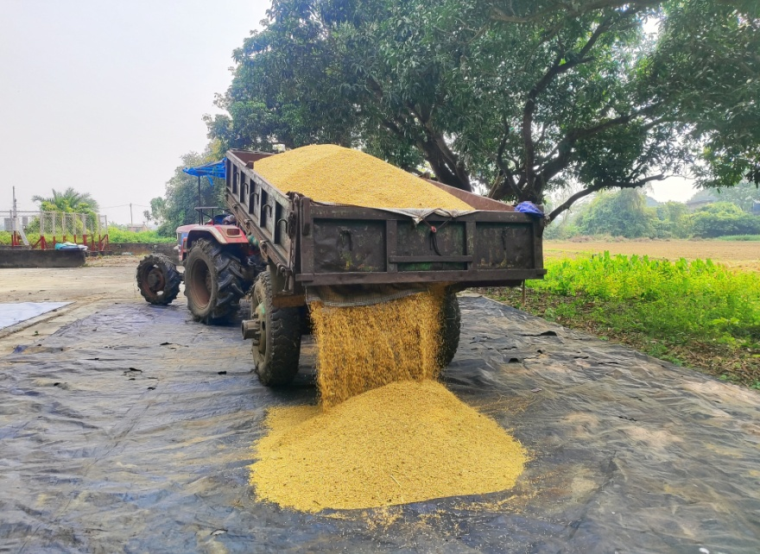
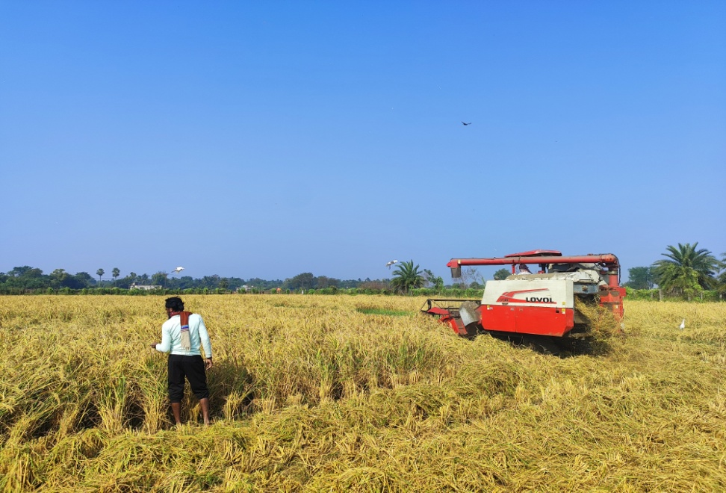
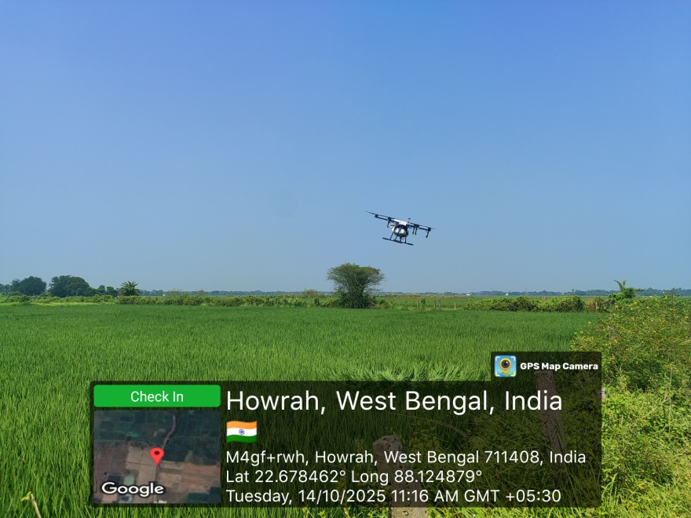

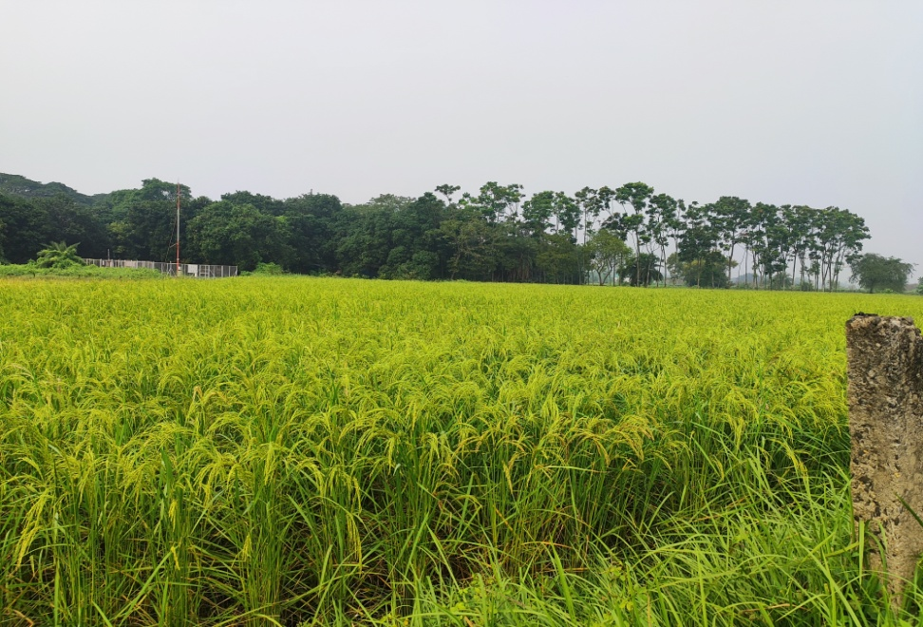

Production of planting materials by the KVKs

Crop | Variety |  | No. of planting material | Value  (Rs) | Provided to number of farmers | Remarks
Exotic Vegetable seedlings
Casicum |  | KSPH – 2301, Varun | 25,000 | 50,000
Broccoli |  | Saki, A-1
Cauliflower & Coloured Cauliflower |  | SW1104,Carotena, Valentena | 25,000 | 50,000
Cabbage |  | Green Express | 25,000 | 50,000
Brinjal |  | VNR - 212 | 25,000 | 50,000
Chilli |  | King Hot - 1102 | 25,000 | 50,000
Tomato |  | LHT-Nandi | 25,000 | 50,000
Fruit Seedling
Dragon fruit | Hylocerus polyrhizus |  | 1000 | 40,000
Total |  |  | 26,000 | 90,000
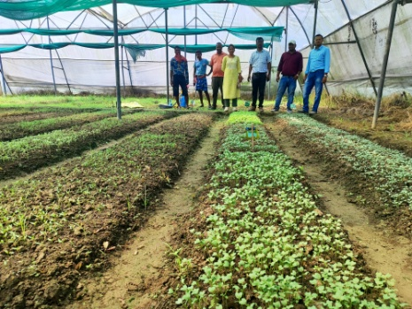
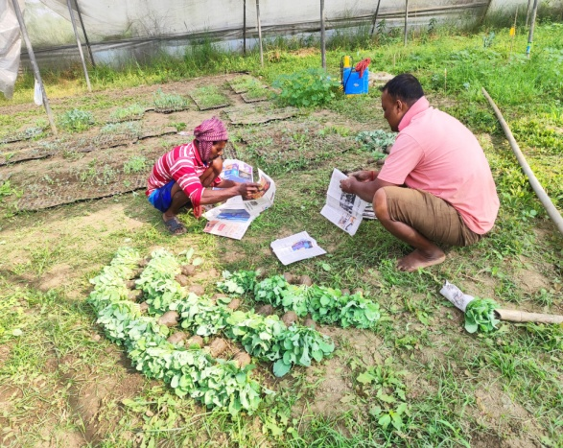
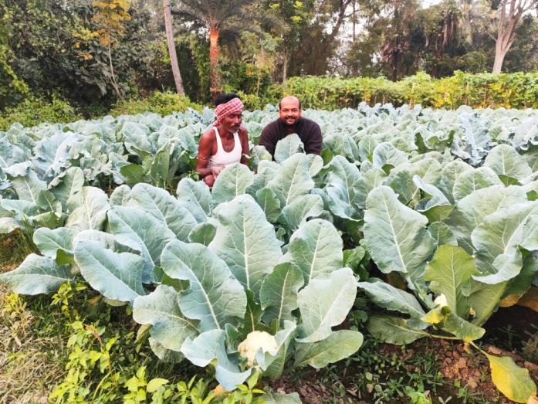

Production of Bio-Products

Name of product | Quantity | Value (Rs.) | No. of Farmers benefitted
Name of product | Kg | Value (Rs.)
 |  |  | SC | ST | Other | Total
Vermi-Compost | 3000 | 45,000
Total | 3000 | 45 000.00

Production of livestock materials

Particulars of Live stock | Name of the breed | Number | Value (Rs.) | No. of Farmers benefitted
 |  |  |  | SC | ST | Other | Total
Poultry | Kadaknath, Vanaraja | 13 | 1300.00
Goatery | Black Bengal | 02 | 5000.00
Duck | White Pekin | 06 | 2,880
Grand Total |  |  | 9,180.00

Good quality photographs of livestock and fisheries:

3.5. b. Seed Hub Programme-“Creation of Seed Hubs for Increasing Indigenous Production of Pulses in India”
i) Name of Seed Hub Centre:

Name of Nodal Officer :
Address :
e-mail :
Phone No. :
Mobile :

ii) Quality Seed Production Reports
Season | Crop | Variety | Production (q)
Season | Crop | Variety | Target | Area sown (ha) | Production | Category of Seed  (F/S, C/S)
Kharif 2024
Rabi 2023-24
Summer/Spring 2025
Kharif 2025
Rabi 2024-25

iii) Financial Progress
Fund received  (2021-22, 2022-23, 2023-24 and 2024-25) | Expenditure (Rs. in lakhs) |  | Unspent balance  (Rs. in lakhs) | Remarks
Fund received  (2021-22, 2022-23, 2023-24 and 2024-25) | Infrastructure | Revolving fund | Unspent balance  (Rs. in lakhs) | Remarks
2021-22
2022-23
2023-24
2024-25
2025-26

iv) Infrastructure Development

Item | Progress
Seed processing unit
Seed storage structure

3.6. (A) Literature Developed/Published (with full title, author & reference)

Item | Title | Author’s name | Number | Circulation
Research paper
Seminar/conference/ symposia papers
Books | Crop Advisory for Khrif Crops | Dr. Kironmay Barui  Dr. Koushik Nag  Dr. Arka Samanta | 1 | 1000
Bulletins
News letter | Howrah KVK News Letter | Dr. Kironmay Barui  Dr. Sudipta Banerjee  Dr. Koushik Nag  Dr. Arka Samanta  Dr. Jayanta Mandal | 2 | 200
Popular Articles
Book Chapter
Extension Pamphlets/ literature | - Dhaner rog poka  - Low Cost Vermicompost production  - Mehodods of Soil sampling | Dr. Arka Samanta  Dr. Kironmay Barui & Dr. Jayanta Mandal  Dr. Kironmay Barui & Dr. Harishankar Koiri | 3 | 1500
Technical reports
Electronic Publication (CD/DVD etc.)
TOTAL |  |  | 6 | 2700

N.B.: Please enclose a copy of each. In case of literature prepared in local language please indicate the title in English

(B) Details of HRD programmes undergone by KVK personnel:

Sl. No. | Name of programme | Name of course | Name of KVK personnel and designation | Date and Duration | Organized by
1. | 5 days Training Programme | Innovation in Digital Extension | Dr. Sudipta Banerjee  SMS(Agril. Extension) | 17-21 November 2025, 5 days | ICAR-NAARM
2. | 5 days HRD training programme | Enhancing Productivity of Degraded lands | Dr. Jayanta Mandal | 24-28, February, 2025 | ICAR-IISWC, Dehradun, U.K.
3.
4.
5.
6.
7.

3.7. Success stories/Case studies, if any (two or three pages write-up on 1-2 best case(s) with suitable action photographs)
Name of farmer | Mr. Sailendranath Bera
Address | Chandrapur, Bagnan, Howrah, WB
Contact details (Phone, mobile, email Id) | 9002921352, sailendrabera9932Qgmail.com
Landholding (in ha.) | 0.40
Name and description of the farm/ enterprise | Mr. Bera is having one acre of GI made saw-tooth type naturally ventilated poly house with micro irrigation system and few low cost poly tunnel. Mainly he is growing high-quality off-season cauliflower, palak, coriander and cucumber.
Economic impact | His impressive plantation of high-quality off-season cauliflower, palak, coriander and cucumber grown within a protected environment ensures year-round productivity and with a remarkable annual net profit of Rs. 11.75 lakh per acre.
Social impact | By bridging the gap between theoretical training and field-level implementation, Mr. Bera has successfully mastered the art of Protected Cultivation to ensure year-round productivity
Environmental impact | As he is using micro irrigation, water use efficiency is very high and with organic way of cultivation as well as use of yellow sticky tape for insects, environmental and soil pollution are very less.
Horizontal/ Vertical spread | 40 ha
Good quality photographs (2-3)

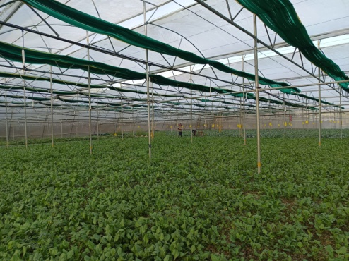
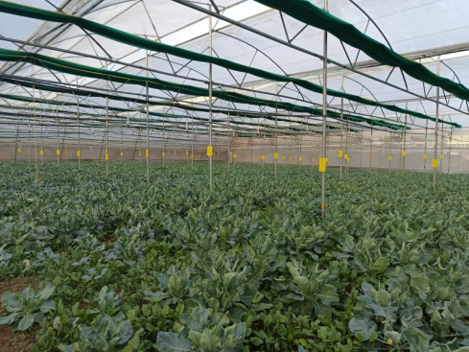
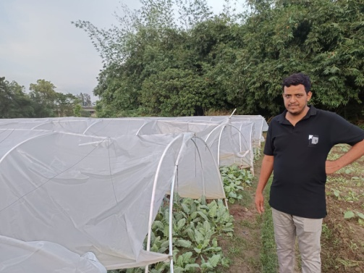

3.8. Give details of innovative methodology or innovative technology of Transfer of Technology developed and used during the year

Sl. No. | Name/ Title of the technology | Name/ Details of the Innovator(s) | Brief details of the Innovative Technology
1 | Intercropping of Ashwagandha in guava orchards | Mr. Suman Shit  Vill: Rameswarpur  Munshirhar  Block: Jagatballavpur  9735233085 | Intercropping Strategy: Ashwagandha is planted in the vacant spaces between guava trees. This utilizes the filtered sunlight and maintains a microclimate conducive to the herb's growth without competing aggressively with the primary fruit crop.  ​Seed Logistics:  ​Source: Seeds were sourced from Murshidabad.  ​Cost: Approximately ₹600 per kg.  ​Sowing Rate: Roughly 4 kg to 5 kg of seeds are required per bigha (a local unit of land area).  ​Maintenance: One of the primary advantages noted is the low input requirement. There are no significant costs for additional fertilizers or specialized pesticides. The main expenditure is focused on labor for harvesting, root cleaning, and processing.  ​Yield and Economic Viability  ​The innovation presents a compelling business case for farmers looking to diversify their income streams.  Value Addition and Marketing  ​The report identifies three tiers of market entry for the harvested Ashwagandha:  ​Raw/Fresh Sale: Lowest price point, sold immediately after harvest.  ​Dried Roots: Higher value; easier to transport and store.  ​Processed Powder: The most lucrative option. By processing roots into powder and selling directly to major pharmaceutical and wellness companies (e.g., Dabur, Himalaya, Star), farmers can potentially quadruple their profits.  ​Key Innovations & Benefits  ​Zero-Waste Potential: While the roots are the most valuable part, the entire plant has utility in medicinal applications.  ​Risk Mitigation: By growing Ashwagandha as a "companion crop," the farmer ensures a steady secondary income that is independent of the guava harvest cycle.  ​Scalability: The low maintenance and high demand from the herbal medicine industry make this a highly scalable model for fruit orchard owners.  ​Conclusion  ​The cultivation of Ashwagandha as an intercrop with guava is a sustainable and highly profitable innovation. It transforms underutilized orchard floor space into a high-yield medicinal "gold mine," provided the farmer focuses on quality drying and explores direct-to-industry value addition.
  Average Yield | 10 q acre
  Market Price | ₹25,000 per quintal
  Premium Price | (Dry/Powder) Up to ₹35,000 per quintal
  Input Cost (Labor/Seed) | ₹45,000
  Estimated Net Profit | Approx ₹ 2.0 l per acre per season

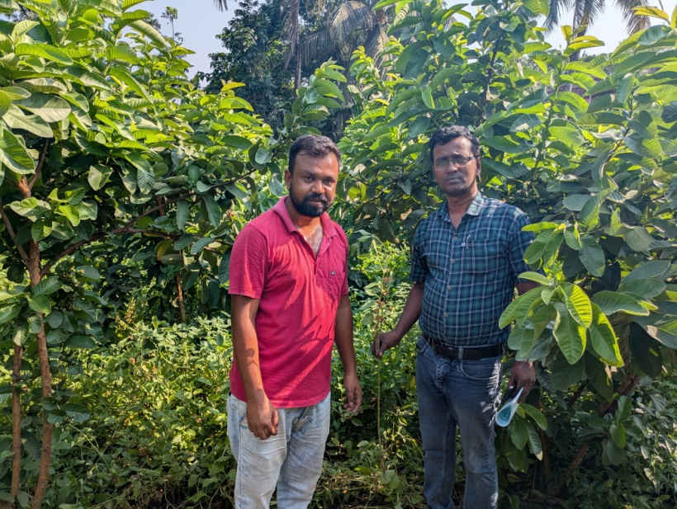
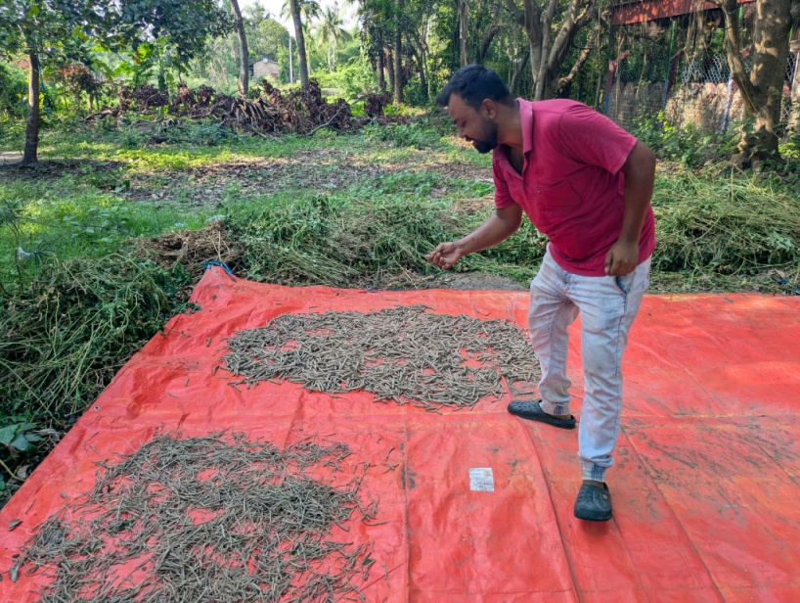

3.9. a. Give details of indigenous technology practiced by the farmers in the KVK operational area which can be considered for technology development (in detail with suitable photographs)

Sl. No. | Crop / Enterprise | ITK Practiced | Purpose of ITK

b. Give details of organic farming practiced by the farmer

Sl. No. | Crop / Enterprise | Area (ha)/ No. covered | Production | No. of farmers involved | Market available (Y/N)

3.10. Indicate the specific training need analysis tools/methodology followed by KVKs

Sl. No. | Brief details of the tool/ methodology followed | Purpose for which the tool was followed

3.11. a. Details of equipment available in Soil and Water Testing Laboratory

Sl. No | Name of the Equipment | Qty.

3.11.b. Details of samples analyzed so far :
Number of soil samples analyzed |  |  | No. of Farmers | No. of Villages | Amount realized  (in Rs.)
Through mini soil testing kit/labs | Through soil testing laboratory | Total

3.11.c. Details on World Soil Day

Sl.  No. | Activity | No. of Participants | No. of VIPs | Name (s) of VIP(s) | Number of Soil Health Cards distributed | No. of farmers benefitted
1. | Rally | 38
2. | Seminar on Soil Health day | 85 | 2 | Mr. Ranjan Kundu, Sabhapati, JBPur, Panchayat Samiti, and Mr. Parimal Saha, Asst. Director of Agriculture, GoWB | 50 | 300
3. | Awareness against paddy straw burning | 65

A brief report on
CELEBRATION OF WORLD SOIL WEEK AT HOWRAH KVK
(4-10th December, 2025)

The Krishi Vigyan Kendra (KVK), Howrah, observed World Soil Week from December 4th to December 10th, 2025, in alignment with the global observance of World Soil Day (WSD) on December 5th, 2025 as per directives of our Hon’ble Vice-Chancellor, BCKV. This week-long event was dedicated to raising awareness and advocating for the sustainable management and protection of soil resources, which are crucial for agriculture, food security, and climate resilience in the district.
​
Global Context and Theme

​The centerpiece of the celebration, World Soil Day 2025, was held under the global theme: "Healthy Soils for Healthy Cities." While Howrah is a predominantly agricultural district, the theme was highly relevant, emphasizing the vital role of soil, even in peri-urban areas, for water infiltration, temperature regulation, carbon storage, and supporting urban and peri-urban food production. The theme encouraged participants to consider soil health across the rural-urban continuum.
​
KVK Howrah's Key Activities (Dec 4th - 10th)
​The Howrah KVK's activities focused on practical demonstration, knowledge dissemination, and direct farmer interaction, possibly as part of a larger regional program organized by its administrative body, Bidhan Chandra Krishi Viswavidyalaya (BCKV):

- Day 1 (04.12.2025): Rally for social campaign :
A colourful and energetic rally was conducted to mark the beginning of Soil Week celebrations with the active participation of the students of DAESI course and staff members of this Kendra. Participants carried placards with slogans such as “Save Soil, Save Future,” “Healthy Soil, Healthy Life,” and “Reduce Chemical Fertilizers” etc. The rally moved through the nearby areas of the locality closure to KVK, spreading the message of soil protection, composting, and sustainable agriculture.
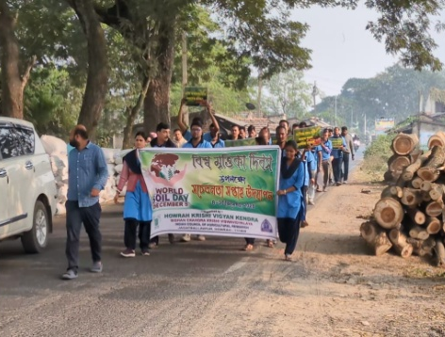
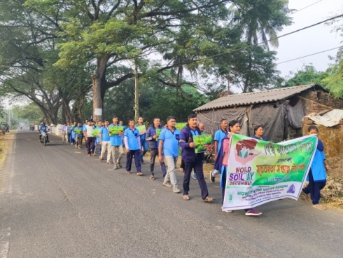
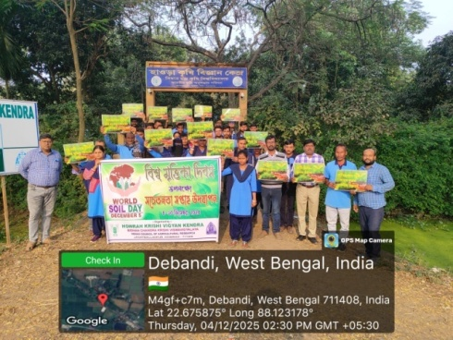

- ​ Day 2 (05.12.2025): Awareness Programs and Special Seminars: A primary event on December 5th, was held at the KVK premises, featuring a Special Seminar on "Rural–Urban Soil Stewardship: Healthy Soils for Healthy Cities and Villages," bringing together farmers, scientists, and policymakers. Mr. Ranjan Kundu, Sabhapati, JBPur, Panchayat Samiti, and Mr. Parimal Saha, Asst. Director of Agriculture, GoWB attended the awareness programme and discussed the importance of soil for better livelihood.
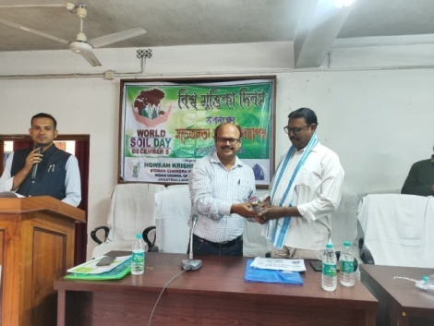
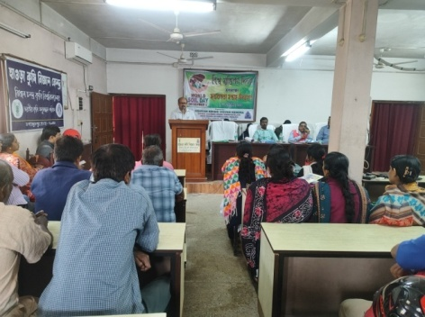
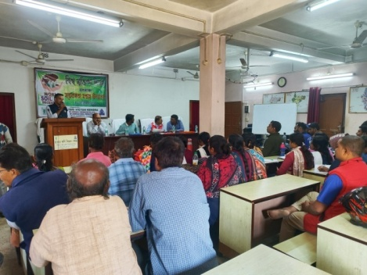
​

Soil Health Card (SHC) Distribution: A major focus was the distribution of newly prepared Soil Health Cards to beneficiary farmers. This was accompanied by detailed advisories based on the SHC results, guiding farmers on nutrient management and fertilizer application based on their specific soil deficiencies.
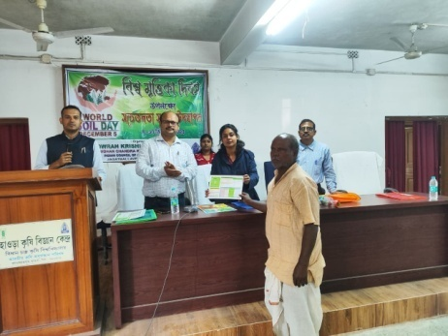
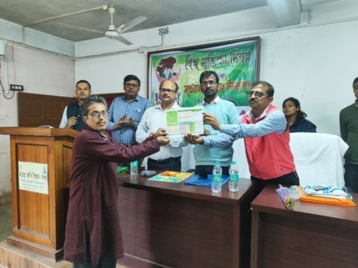
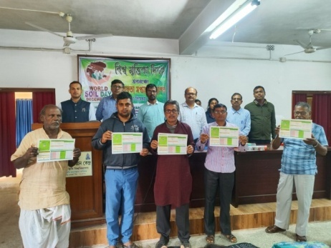
​

​Farmer-Scientist Interactions: Throughout the week, interactions provided a platform for farmers to discuss their specific soil-related challenges, such as issues with soil testing, nutrient deficiencies common in the Gangetic alluvium of the district, and the impact of frequent inundation on soil health.
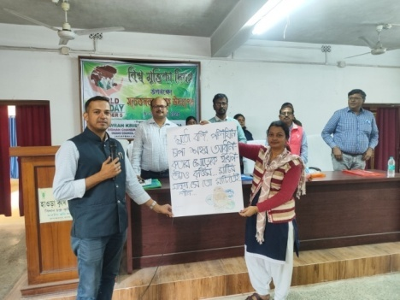
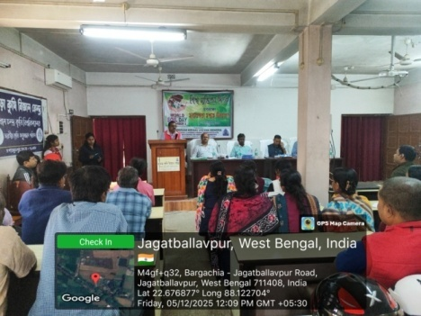
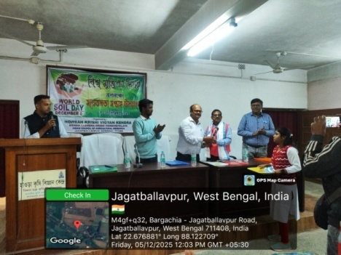
​

Poem Recitation on Soil: A poem recitation event was arranged to encourage creativity among students. Selected poems praised the beauty and importance of soil. An example poem is given below:

“Soil is our Mother”
Soil gives life, soil gives food,
Keeps our fields so fresh and good,
Protect the soil, plant more trees,
Let our earth live in peace and ease.

Essay Writing Competition: An essay writing competition was conducted on themes such as “Importance of Soil in Human Life,” “Soil Conservation for Future Generations,” and “Role of Farmers in Soil Management.” Students expressed their views on soil degradation, erosion control, organic farming, and sustainable development. The best essays were awarded prizes.
- Day 5 (08.12.2025): Awareness Programs on Paddy Straw Management for Healthy Soil: Straw burning in situ condition is becoming a huge problem now-a-days. It not only promotes pollutions through releasing PM2.5 and PM10 particles, Carbon monoxide (CO), Nitrogen oxides, Volatile organic compounds (VOCs) and Carcinogenic compounds like benzene; but also decorate the soil health status by damaging the microorganisms, earthworms, and nutrients essential for soil fertility. It also reduces soil’s water retention capacity. To aware the ill effects of straw burning a programme was conducted and farmers and farm women learnt the effective utilization pattern of paddy straw after harvest through compost making or mushroom production etc.
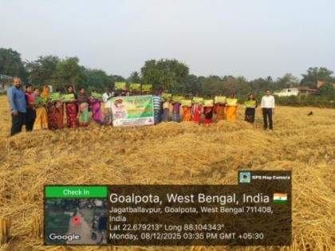
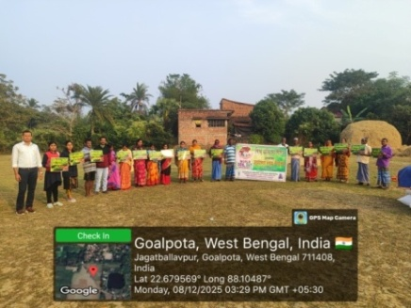

- Day 6 (09.12.2025): Exposure Visit Conducted for School Students: Around 130 students from PM Shre Kendriya Vidyalaya Ichapore 1, North 24 paraganas along with 9 teachers conducted an Field trip-cum-exposure visit to Howrah KVK to explore different demonstration units, participated in hands on training and gained vast knowledge about different activities of the Krishi Vigyan Kendra as a part of observation of World Soil week. Director ICAR-ATARI, Kokata Dr. Pradip Dey interacted with the students and signify the importance of World Soil Day. Demonstration units like Hydroponics, Ornamental Fishes, Mushroom Production, Vermicompost, IFS attracted the students very much.

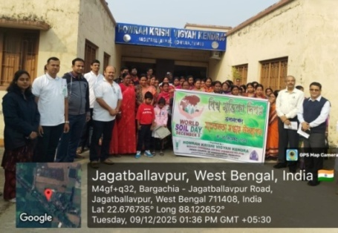
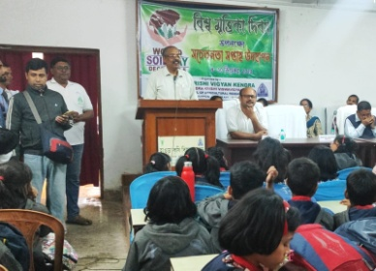
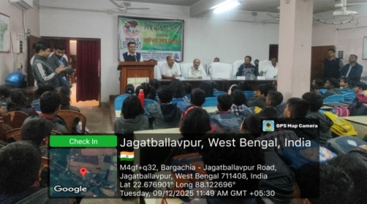

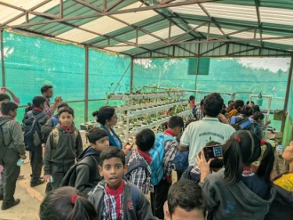
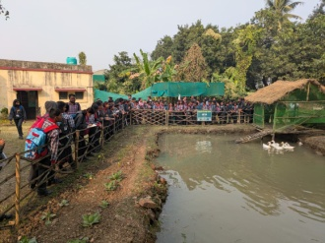
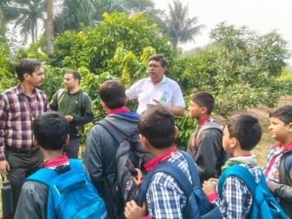
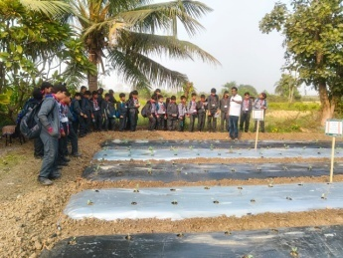

Day 7 (10.12.2025): Method Demonstration on Soil Sample Collection: The KVK scientists conducted demonstrations and training sessions on Soil Sample Collection for testing at farmers field of Jhingra village of Jagatballavpur block.
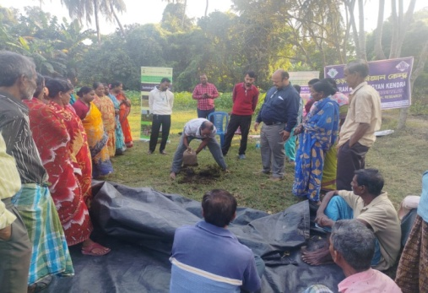
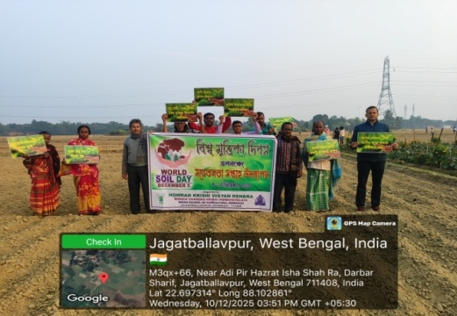

Outcome
​The Soil Week Programme organized by Howrah Krishi Vigyan Kendra under the administrative management of Bidhan Chandra Krisdhi Viswavidyalaya successfully highlighted the vital importance of soil conservation for sustainable agriculture and environmental protection. Through activities such as rallies, awareness campaigns, essay and poem competitions, and community interactions, participants gained a deeper understanding of soil health, its role in food security, and the urgent need to prevent soil degradation.
Overall, the week-long observance strengthened our collective resolve to adopt soil-friendly practices, promote organic inputs, reduce chemical misuse, and protect this precious natural resource, the soil.
The enthusiastic participation of farmers, farm women, students, and community members made the programme impactful and meaningful. The programme ended with a pledge by all the participants to continue to promoting soil conservation practices and to work collectively towards ensuring healthy soil, healthy food, healthy crops, and the healthy future for generations to come.

3.11.d. Details of other samples like Plant, Water analyzed so far
Name of Samples analyzed | No. of Samples analyzed | No. of Farmers benefitted | No. of Villages covered | Amount realized (Rs.)
Plant
Water
Other
(fertilizers, manure, food etc.)

3.12. Activities of rain water harvesting structure and micro irrigation system

No of training programme | No of demonstrations | No of plant material produced | Visit by the farmers | Visit by the officials

3.13. Technology week celebration

Type of activities | No. of activities | Number of participants | Related crop/livestock technology

3.14. RAWE/ FET programme - is KVK involved? (Y/N)

No of student trained | No of days stayed
8 | 90

ARS trainees trained | No of days stayed

3.15. List of VIP visitors (Minister/ MP/MLA/DM/VC/Zila Sabhadipati/Other Head of Organization/Foreigners)

Date | Name of the person | Purpose of visit

- IMPACT

  - Impact of KVK activities (Not to be restricted for reporting period).

Name of specific technology/skill transferred | No. of participants | % of adoption | Change in income (Rs.)
Name of specific technology/skill transferred | No. of participants | % of adoption | Before (Rs./Unit) | After (Rs./Unit)
NB: Should be based on actual study, questionnaire/group discussion etc. with ex-participants

4.2. Cases of large scale adoption
(Please furnish detailed information for each case)
Horizontal spread of technologies
Technology | Horizontal spread
Give information in the same format as given below

Name of farmer
Address
Contact details (Phone, mobile, email Id)
Landholding (in ha.)
Name and description of the farm/ enterprise
Economic impact
Social impact
Environmental impact
Horizontal/ Vertical spread
Good quality photographs (2-3)

4.3.Details of impact analysis of KVK activities carried out during the reporting period

Sl. No. | Brief details of technology | Impact of the technology in subjective terms | Impact of the technology in objective terms

4.4. Details of innovations recorded by the KVK

Thematic area
Name of the Innovation
Details of Innovator
Back ground of innovation
Technology details
Practical utility of innovation

4.5. Details of entrepreneurship development

JOURNEY OF A SMALL FARMAR TO SUCCESSFUL MUSHROOM ENTERPRENURE
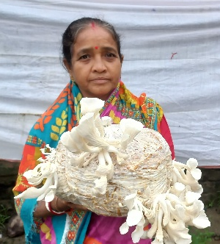
Farmer’s Name: PADMA SENAPATI
Age: 52 years
Address: Vill+P.O: Joargori, P. S. Rajapur,
Block: Uluberia II, Howrah, 711303
Mobile: 9836531630
Education: Madhyamik
Entrepreneurship: Oyester mushroom cultivation
Name of Group: Mukti Anandadhara

Entrepreneurship development
Name of the enterprise | Successful entrepreneur through Mushroom cultivtion
Name & complete address of the entrepreneur | Mrs. Padma Senapati  Address: Vill+P.O: Joargori, Block: Uluberia II, Howrah, 711303  Mobile: 9836531630  Education: Madhyamik  Name of Group: Mukti Anandadhara
Interventions of KVK with quantitative data support: | In the village Joargori, a farm woman named Padma Senapati had a small piece of land that was not enough to provide regular income throughout the year. Due to rising cultivation costs and uncertain weather conditions, she started searching for an alternative source of income that required less land and investment. Then she attended a five days training programme on mushroom cultivation organized by the Howrah Krishi Vigyan Kendra (KVK) in 2023. During the training, she learned about oyster mushroom production, compost preparation, spawn use, temperature management, harvesting, packaging, and marketing techniques.  Inspired by the training with the technical support of Howrah KVK, Padma devi established a low-cost mushroom cultivation unit and started producing oyster mushroom. Technologies for commercial production has been demonstrated through trainings and farm demonstrations to farmers and rural youths.  Within 25 to 30 days, the mushroom crop was ready for harvesting. she sold fresh mushrooms in the local market and nearby hotels. Customers appreciated the quality and freshness of her produce. She earned a good profit from the first cycle itself.
Timeline of the entrepreneurship development | She started to go for the mushroom production during 2023-2024 in a small scale. Since last 3 years, she also established a low-cost mushroom cultivation unit and started producing oyster mushroom.
Technical Components of the Enterprise | Total 200 nos. farmers, rural youth and farm women were trained on mushroom cultivation from Howrah KVK. Out of total trainees more than hundred are actively engaged in production of mushroom on commercial scale, 3 individuals have adopted the technique of mushroom spawn production as source of vocation for income generation. Average annual net income through this vocation is Rs. 1.50 lakh per individual per year.  Now Padma Devi formed a mushroom producing self-help group with other women named ‘Mukti Anandadhara’ (12 members) in the village. Together, they established a small-scale industrial unit and presently earning net income of Rs. 2.50 lakh per unit per year.  They started producing value-added mushroom products such as mushroom pickle and dried mushrooms. They also participated in agricultural fairs and exhibitions to promote their products.
Status of entrepreneur before and after the enterprise | Before starting the mushroom enterprise, the entrepreneur depended mainly on seasonal agricultural labour and small-scale farming for livelihood. Income was very low and irregular, ranging from about ₹3,000 to ₹5,000 per month, which was not sufficient to meet family needs throughout the year. Family members, especially women and rural youth, had limited employment opportunities and remained underutilized. Agricultural waste such as paddy straw was often burnt or left unused. The entrepreneur had very little technical knowledge about scientific cultivation practices, value addition, or marketing. Market access was restricted only to nearby village markets, and financial savings were minimal. After adopting mushroom cultivation as an enterprise with the support of KVK training and technical guidance, the entrepreneur experienced remarkable socio-economic improvement. Mushroom farming provided regular year-round employment and increased the monthly income to around ₹18,000 to ₹30,000. Family members became actively involved in production, processing, packaging, and marketing activities, leading to better utilization of family labour. Women gained financial participation and confidence through involvement in the enterprise. Agricultural waste was efficiently converted into a productive growing substrate, promoting sustainable farming practices. Overall, the enterprise significantly improved the family’s standard of living, including better housing, education, nutrition, and healthcare support.
Present working condition of enterprise in terms of raw materials availability, labour availability, consumer preference, marketing the product etc. (Economic viability of the enterprise): | Presently, Mushroom production and spawn production both the units running very well.  - Mushroom Spawn: Rs. 5.50 lakh/year (0.5 quintal/day)  - Fresh Mushroom: Rs. 30 lakh/year (0.20 quintal/day)  - Gross turnover: Rs. 50 lakhs  - Net profit: Rs. 25.0-26.0 lakhs/year
Horizontal spread of enterprise | 0.39 ha

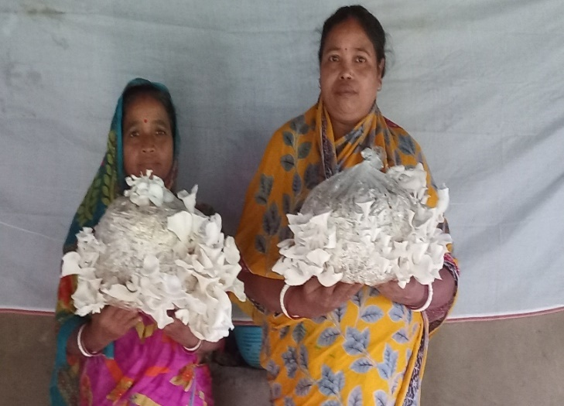
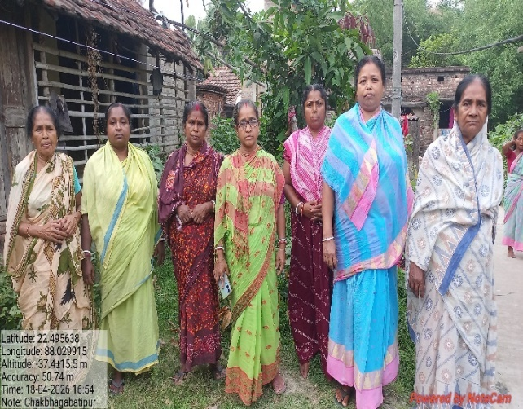

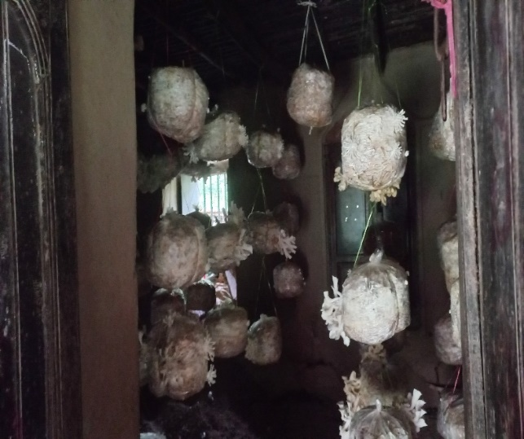
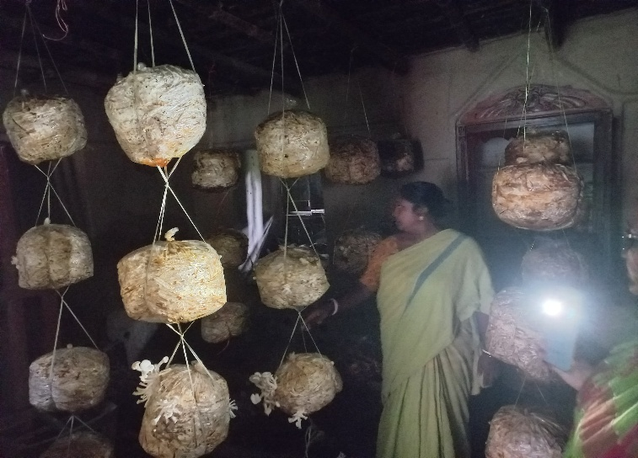
epreneur development

4.6. Any other initiative taken by the KVK

5. LINKAGES
5.1. Functional linkage with different organizations

Name of organization | Nature of linkage
Department of Agriculture, Howrah District | Training, Joint visit
District NREGA Cell & DRDC | Skill development training
Department of Horticulture & Food Processing, GoWB | Training, Joint visit
ATMA | Exposure visit, Short Term Research, Scientist Interaction, Farm School
SAMETI | Diploma course, Skill development training
BCKV | Technical support & Administrative management
ICAR | Technical support
Ambuja Cement Foundation | Farmers Club, Training, Technical backstopping,
MANAGE | DAESI
ASCI | Skill development training for rural youth.
World Bank on Water Users Associations under WBADMIP | Training, visit, input distribution
ICT-NGO | Training, visit
National Security Guard | Millet oriented training, mela etc
Neheru Yuva Kendra | Technology transfer, advisory service
Kendriya Vidyalaya | Exposure visit, students' awareness, ATL-visit

5.2. List of special programmes undertaken during 2025 by the KVK, which have been financed by ATMA/ Central Govt/ State Govt./NABARD/NHM/NFDB/Other Agencies (information of previous years should not be provided)

a) Programmes for infrastructure development

Name of the programme/scheme | Purpose of programme | Date/ Month of initiation | Funding agency | Amount (Rs.)
Short Term Research under ATMA | Development of low cost hydroponic fodder production unit | November-December | District ATMA | 2.5 L

(b) Programme for other activities (training, FLD, OFT, Mela, Exhibition etc.)

Name of the programme/scheme | Purpose of programme | Date/ Month of initiation | Funding agency | Amount (Rs.)

- PERFORMANCE OF INFRASTRUCTURE IN KVK

6.1. Performance of demonstration units (other than instructional farm)

Sl. No. | Name of demo Unit | Year of estt. | Area  (Sq.mt) | Details of production |  |  | Amount (Rs.) |  | Remarks
 |  |  |  | Variety/breed | Produce | Qty. | Cost of inputs | Gross income | Remarks
1. | Poly House | 2015 | 250 | - | - | - | - | - | Use for demonstration purpose
2. | Shed House | 2015 | 250 | ---- | — | — | — | — | Use for demonstration purpose
3. | Green House | 2012 | 500 | Dragon fruit seedling | 1000 | — | — | 40,000 | There are still Some dragon fruit seedling
4. | Mushroom  production | 2020 | 79 | Oyester mushroom | Food purpose | 30 kg | 2,500 | 3,600
5. | Vermicompost  production | 2020 | 112 | — | Fertilizer | 3000 kg | 20,000 | 45,000
7. | Low cost poly house | 2021 | 200 | Exotic vegetables | Different vegetables seedlings | 25,000 no | 30,000 | 50,000
8. | Ornamental Fish unit | 2024 |  |  | - | - | - | - | Use for demonstration purpose

6.2. Performance of Instructional Farm (Crops)

Name  of the crop | Date of sowing | Date of harvest | Area (ha) | Details of production |  |  | Amount (Rs.) |  | Remarks
 |  |  |  | Variety | Type of Produce | Qty.(q) | Cost of inputs | Gross income | Remarks
Winter  Paddy | 23.07.2025-02.08.2025 | 04.12.2025 to 09.12.2025 | 1 | Swarna Sub-1 | TL | 48 | 1,50,000 | 2,58,000 (Kind)
Winter  Paddy | 23.07.2025-02.08.2025 | 04.12.2025 to 09.12.2025 | 1.06 | Jamuna | TL | 54 | 1,50,000 | 2,58,000 (Kind)
Winter  Paddy | 23.07.2025-02.08.2025 | 04.12.2025 to 09.12.2025 | 0.66 | Santosi | TL | 15 | 1,50,000 | 2,58,000 (Kind)
Winter  Paddy | 23.07.2025-02.08.2025 | 04.12.2025 to 09.12.2025 | 0.66 | Gobindobhog | TL | 20 | 1,50,000 | 2,58,000 (Kind)
Vegetables & fruits  Seedling | Though out the year |  | 400 sq.m. | Exotic Vegetables & dragon fruit | -- | Total No 26,000 | 60,000 | 90,000

  - Performance of Production Units (bio-agents / bio-pesticides/ bio-fertilizers etc.,)

Sl.  No | Name  of the animal / bird / aquatics | Details of production |  |  | Amount (Rs.) |  | Remarks
Sl.  No | Name  of the animal / bird / aquatics | Breed | Type of Produce | Qty. | Cost of inputs | Gross income | Remarks
1. | Poultry | Kadaknath, & Vanaraja | — | No - 13 | 12,000 | 6,115 (cash)  1,300 (kind)
2. | Duck | White pekin | - | No -06 | 12,000 | 480 (cash)  2,880 (Kind)
3. | Goatery | Black Bengal | — | No -02 | 12,000 | 5,000 (kind)  16,000 (cash)
Total

  - Performance of instructional farm (livestock and fisheries production)

Sl.  No | Name  of the animal / bird / aquatics | Details of production |  |  | Amount (Rs.) |  | Remarks
Sl.  No | Name  of the animal / bird / aquatics | Breed | Type of Produce | Qty. | Cost of inputs | Gross income | Remarks
1.
2.
3.

  - Utilization of hostel facilities

Accommodation available (No. of beds)

Months | No. of trainees stayed | Trainee days  (days stayed) | Reason for short fall (if any)
Total :
(For whole of the year)

  - Utilization of staff quarters

Whether staff quarters has been completed:

No. of staff quarters:

Date of completion:

Occupancy details:
Months | Q I | QII | Q III | QIV | Q V | QVI

- FINANCIAL PERFORMANCE

7.1. Details of KVK Bank accounts
Bank account | Name of the bank | Location | Account Number
Howrah Krishi Vigyan Kendra | SBI, Jagatballavpur Branch | Jagatballavpur  IFSC Code- SBIN0011388 | 30781940677
Howrah Krishi Vigyan Kendra (Revolving Fund) | SBI, Jagatballavpur Branch | Jagatballavpur  IFSC Code- SBIN0011388 | 30781901252

  - Utilization of funds under CFLD on Oilseed (Rs. In Lakhs)

Item | Released by ICAR |  | Expenditure |  | Unspent balance as on -
Item | Kharif | Rabi | Kharif | Rabi | Unspent balance as on -
Groundnut & Sesame | - | 7.255 | - | 24.99485 | (-)17.73985

7.3. Utilization of funds under CFLD on Pulses (Rs. In Lakhs)
Item | Released by ICAR |  | Expenditure |  | Unspent balance as on 1st April 2013
Item | Kharif | Rabi | Kharif | Rabi | Unspent balance as on 1st April 2013

  - Utilization of KVK funds during the year 2025-26(Not audited)

Sl.  No. | Particulars | Sanctioned | Released | Expenditure
A. Recurring Contingencies
1 | Pay & Allowances |  | 14985000 | 14771200
2 | Traveling allowances |  | 100000 | 51198
3 | Contingencies
A
B
C
D
E | Other than SCSP |  | 53000 | Approx.53000
F | SCSP |  | 62500 | Approx. 62500
G
H
I
J | Swachhta Expenditure |  | 32000 | 32000
TOTAL (A)
B. Non-Recurring Contingencies
1 | IFS |  | 650000 | 0*
2
3
4
TOTAL (B)
C. REVOLVING FUND
GRAND TOTAL (A+B+C)
- Due to sudden deployment of entire scientific staff including Head by ECI in connection SIR duty

7.5. Status of revolving fund (Rs. in lakh) for last five years

Year | Opening balance as on 1st April | Income during the year | Expenditure during the year | Net balance in hand as on 1st April of each year (Kind + cash)
2021-22 | 2.98042 | 2.82899 | 3.10292 | 4.50649 +0.744 as Kind
2022-23 | 5.57 | 3.08303 | 2.66842 | 5.98461
2023-24 | 5.98461 | 4.70196 | 1.17832* | 9.50825* + 1,30,000 as Kind
2024-25 | 10.75500 | 3.77682 | 4.56000 | 9.97182+ 1.70,000 as kind
2025-26 | 12.47454 | 8.82546 | 7.50000 | Approx.13.8 +1.8 as kind

  - (i) Number of SHGs formed by KVKs
(ii) Association of KVKs with SHGs formed by other organizations indicating the area of SHG activities
(iii) Details of marketing channels created for the SHGs

  - Joint activity carried out with line departments and ATMA

Name of activity | Number of activity | Season | With line department | With ATMA | With both
Short term research | 1 | 2025 | Agriculture | ATMA | both
Training | 14 | 2025 | Agriculture | ATMA | both
Training | 6 | 2025 | ARD
Lowcost fodder kit distribution | 5 | 2025 | ARD | ATMA | Both
Training | 6 | 2025 | Horticulture
DLC meeting | 5 | 2025 | Agriculture, fishery, ARD

8. Other information

8.1. Prevalent diseases in Crops

Name of the disease | Crop | Date of outbreak | Area affected (in ha) | % Commodity loss | Preventive measures taken for area (in ha)
Downy mildew | Rose | January | 20 | 45 | OFT was conducted and recommendation was given as application of Azoxystrobin 4.7% + Mancozeb 59.7% + Tebuconazole 5.6% WG@ 3gm/l at 15 days interval to manage this disease.
Black Leg | Potato | February | 15 | 30 | OFT was conducted and recommendation was given as application of Streptocycline @1g + Copper oxychloride @4g/ liter of water at 10 days interval.
Yellow stem borer | Paddy | February | 30 | 40 | Azadirachtin 10000 ppm @ 1.5 ml/l alternate with cartap hydrochloride 4G and chlorantraniiprole 18.5% w/w 0.33ml/ liter of water at 10 days interval.

8.2. Prevalent diseases in Livestock/Fishery
Name of the disease | Species affected | Date of outbreak | Number of death/ Morbidity rate (%) | Number of animals vaccinated | Preventive measures taken in pond (in ha)

9.1. Nehru Yuva Kendra (NYK) Training

Title of the training programme | Period |  | No. of the participant |  | Amount of Fund Received (Rs)
 | From | To | M | F

9.2. PPV & FR Sensitization training Programme
Date of organizing the programme | Resource Person | No. of participants | Registration (crop wise)
 |  |  | Name of crop | No. of registration

9.3. Kisan Mobile Advisories (National Farmers’ Portal/ SMS Portal/ mKisan Portal)

Type of message | No. of messages sent  (Text + Voice + Video) | No. of farmers benefitted
Crop | 58 | 626872
Livestock
Fishery
Weather | 11 | 110918
Marketing
Awareness | 8 | 50247
Other
Total | 77 | 788037

9.4. KVK Portal and Mobile App

Sl. No. | Particulars | Description
1. | No. of visitors visited the portal
2. | No. of farmers registered in the portal
3. | Mobile Apps developed by KVK
4. | Name of the App
5. | Language of the App
6. | Meant for crop/ livestock/ fishery/ others
7. | No. of times downloaded

9.5. a. Observation of Swachh Bharat Programme
Date/ Duration of Observation | Activities undertaken
21.08.2026 , 23.09.2026, 15.10.26, 10.11.26, 26.11.26, 06.01.2026, 04.12.2026, 17, 19.2026, 19.2.26  14.01.2026, 28.01.2026, 11.02.2026  26.02.2026,10.03.2026, 27.03.2026 | Cleaning, waste management, Godown cleaning, Identification of scrap material.
03.02.2026 | Awareness programme at Chandrapur, Bagnan
09.02.2026 | Awareness programme at Kamalapur New Set-up Upper Primary School
02.03.2026 | Awareness programme at Chandul Jr. High School

b. Details of Swachhta activities with expenditure

Activities | Number | Expenditure (in Rs.)
- Digitization of office records/ e-office | 2 | 0
- Basic maintenance
- Sanitation and SBM | 5 | 2000
- Cleaning and beautification of surrounding areas | 4 | 2000
- Vermicomposting/  Composting of biodegradable waste management & other activities on generate of wealth for waste | 17 | 18750
- Used water for agriculture/ horticulture application
- Swachhta Awareness at local level | 3 | 6500
- Swachhta Workshops
- Swachhta Pledge | 1 | 0
- Display and Banner | 1 | 500
- Foster healthy competition
- Involvement of print and electronic media
- Involving the farmers, farm women and village youth in the adopted villages (no of adopted village) | 3 | 2000
- No of Staff members involved in the activities | 10 | 250
- No of VIP/VVIPs involved in the activities
16. Any other specific activity (in details)
Total |  | 32000

9.6. Observation of National Science day

Date of Observation | Activities undertaken
28.02.2025 | Focused on Self employment for the rural youth.

9.7. Programme with Seema Suraksha Bal/ BSF
Title of Programme | Date | No. of participants

HOWRAH KVK IN NATIONAL SECURITY GUARD’S (NSG) MILLET MELA

The 29 Special Composite Group, National Security Guard (@nsgblackcats), under the Ministry of Home Affairs, Government of India has organized a Millet Mela at its campus at at Action Area - 3, New Town Rajarhat, Kolkata – 700135 on 18th January 2025 to create awareness about the health and nutritional benefits of millets among serving personnel, including family members of NSG. The Millet Mela was inaugurated by Colonel Anil Kumar, Group Commander, 29 Special Composite Group, NSG. He commended the collaborative efforts of ICAR-ATARI, Kolkata, and Howrah KVK, highlighting their seamless coordination in bringing this impactful event to fruition, which celebrated the importance of millets in promoting a healthier future. Dr Pradip Dey, Director, ICAR-ATARI, Kolkata was present along with the team KVK,.
Dr. Kironmay Barui, Senior Scientist and Head of Howrah KVK act as the judge in the “best- dish contest” prepared by the commandos and their families.
In this best-dish contest, family members of NSG cooked and displayed millet-based dishes, with awards given based on innovation and sensory evaluation (taste, aroma, appearance, and texture). Total sixteen participants were there and they had prepared various innovative dishes like Millet Idly, Millet Paratha, Millet Momo, Millet Steam Roll, Ragi Chocoladdu, Ragi Kachodi, Ragi Cake, Millet Chowmin, Millet Cutlet, Kakara Pittha along with conventional dishes like Jowar Khichdi, Bajra Khichdi, Bajra Laddu, Bajra Matthi, Parmal, Millet Fried Rice, Millet Tikki etc.
Howrah KVK showcased millet’s nutritional value and production technologies through informative posters at their stall and also distributed one leaflet on this. Howrah KVK also prepared and served Khichdi (barnyard millet) and Kheer (foxtail millet), which were well received..

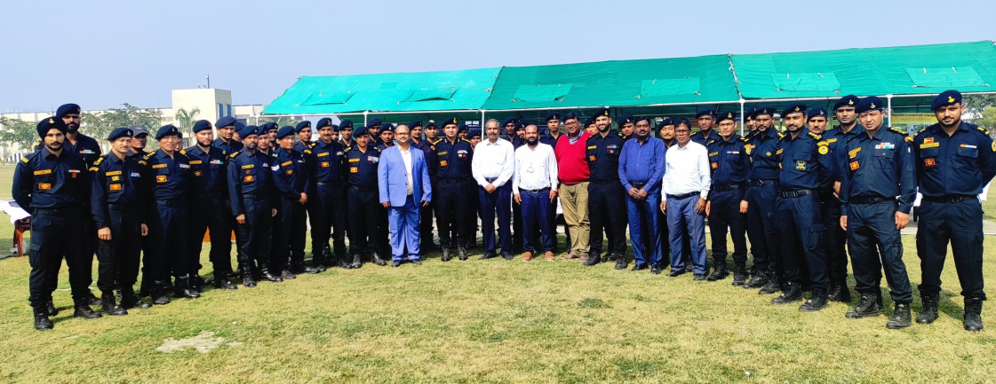
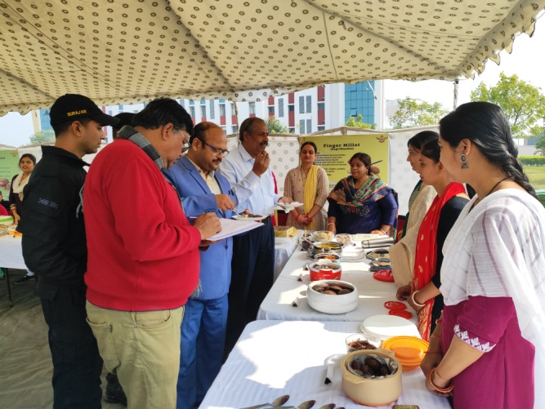
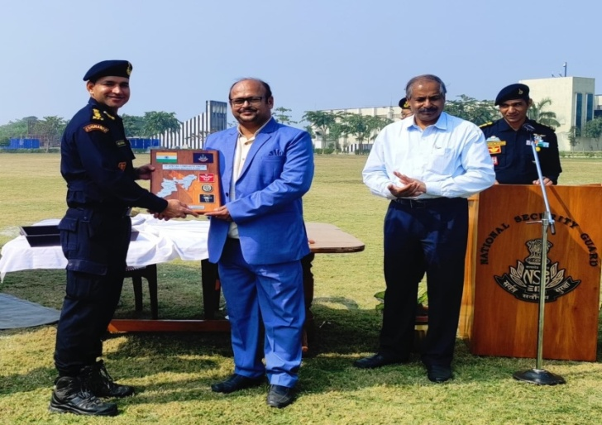
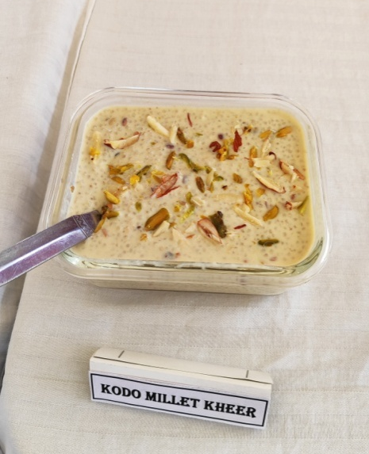
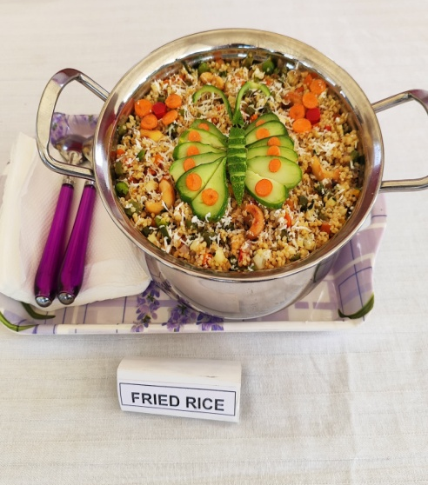
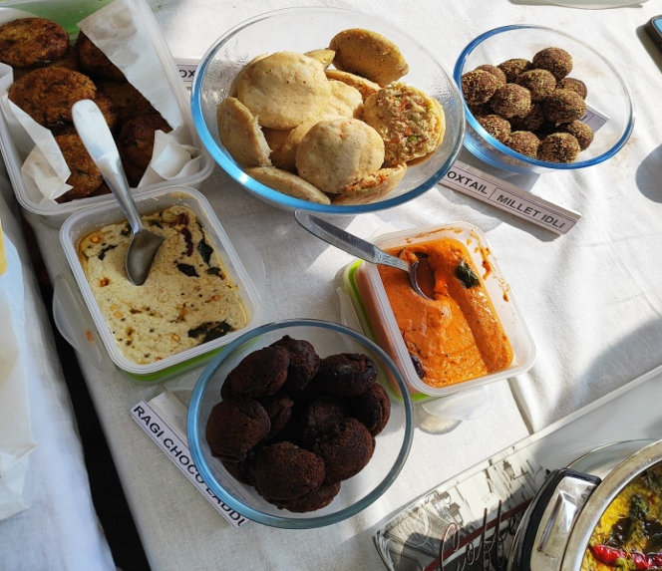
Assessing different food items made from various millet
Various recepies prepared from Millet by NSG Family Members’ during Millet Mela 2025

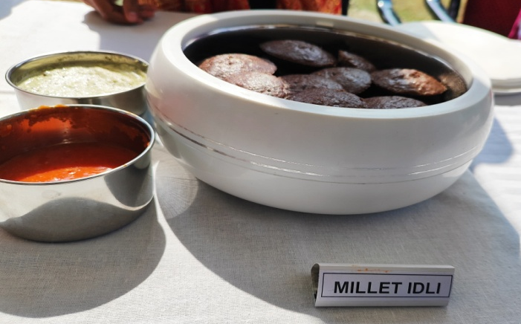
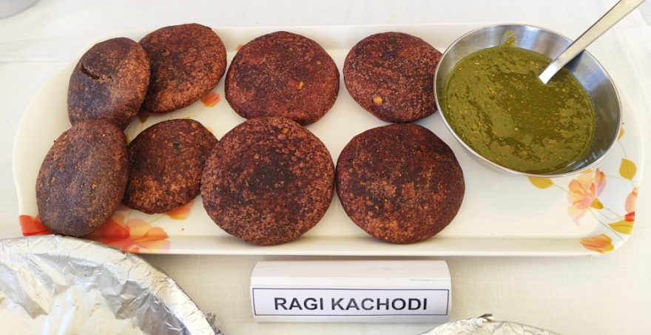

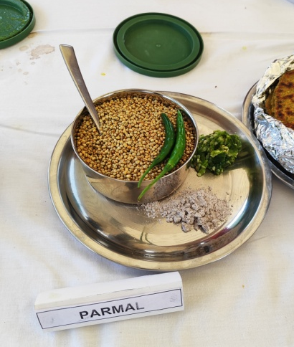
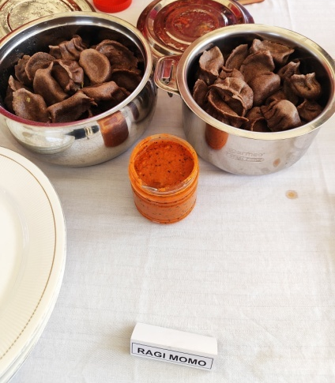
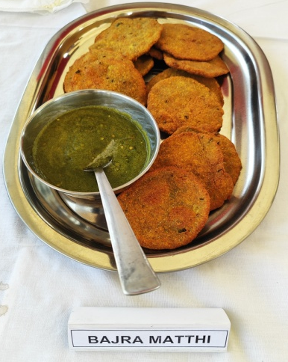
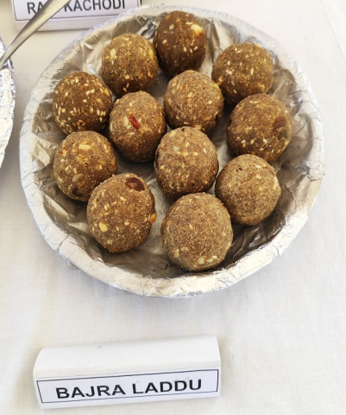

9.8. Agriculture Knowledge in rural school

Name and address of school | Date of visit to school | Areas covered | Teaching aids used
Priyanath Union Pathsala | 07.01.2026 | Swachhata Awareness programme
Kamalapur New Set-up Upper Primary School | 09.02.2026 | Swachhata Awareness programme
Chandul Jr. High School | 02.03.2026 | Swachhata Awareness programme
 |  | Parthenium Awareness Program
Give good quality 1-2 photograph(s)

9.9. Details of ‘Pre-Rabi Campaign’ / ‘Pre-Kharif Campaign’ Programme

Date of programme | No. of Union Ministers attended the programme | No. of Hon’ble MPs (Loksabha/ Rajyasabha) participated | No. of State Govt. Ministers | Participants (No.) |  |  |  |  |  |  | Coverage by Door Darshan (Yes/No) | Coverage by other channels (Number)
 |  |  |  | MLAs Attended the programme | Chairman ZilaPanchayat | Distt. Collector/ DM | Bank Officials | Farmers | Govt. Officials, PRI members etc. | Total | Coverage by Door Darshan (Yes/No) | Coverage by other channels (Number)
Please provide good quality photographs:
9.10. Details of Swachhta Hi Seva/ Swachhta Pakhwada programme organized

Sl.  No. | Activity | No. of villages Involved | No. of Participants | No. of VIPs | Name (s) of VIP(s)
1. | 21 | 6 | 480 | 0 | 0
Please provide good quality photographs:

9.11. Details of Mahila Kisan Divas programme organized

Sl.  No. | Activity | No. of villages Involved | No. of Participants | No. of VIPs | Name (s) of VIP(s)
1. | Hands on training on Mushroom and Vermicompost | 5 | 50
Please provide good quality photographs:

9.12. No. of Progressive/Innovative/Lead farmer identified (category wise)

Sl.  No. | Name of Farmer | Address of the farmer with contact no. | Innovation/ Leading in enterprise

9.13. Revenue generation
Sl.No. | Name of Head | Income(Rs.) | Sponsoring agency
1. | DAESI | 1,60,000.00 | MANAGE, Hyderabad
2. | IRISE skill dev. training for rural youth | 2,90,500.00 | Syngenta India Foundation

9.14. Resource Generation:
Sl.No. | Name of the programme | Purpose of the programme | Sources of fund | Amount  (Rs. lakhs) | Infrastructure created
 | DAESI | Diploma training courses for Input dealers | Input dealers | 22.4 | Nill
 | IRISE training | skill dev. training for rural youth | Syngenta India Foundation | 2.905 | Nil

9.15. Performance of Automatic Weather Station in KVK
Date of establishment | Source of funding i.e. IMD/ ICAR/ Others (pl. specify) | Present status of functioning

9.16. Contingent crop planning
Name of the state | Name of district/KVK | Thematic area | Number of programmes organized | Number of Farmers contacted | A brief about contingent plan executed by the KVK

10. Report on Cereal Systems Initiative for South Asia (CSISA)

- Year:
- Introduction / General Information:

 | Title | Objective | Treatment details | Date of sowing | Replication | Result with photographs
Experiment 1
Experiment 2
Experiment 3
…
..
Others (If any)
Please provide good quality photographs:

11. Details of DAPST/ TSP

- Achievements of physical output under TSP during 2025

Progress of DAPST for the year 2025 (Jan. to Dec., 2025)
Name of KVK
Sl. No. | Item/Activity |  | Units | Activities/ Items No. |  | No. of Beneficiaries
Sl. No. |  |  | Units | Annual Targets | Achievements | Annual Targets | Achievements
1 | Trainings (Capacity building/ Skill Development etc.) |  | No.
1 | 1.1 | 1-3 days | No.
1 | 1.2 | 4-10 days | No.
1 | 1.3 | 2-4 weeks | No.
1 | 1.4 | More than 4 weeks | No.
2 | On Farm Trials (OFTs) |  | No.
3 | Front Line Demonstrations (FLDs) and other demonstrations |  | No.
4 | Awareness camps, exposure visits etc. |  | No.
5 | Input Distribution
5 | 5.1 | Seeds (Field Crops) | Tonnes
5 | 5.2 | Seeds (High Value Crops, spices etc.) | kg
5 | 5.3 | Seeds (Root & Tuber Crops) | tonnes
5 | 5.4 | Nursery plants | No.
5 | 5.5 | Cutting , slips, suckers, etc | No.
5 | 5.6 | Mushroom Spawns/ Bio-Fertilizers (in Packets) | Packets
5 | 5.7 | Honey Bee Colonies | No.
5 | 5.8 | Animals-large (Cattle/ Buffalo/ camel/horse/donkey/Mithun/Yak etc.) | No.
5 | 5.9 | Animals-small (pig, sheep, goat etc.) | No.
5 | 5.1 | Poultry chicks / duckling etc | No.
5 | 5.11 | Fish Spawns/ fingerlings | No.
5 | 5.12 | Small equipment's (upto Rs 2000) | No.
5 | 5.13 | Medium Equipment's/ machinery (upto Rs 25000) | No.
5 | 5.14 | Large Equipment's / machinery (> Rs. 25000) | No.
5 | 5.15 | Infrastructure / Civil Works/ Ponds etc | No.
5 | 5.16 | Setting up plant nursery/ seed farm/ hatchery | No.
5 | 5.17 | Land development/ Reclamation / Conservation | hectares
5 | 5.18 | Fertilizers (NPK)/ Secondary fertilizers | tonnes
5 | 5.19 | Micro nutrients | tonnes
5 | 5.2 | FYM/ Vermicompost | tonnes
5 | 5.21 | Soil amendments (Gypsum, lime etc.) | tonnes
5 | 5.22 | Plant protection chemicals | kg
5 | 5.23 | Plant growth Promoter | kg
5 | 5.24 | Animal Feed | tonnes
5 | 5.25 | Animal Fodder | tonnes
5 | 5.26 | Animal medicines | doses
5 | 5.27 | Any other (Liquid PSB etc.) | Litre
6 | Services/Facilitation
6 | 6.1 | Animal Health Camps | No.
6 | 6.2 | Artificial Insemination / Vaccination | No.
6 | 6.3 | Veterinary Services (Hospitalization, on-site treatment, PD, surgery etc) | No.
6 | 6.4 | Testing samples of Soil, plant, water, feed, fodder and livestock | No.
6 | 6.5 | Promotion of agri-entrepreneurship | No.
6 | 6.6 | Promotion of IFS, IOFS, Natural Farming, Nutrigarden, kitchen garden, orchards etc | No.
6 | 6.7 | Creation of market links of farm produces | No.
6 | 6.8 | Use of Institute Facilities (Processing etc.) (in Hours) | Hours
6 | 6.9 | Subsidies/ Assistance (50% of Project cost, Max. Rs 10,000/beneficiary) | No.
7 | Distribution of Literature |  | No.
8 | Employment generation for livelihood |  | (Man-months)
9 | Fellowship, Stipends or Scholarship |  | No.
10 | Area oriented R&D Activity (project addressing the problems of agri. Sector faced by the SC/STs and benefit directly, which is measurable and identifiable |  | No. of projects
11 | Monitoring & Evaluation of DAPSC/ST (upto 3%)
12 | Any other (specify)

- Fund received under TSP in 2025-26 (Rs. In lakh):

12. Details of DAPSC/ SCSP

- Achievements of physical output under SCSP during 2025

Progress of DAPSC for the year 2025 (Jan. to Dec., 2025)
Name of KVK
Sl. No. | Item/Activity |  | Units | Activities/ Items No. |  | No. of Beneficiaries
Sl. No. |  |  | Units | Annual Targets | Achievements | Annual Targets | Achievements
1 | Trainings (Capacity building/ Skill Development etc.) |  | No. | 25 | 34 | 750 | 1000
1 | 1.1 | 1-3 days |  | 20 | 34 | 600 | 1000
1 | 1.2 | 4-10 days |  | 5 | 0 | 150 | 0
1 | 1.3 | 2-4 weeks |  | 0 | 0 | 0 | 0
1 | 1.4 | More than 4 weeks |  | 0 | 0 | 0 | 0
2 | On Farm Trials (OFTs) |  | No. | 0 | 0 | 0 | 0
3 | Front Line Demonstrations (FLDs) and other demonstrations |  | No. | 15 | 10 | 200 | 720
4 | Awareness camps, exposure visits etc. |  | No. | 4 | 3 | 200 | 160
5 | Input Distribution |  |  |  | 0 |  | 0
5 | 5.1 | Seeds (Field Crops) |  | 1.5 | 1.32 | 300 | 485
5 | 5.2 | Seeds (High Value Crops, spices etc.) |  | 3 | 0 | 300 | 0
5 | 5.3 | Seeds (Root & Tuber Crops) |  | 4 | 0 | 40 | 0
5 | 5.4 | Nursery plants |  | 40000 | 20000 | 200 | 100
5 | 5.5 | Cutting , slips, suckers, etc |  | 1000 | 0 | 100 | 0
5 | 5.6 | Mushroom Spawns/ Bio-Fertilizers (in Packets) |  | 100 | 400 | 100 | 155
5 | 5.7 | Honey Bee Colonies |  | 0 |  | 0
5 | 5.8 | Animals-large (Cattle/ Buffalo/ camel/horse/donkey/Mithun/Yak etc.) |  | 0 |  | 0
5 | 5.9 | Animals-small (pig, sheep, goat etc.) |  | 0 |  | 0
5 | 5.1 | Poultry chicks / duckling etc |  | 3000 | 2000 | 200 | 200
5 | 5.11 | Fish Spawns/ fingerlings |  |  | 0 |  | 0
5 | 5.12 | Small equipment's (upto Rs 2000) |  | 400 | 40 | 400 | 40
5 | 5.13 | Medium Equipment's/ machinery (upto Rs 25000) |  | 30 | 20 | 30 | 20
5 | 5.14 | Large Equipment's / machinery (> Rs. 25000) |  | 0 |  | 0
5 | 5.15 | Infrastructure / Civil Works/ Ponds etc |  | 0 |  | 0
5 | 5.16 | Setting up plant nursery/ seed farm/ hatchery |  | 0 |  | 0
5 | 5.17 | Land development/ Reclamation / Conservation |  | 0 |  | 0
5 | 5.18 | Fertilizers (NPK)/ Secondary fertilizers |  | 0.1 | 0 | 50 | 0
5 | 5.19 | Micro nutrients |  | 0.01 | 0 | 50 | 0
5 | 5.2 | FYM/ Vermicompost |  | 1 | 0 | 100 | 0
5 | 5.21 | Soil amendments (Gypsum, lime etc.) |  |  | 0 |  | 0
5 | 5.22 | Plant protection chemicals |  | 20 | 0 | 300 | 0
5 | 5.23 | Plant growth Promoter |  | 1 | 0 | 100 | 0
5 | 5.24 | Animal Feed |  | 1 | 0.2 | 400 | 200
5 | 5.25 | Animal Fodder |  | 1 | 0 | 15 | 0
5 | 5.26 | Animal medicines |  | 0 |  | 0
5 | 5.27 | Any other (Liquid PSB etc.) |  | 0 |  | 0
6 | Services/Facilitation |  |  |  | 0 |  | 0
6 | 6.1 | Animal Health Camps |  | 0 |  | 0
6 | 6.2 | Artificial Insemination / Vaccination |  | 0 |  | 0
6 | 6.3 | Veterinary Services (Hospitalization, on-site treatment, PD, surgery etc) |  | 0 |  | 0
6 | 6.4 | Testing samples of Soil, plant, water, feed, fodder and livestock |  | 0 |  | 0
6 | 6.5 | Promotion of agri-entrepreneurship |  | 4 | 2 | 4 | 2
6 | 6.6 | Promotion of IFS, IOFS, Natural Farming, Nutrigarden, kitchen garden, orchards etc |  | 10 | 5 | 10 | 5
6 | 6.7 | Creation of market links of farm produces |  | 0 |  | 0
6 | 6.8 | Use of Institute Facilities (Processing etc.) (in Hours) |  | 0 |  | 0
6 | 6.9 | Subsidies/ Assistance (50% of Project cost, Max. Rs 10,000/beneficiary) |  | 0 |  | 0
7 | Distribution of Literature |  | No. | 2500 | 1700 | 2500 | 1700
8 | Employment generation for livelihood |  | (Man-months) |  | 0 |  | 0
9 | Fellowship, Stipends or Scholarship |  | No. |  | 0 |  | 0
10 | Area oriented R&D Activity (project addressing the problems of agri. Sector faced by the SC/STs and benefit directly, which is measurable and identifiable |  | No. of projects |  | 0 |  | 0
11 | Monitoring & Evaluation of DAPSC/ST (upto 3%) |  |  |  | 0 |  | 0
12 | Any other (specify) |  |  | 1 | 1 | 400 | 400

- Fund received under SCSP in 2025-26 (Rs. In lakh): 6.25

13.Progress report of NICRA KVK (Technology Demonstration component) during the period
(Applicable for KVKs identified under NICRA)

Natural Resource Management
Name of intervention undertaken | Numbers under taken | No of units | Area (ha) | No of farmers covered / benefitted |  |  |  |  |  |  |  |  |  | Remarks
 |  |  |  | SC |  | ST |  |  | Other |  | Total
 |  |  |  | M | F |  | M | F | M | F | M | F | T

Crop Management

Name of intervention undertaken | Area (ha) | No of farmers covered / benefitted |  |  |  |  |  |  |  |  |  | Remarks
 |  | SC |  | ST |  |  | Other |  | Total
 |  | M | F |  | M | F | M | F | M | F | T

Livestock and fisheries

Name of intervention undertaken | Number of animals covered | No of units | Area (ha) | No of farmers covered / benefitted |  |  |  |  |  |  |  |  |  | Remarks
 |  |  |  | SC |  | ST |  |  | Other |  | Total
 |  |  |  | M | F |  | M | F | M | F | M | F | T

Institutional interventions

Name of intervention undertaken | No of units | Area (ha) | No of farmers covered / benefitted |  |  |  |  |  |  |  |  |  | Remarks
 |  |  | SC |  | ST |  |  | Other |  | Total
 |  |  | M | F |  | M | F | M | F | M | F | T

Capacity building
Thematic area | No of Courses | No of beneficiaries
 |  | SC | ST |  |  | Other |  |  | Total
 |  | M | F | M | F |  | M | F | M | F | T

Extension activities
Thematic area | No of activities | No of beneficiaries
 |  | SC | ST |  |  | Other |  |  | Total
 |  | M | F | M | F |  | M | F | M | F | T

Detailed report should be provided in the circulated Performa

Technology (ies) popularized/ scaled up during the year

a)
b)
c)

14. Awards/Recognition received by the KVK

Sl. No. | Name of the Award | Year | Conferring Authority | Amount | Purpose

Award received by Farmers from the KVK district
Sl. No. | Name of the Award | Name of the Farmer | Year | Conferring Authority | Amount | Purpose

- Any significant achievement of the KVK with facts and figures as well as quality photograph

HOWRAH KVK ROLLS OUT LOW-COST HYDROPONIC FODDER PRODUCTION MODEL TO ENSURE ROUND-THE-YEAR ACCESS TO AFFORDABLE GREEN FODDER

In an era where the vagaries of the monsoon often render traditional pastoral lands an inundated morass, the Howrah KVK has engineered a quintessential paradigm shift. This KVK has unveiled a low-cost, farmer-friendly hydroponic fodder production model, designed to circumvent the perennial scarcity of green forage.
​​Recently, this research project funded by ATMA reached a significant milestone, when a phalanx of eminent dignitaries graced the Hydroponic Unit with their presence. The delegation included Dr. P. Deepap Priya, District Magistrate, Howrah, the Deputy Director, ARD, Howrah, Sabhapati of Jagatballavpur Panchayat Samiti,​ the BDO and officials from other line Departments.
​In a gesture of tangible empowerment, five such hydroponic units developed by Howrah KVK were distributed to local beneficiaries selected by ATMA. Dr. Priya, in a discourse marked by profound appreciation, lauded the KVK for its tireless pursuit of agricultural excellence and its commitment to mitigating the hardships of our rural populace.
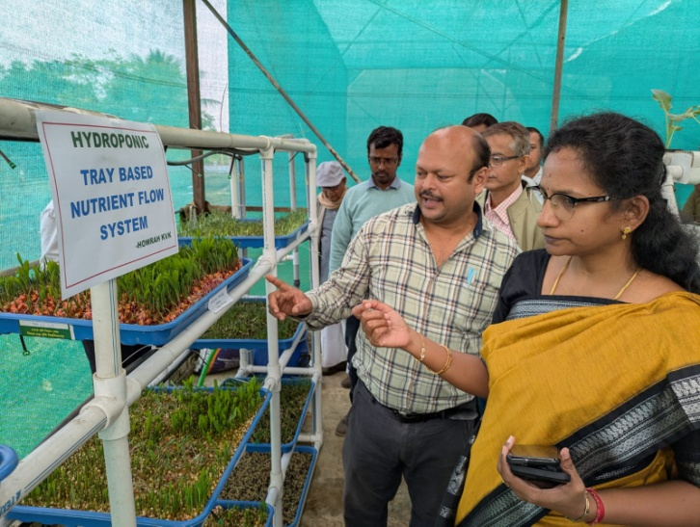
​Howrah KVK under the administrative control of BCKV, has indeed been making waves with this recent initiatives having the formal coverage on the ICAR website as well as in leading Bengali news paper like Anandabazar and Bartaman.
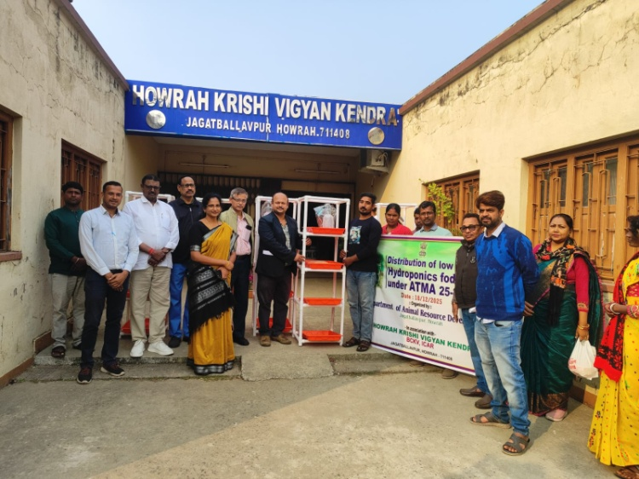

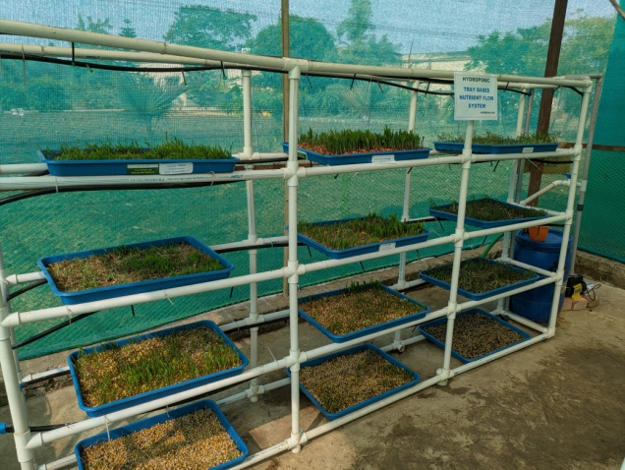
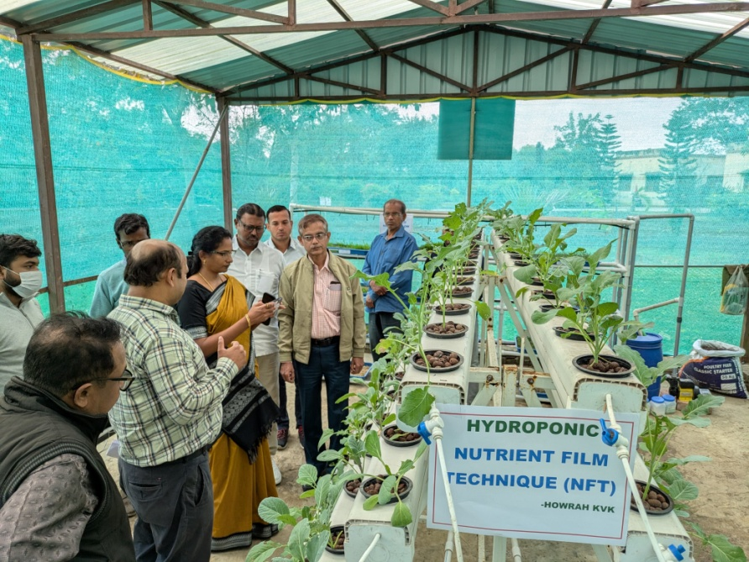

- Number of commodity based organizations/ farmers’ cooperative society/ FPO formed/ associated with during last one year (Details of the group/society may be indicated)

Sl. No. | Name of the organization/ Society | Trust Deed No.& date | Date of Trust Registration  Address | Proposed Activity | Commodity Identified | No. of Members | Financial position  (Rupees in lakh) | Success indicator

- Integrated Farming System (IFS)
Details of KVK Demo. Unit
Sl.  No. | Module details (Component-wise) | Area under IFS (ha) | Production (Commodity-wise) | Cost of production in Rs. (Component-wise) | Value realized in Rs. (Commodity-wise) | No. of farmer adopted practicing IFS | % Change in adoption during the year
Not yet started

- Information on Visit of Ministers to KVKs, if any (Please provide good quality photographs)

Date of Visit | Name of Hon’ble Minister | Name of Ministry | Salient points in his/ her observation  (2-3 bulleted points)

- a) Information on ASCI Skill Development Training Programme, if undertaken during 2024

Name of the Job role | Name of the certified Trainer of KVK for the Job role | Date of start of training | Date of completion of training | No. of participants |  |  |  |  |  | Whether uploaded to SIP Portal (Y/N) | Fund utilized for the training (Rs.)
 |  |  |  | SC |  | ST |  | Other |  | Whether uploaded to SIP Portal (Y/N) | Fund utilized for the training (Rs.)
 |  |  |  | M | F | M | F | M | F | Whether uploaded to SIP Portal (Y/N) | Fund utilized for the training (Rs.)
(Please provide good quality photographs)

b) Information on Skill Development Training Programme (Other than ASCI or less than 200 hrs., if any) if undertaken during 2024

Thematic area of training | Title of the training | Duration (in hrs.) | No. of participants |  |  |  |  |  |  |  |  | Fund utilized for the training (Rs.)
 |  |  | SC |  | ST |  | Other |  | Total
 |  |  | M | F | M | F | M | F | M | F | T
- Information on NARI Project(if applicable)

Name of Nodal Officer | No. of OFT on specified aspects | Title(s) of OFT | No. of FLD on specified aspects | No. of capacity development programme on specified aspects | Total no. of farm women/ girls involved in the project | Details of Issues related to gender mainstreaming addressed through the project

- Any other programme organized by KVK, not covered above

Sl.  No. | Name of the programme | Date of the programme | Venue | Purpose | No. of participants

A BRIEF REPORT ON “VIKSIT KRISHI SANKALP ABHIYAN” (VKSA)
CONDUCTED BY HOWRAH KRISHI VIGYAN KENDRA, BCKV

Howrah Krishi Vigyan Kendra under the management of Bidhan Chandra Krishi Viswavidyalaya has successfully organised the “Viksit Krishi Sankalp Abhiyan” and Pre-Kharif Campaign during 29th May to 12th June 2025 initiated by the Ministry of Agriculture & Farmers’ Welfare, Government of India and ICAR in collaboration with ICAR-NINFET, ICAR-CRIJAF and ICAR-NBSS & LUP. Before we start, this Kendra has prepared a route map and three different teams for proper planning and execution. This Viksit Krishi Sankalp Abhiyan & Pre-Kharif Season outreach programs were conducted across 240 villages covering all the 14 blocks in Howrah district, West Bengal, engaging 19251 male and 11896 female farmers (total 31147) in 59 events.
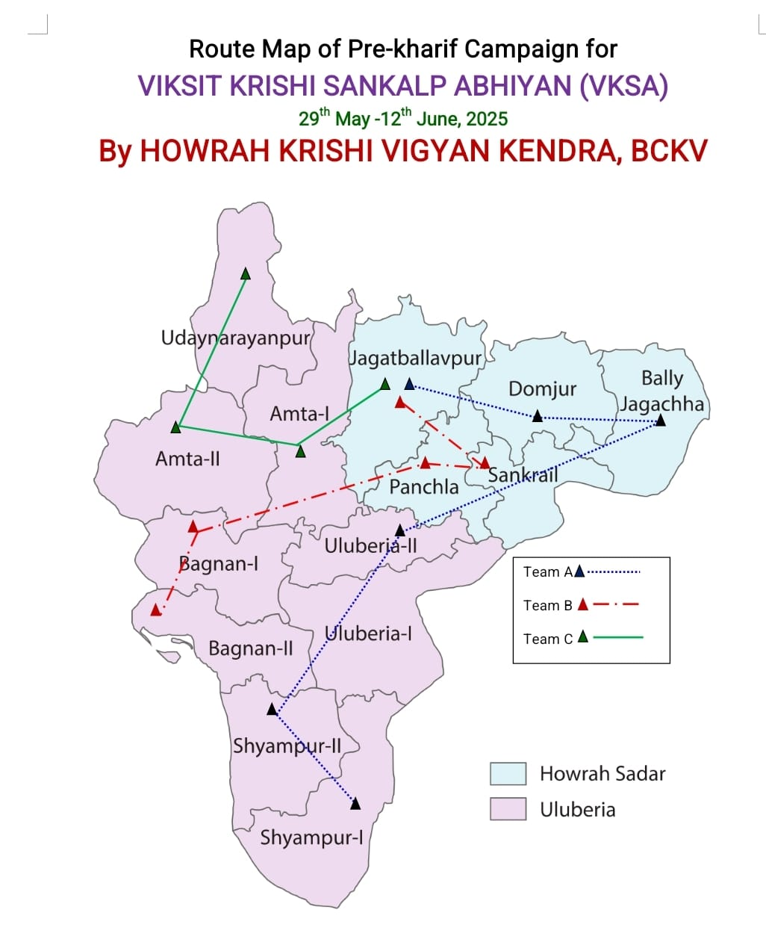
The inaugural programme of VKSA was conducted on 29th May 2025 at Goalpota village in presence of Deputy Director, ARD,Government of West Bengal, Howrah and Various scientists from ICAR organizations.

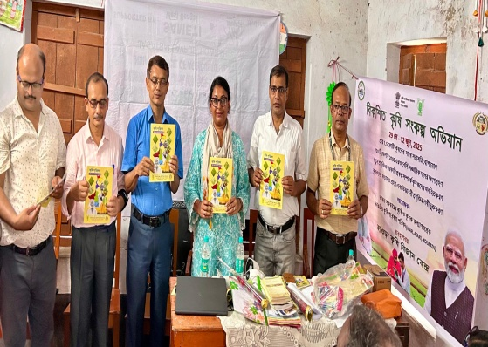

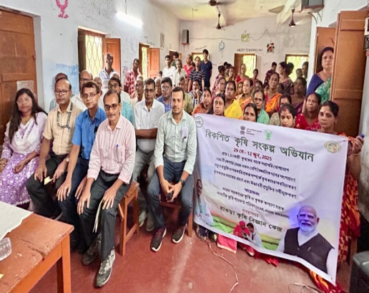
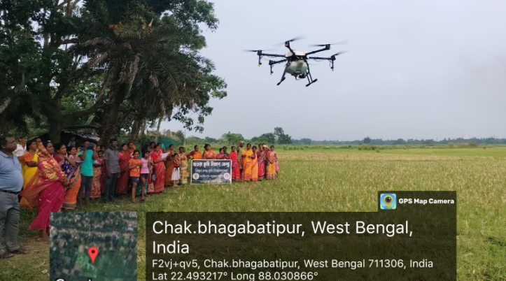

During the inaugural session one Krishi-Pushtika was inaugurated by the guests focusing agro-advisory for kharif crops. A total of 2,500 pamphlets were distributed, emphasizing sustainable agriculture, soil conservation, and enhanced livelihoods through schemes like Schedule Caste Sub-Plan (SCSP), Government schemes & leaflets. The discussions of programs focused on utility of soil health cards, natural farming, paddy cultivation, beetle vine cultivation, FPC formation, farm mechanization, seed treatment, women empowerment, soil testing, beekeeping, vermicompost preparation, mushroom production, protected cultivation, off-season vegetable cultivation, plant protection measures and government schemes like PMMSY, PM-Kishan, Kishan Samman Nidhi. Programme like Animal Health Camp, Drone Demonstration were also included in the Abhiyan.
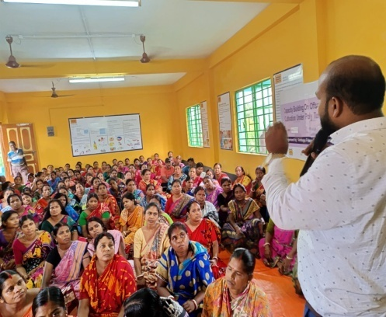
Farmers raised quarries on pest management; cultivation practices of vegetables, paddy, jute, beetle vine, potato, sesame, and groundnut and how to get access on different Government Schemes as well as unsatisfactory market price. Farmer’s feedback in Google sheet has been collected during the programme and sent to ICAR-ATARI. Daily achievements were also uploaded in VKSA portal regularly. Key experts included Dr. Kironmay Barui, Dr. Koushik Nag, Dr. Sudipta Banerjee, Dr. Arka Samanta and Dr. Jayanta Mandal from Howrah KVK; Dr. Dhananjoy Burman, Dr. Krishna Gopal Mandal, Dr. Kunal Mandal, and Dr. Debabrata Sarkar from ICAR-CRIJAF; Dr. D. P. Ray, Dr. Prateek Shrivastava, Dr. Manisha Jagdale, and Dr. Sanchita Biswas Murmu from ICAR-NINFET and Dr. Amrita Daripa from ICAR-NBSS & LUP.
The valedictory programme was conducted at Joypur village of Amta-II Block on 12th June 2025 with glorious presence of Dr. D. B. Shakyawar. All the experts and supporting staffs were felicitated during the programme.
Howrah KVK had made a wide coverage of this 15 days mega event through various local and state level newspapers, Doordarshan and though social media. At the end of the programme feedback from the scientist of various ICAr institute were captured and share the same with ICAr-0ATARI, Kolkata
All the scientist and supporting staff associated with this programme were falicitated by Howrah KVK.
